KB – HRS Change Report
Table of Contents
Purpose and Overview 1
Process Inputs 1
Process Outputs 1
Procedure Steps 1
Tables 7

Purpose and Overview
The HRS Change report identifies employee records that exist in the CAT and have undergone a change in HRS. A change is defined as an update to the fields Business Unit, HR Department, Position Number, Jobcode, Pay Basis, Title, FTE, Payroll Status, or Comprate, as well as Hires, Rehires, Transfers, or Terminations.
This report will pull using similar logic that populates the Recent and Future HR / Compensation Transactions section in the CAT. This report will serve as an update notification of all these changes. Users will need to then review the records on this report and determine if the compensation changes entered in the CAT are still accurate, if a new record in the CAT needs to be created, or if a CAT record needs to be deleted. The HRS Change report is only of use when the Automatic HRS Update Feed is ON.

Process Inputs
- Fiscal Year
- Effective Dates
- Business Unit
- Division (Optional)
- Department (Optional)
- Employee Class

Process Outputs
- Excel document with a population that meets the run control criteria and has undergone a change in HRS in one of the key fields outlined above.

Procedure Steps
- Navigate to Workforce Administration > UW External HR Systems > Compensation Admin Tool > CAT Reports > HRS Change Report.
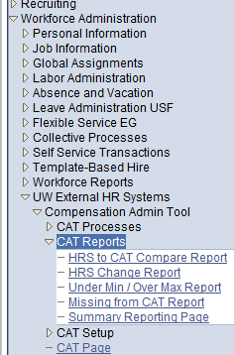
- Click Search under the Find an Existing Value tab to select a previously created Run Control ID, or create a new Run Control ID by selecting Add a New Value. To create a new Run Control ID, assign a unique identifier as the Run Control ID (eg. initials_date_etc.) into the Run Control ID box and select Add.
- Note: Run Control ID sets the report parameters. Users can create one ID, and use it to process multiple reports/processes, or create a new ID for each report/process.
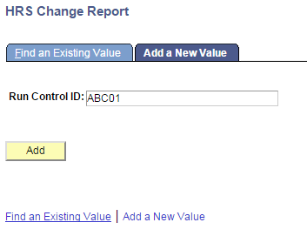
- Enter parameters to define criteria for the HRS Change Report.
  - Select the upcoming Fiscal Year used for CAT budgeting planning purposes. This field will default to the latest fiscal year setup in the CAT.
  - Select a range of effective dates within the chosen fiscal year.
    - Select a From Date.
    - Select a To Date.
  - Select a Business Unit.
  - If desired, select a Division.
  - If desired, select a Department.
    - If available, the Department field will become editable when the user selects a Division from the search tool or enters one manually and presses the tab button out of the field.
  - Click Select Values in the employee class box if you wish to exclude certain employee classes from the report. The default is for all employee classes to be included. Employee classes that are not included in the CAT will not pull onto CAT reports.
  - Click Save in the bottom left to save the parameters for the report.
  - Click Run in the top right to run the report.
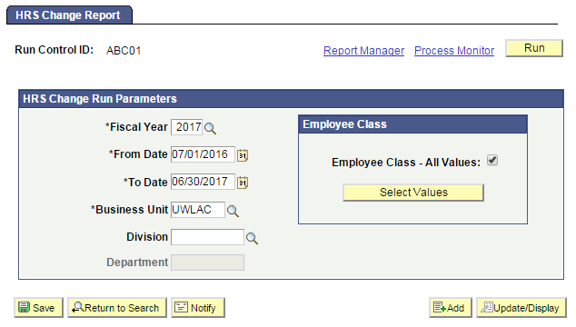
- User will be automatically directed to the Process Scheduler Request page. From this page, select OK.
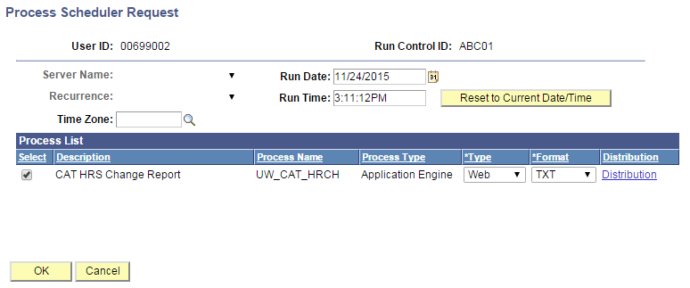
- Note the Process Instance number under the Process Monitor link. This designates the specific instance of the report run.
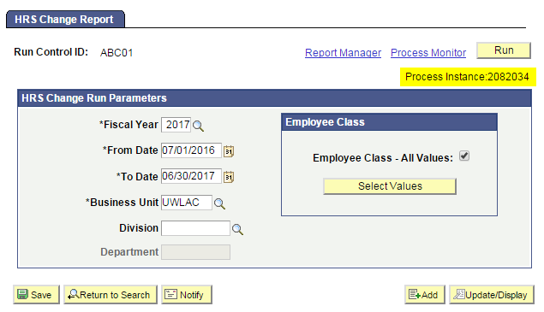
- Click Process Monitor at the top right of the window.
- Search for your process instance number under Process List, which will indicate the status of the report generation. When the report is complete, Run Status will be “Success” and Distribution Status will be “Posted”.
  - If Run Status is “Queued,” it indicates that the report generation is waiting to start.
  - If Run Status is “Processing,” it indicates that the report generation is processing.
  - Click Refresh at the top right of the window to refresh the status of the document.
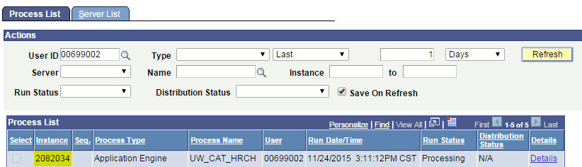
- Once the Run Status hits “Success” and the Distribution Status hits “Posted,” download the output.
  - Click Details.
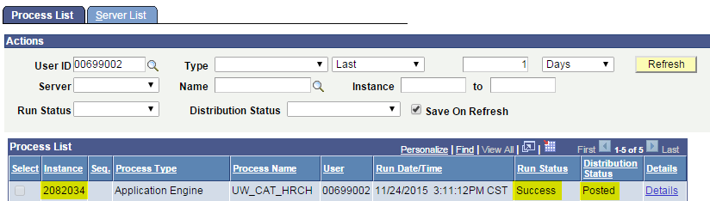
  - Click View Log/Trace at the bottom right of the window.
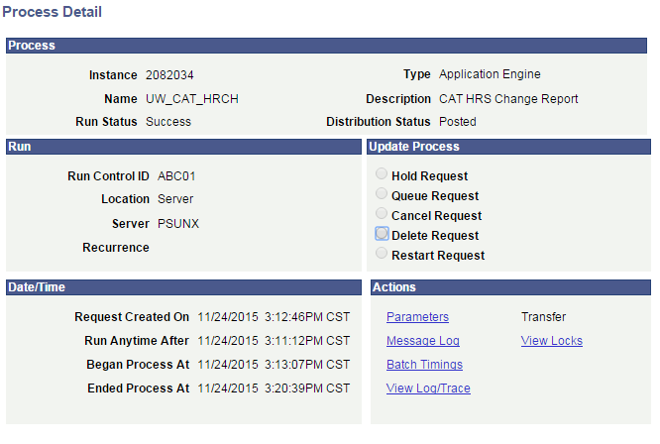
  - Under File List, click the file with the .xls extension to download the output. Note: you may have two .xls outputs if you have any additional splits.
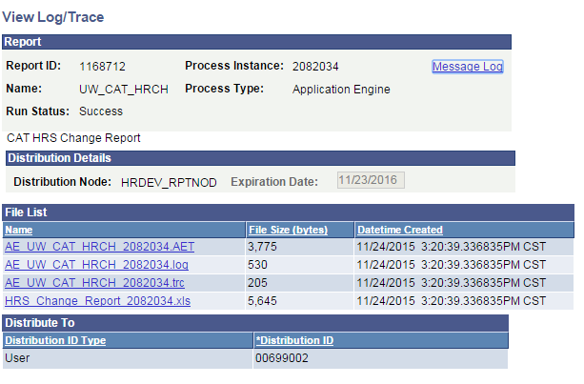
  - When opening the file in Excel, if an error message appears indicating that “The file you are trying to open…is in a different format than specified by the file extension,” click Yes.
  - Note that different internet browsers may have different opening processes.
- Review the report.
  - The excel output file will look like the screenshot below
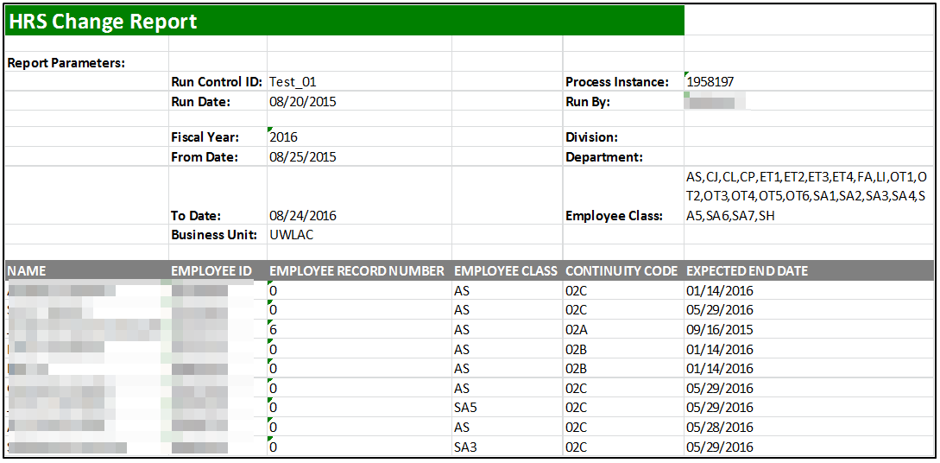
  - The report displays one row per emplid/emplrcd combination per row
    - For a new hire – only the updated fields will be populated.
    - For a termination – only the original fields will be populated.
    - For a transfer – both original and updated fields will be populated.
    - For a field that has not undergone no change in HRS – both original and updated fields will be blank
    - If more than one ‘action/action reason’ has been entered in HRS in the defined time period, the most recent change to an emplid/emplrcd will appear
  - A description of the different header fields is displayed in Table 1 below
  - Action items that may be taken based on the report output are listed in Table 2

Tables
Table 1: Output Header Fields
Report Parameters
Field Name | Description
Run Control ID | The run control identification entered when report was created.
Run Date | The date the report was created.
Fiscal Year | The fiscal year of the data pulled for the report.
From Date | The starting effective date of the CAT you wish to compare against in HRS.
To Date | The ending effective date of the CAT you wish to compare against in HRS.
Business Unit | The Business Unit selected in the run control.
Process Instance | The number assigned by PeopleSoft for each process.
Run By | The user ID of the user who ran the report.
Division | The Division (if any) selected in the run control.
Department | The Department (if any) selected in the run control.
Employee Class | The Employee Class as selected in the run control
Report Columns
Column | Description
NAME | First & Last name from HRS for employee records that exist in the CAT and have had a change in HRS. This value should always display on the report.
EMPLOYEE ID | EmplID from HRS for employee records that exist in the CAT and have had a change in HRS. This value should always display on the report.
EMPLOYEE RECORD NUMBER | Employee Record from HRS for employee records that exist in the CAT and have had a change in HRS. This value should always display on the report.
EMPLOYEE CLASS | Empl Class from HRS for empl records that exist in the CAT and have had a change in HRS. This value should always display on the report.
CONTINUITY CODE | Continuity Code from HRS for employee records that exist in the CAT and have had a change in HRS. This value should always display on the report.
EXPECTED END DATE | EJED from HRS for empl records that exist in the CAT and have had a change in HRS. This value should always display on the report.
BASE CAT COMPRATE | The Comprate of the employee record from CAT.
ORIGINAL BUSINESS UNIT | Business Unit from HRS before the change for empl records that exist in the CAT and have had a change in HRS.
UPDATED BUSINESS UNIT | Business Unit from HRS after the change (from max effective row) for empl records that exist in the CAT and have had a change in HRS.
ORIGINAL HOME DEPT | Home Dept from HRS before the change for empl records that exist in the CAT and have had a change in HRS.
UPDATED HOME DEPT | Home Dept from HRS after the change (from max effective row) for empl records that exist in the CAT and have had a change in HRS.
ORIGINAL HRS POSITION NUMBER | Position Number from HRS before the change for empl records that exist in the CAT and have had a change in HRS.
UPDATED HRS POSITION NUMBER | Position Number from HRS after the change (from max effective row) for empl records that exist in the CAT and have had a change in HRS.
ORIGINAL HRS JOB CODE | Job Code from HRS before the change for empl records that exist in the CAT and have had a change in HRS.
UPDATED HRS JOB CODE | Job Code from HRS after the change (from max effective row) for empl records that exist in the CAT and have had a change in HRS.
ORIGINAL PAY BASIS | Pay Basis from HRS before the change for empl records that exist in the CAT and have had a change in HRS.
UPDATED PAY BASIS | Pay Basis from HRS after the change (from max effective row) for empl records that exist in the CAT and have had a change in HRS.
ORIGINAL JOB TITLE | Title from HRS before the change for empl records that exist in the CAT and have had a change in HRS.
UPDATED JOB TITLE | Title from HRS after the change (from max effective row) for empl records that exist in the CAT and have had a change in HRS.
ORIGINAL FTE | FTE from HRS before the change for empl records that exist in the CAT and have had a change in HRS.
UPDATED FTE | FTE from HRS after the change (from max effective row) for empl records that exist in the CAT and have had a change in HRS.
ORIGINAL PAYROLL STATUS | LOA status from HRS before the change for empl records that exist in the CAT and have had a change in HRS.
UPDATED PAYROLL STATUS | LOA status from HRS after the change (from max effective row) for empl records that exist in the CAT and have had a change in HRS.
ORIGINAL HRS COMPRATE | Comprate from HRS before the change for empl records that exist in the CAT and have had a change in HRS.
UPDATED HRS COMPRATE | Comprate from HRS after the change (from max effective row) for empl records that exist in the CAT and have had a change in HRS.
EMPLOYEE HIRED? | Y/N based on if there is a Hire row in HRS in the specified effective dated range.
EMPLOYEE REHIRED? | Y/N based on if there is a Rehire row in HRS in the specified effective dated range.
EMPLOYEE TRANSFERRED? | Y/N based on if there is a Termination row in HRS in the specified effective dated range.
EMPLOYEE TERMINATED? | Y/N based on if there is a Transfer row in HRS in the specified effective dated range.

Table 2: Action Items based on Report Output
Job Changes in HRS that Occurred | Action Item
Title Change | Review and Potentially Edit Comp Increases
Comprate Change | Review and Potentially Edit Comp Increases
New Hire | Potentially Add to CAT
FTE, EJED Change | Potentially Edit Planned FTE or Remove from CAT

