KB – CAT Summary Reporting Page

Table of Contents

Purpose and Overview 1

CAT Summary Page Functionality 1

Search Criteria Section 1

Results Section & Output Value Overview 3

CAT Summary Page – Results Section 3

Procedure Steps 7

Tables 10

# Purpose and Overview

The CAT Summary Report is an online page within the CAT solution that allows users to summarize key metrics critical for analyzing compensation distribution against the employee population. This page allows for flexibility in summarizing information from the CAT page, focusing on compensation changes and Continuing Staff Basis. Users can access the Summary Reporting page to monitor the allocated compensation changes as a percentage of the continuing staff base to make sure it is meeting the pay plan guidelines.

The CAT Summary Report only reflects data entered into the CAT page and does not include data from the AAP page. The report calculates data for “CSB FTE” and “CSB Amount” marked as yes in the “Add Salary to Continuing Staff Base?” check box from the CAT page and only summarizes data for the Action Reasons that are marked “Include in CSB” on the Annual Setup Page for each institution. For reference, please see the Annual Setup KB on the CAT Project User Acceptance Testing web page.

# CAT Summary Page Functionality

## Search Criteria Section

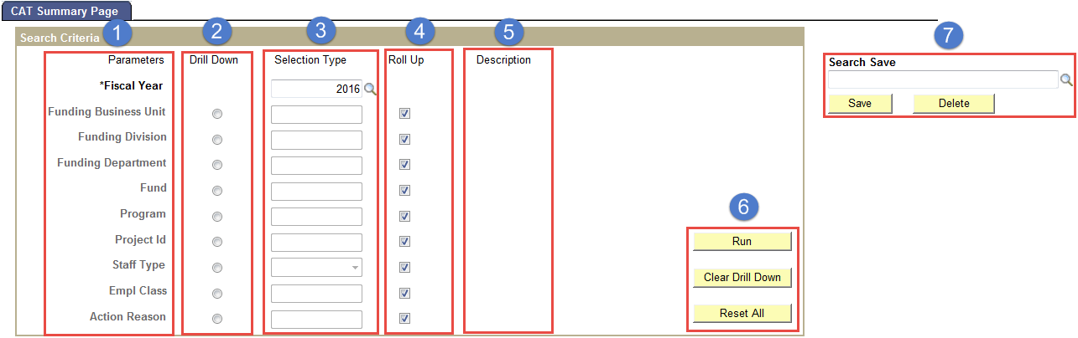

1. **Parameters**

* Fiscal Year
* Funding Business Unit
* Funding Division
* Funding Department
* Fund
* Program
* Project Id
* Staff Type
* Employee Class
* Action Reason

1. The **Drill Down** radio button provides the option to view data at a greater level of detail

* Example: Reviewing *Funding Division* totals in a particular *Funding Business Unit*

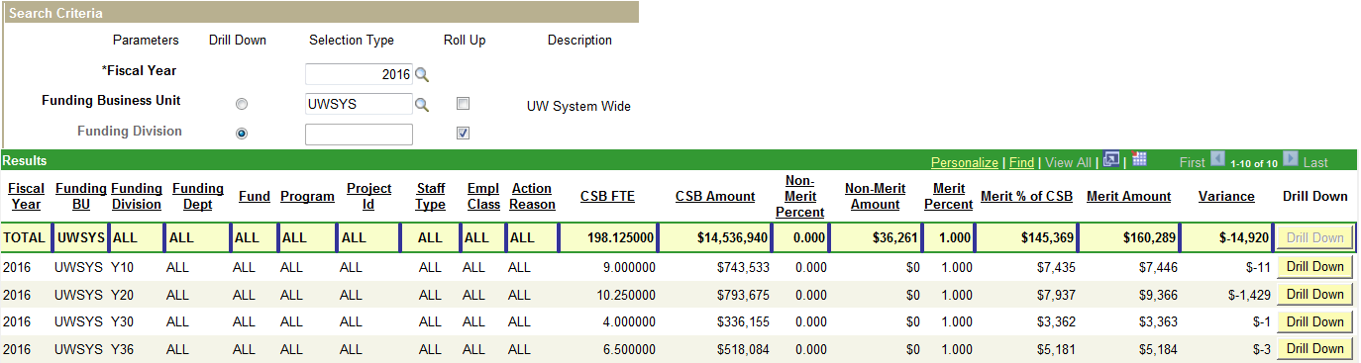

* The following applies when using the **Drill Down** button
  + Only one can be selected at a time
  + Corresponding **Roll Up** must be “unchecked”
  + **Funding Division** cannot be drilled down without first specifying the **Funding Business Unit**
  + **Funding Department** cannot be drilled down unless both **Funding Division** and **Funding Business Unit** are specified
  + **Fund**, **Program**, **Project Id**, **Staff Type**, **Empl Class**, and **Action Reason** can all be drilled down to the **Fiscal Year**, **Funding Business Unit**, **Funding Division**, and/or **Funding Department level**
    1. These do not involve a hierarchy of steps like Funding Business Unit, Funding Business Unit, and Funding Business Unit do.

1. **Selection Type** is used to define a specific Parameter value

* **Roll Up** checkbox must be “unchecked” to enter a value

1. The **Roll Up** check box determines the level of detail the report returns

* *Unchecked* – Must define a specific value for that particular parameters
* *Checked* – All amounts within that parameters will be included in the results

1. **Description** gives long description of the **Selection Type**
2. Control buttons on the CAT Summary Page

* **Run** button is used to retrieve report results based on parameters entered
* **Clear Drill Down** button removes selected **Drill Down**
* **Reset All** button resets all Search Result criteria to their default values

1. **Search Save** provides the option to save any Search Criteria

* Saved searches are for information purposes only, and will not default any Search Criteria fields

## Results Section & Output Value Overview

Based on input parameters, employee population included in Continuing Staff Base (CSB), Action Reasons included in CSB and Base Increase Percent by Action Reason, the results table lists totals for **CSB FTE**, **CSB Amount**, **Non-Merit Percent,** **Non-Merit Amount, Merit Percent, Merit Amount, Merit Percent of CSB,** and **Variance**. It is important for the user to understand where these output values come from, and what they do and do not include.

### CAT Summary Page – Results Section



1. **Parameters**

* Description: Displays report parameters entered in the Search Criteria section.
  + Note**:** When **Roll Up** is selected in the **Search Criteria**, “ALL” will display when Roll Up is selected

1. **CSB FTE**

* Description: The **CSB FTE** is the sum of all **Budgeted FTE** for all employees who are included in the Continuing Staff Base.
* Example:

1. Employees who’s **Add Salary to Continuing Staff Base?** box “checked” are included in the **CSB FTE** total
2. Those employee’s **Budgeted FTE** are then added to the **CSB FTE** total

*Input Value(s) – CAT Page*

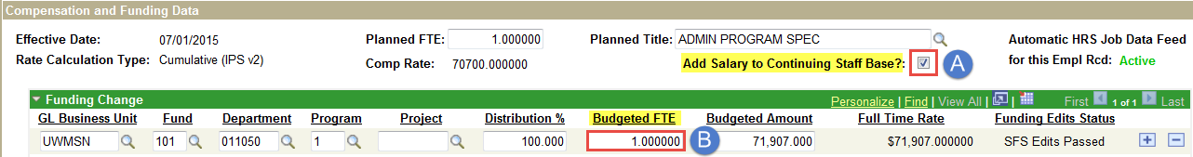

*Output Results – CAT Summary Page*

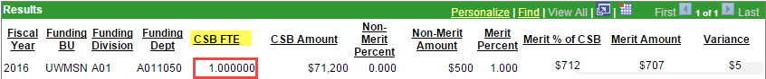

1. **CSB Amount**

* Description: The **CSB Amount** is the sum of employee base compensation plus compensation changes that are included in CSB.
  + *Formula*: *(Comp Rate + Change Amount ($)) * Budgeted FTE = CSB Amount*
* Example:

1. First, *only* employees with the **Add Salary to Continuing Staff Base** checkbox “*checked*” will be included in the **CSB Amount** calculation.
2. Those Employees **Comp Rates** (annualized salary) will then be added to the **CSB Amount.**

*Input Value(s) – CAT Page*



1. In addition, **Compensation Changes** are added based on whether the **Action Reasons** is indicated to be **Included in CSB -** this is defined on the *Annual Setup* page.

*Input Value(s) – Annual Setup Page*

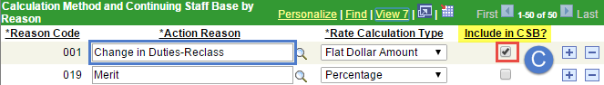

1. The **Change Amount ($)** for all **Action Reasons** marked to be **Included in CSB** will be added to the CSB Amount.

*Input Value(s) – CAT Page*

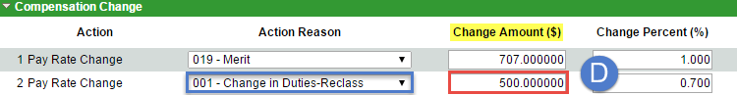

1. **Budgeted FTE** is then multiplied by the total amount (base salaries + comp changes).

*Input Value(s) – CAT Page*



*Output Results – CAT Summary Page*

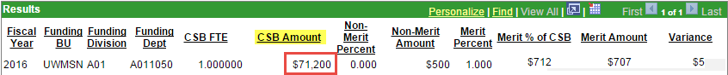

1. **Non-Merit Percent**

* Description: The **Non-Merit Percent** is a fixed percent defined by each *Funding Business Unit* for non-merit compensation increases.
  + Note: **Non-Merit Percent** will only display when *Employee Class* and *Action Reason* input parameters are specified or the *Action Reason* “Drill Down” is selected
* Example:

*Input Value(s) – Annual Setup Page*

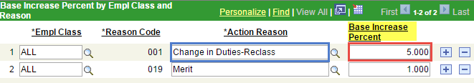

*Output Results – CAT Summary Page*



1. **Non-Merit Amount**

* Description: **Non-Merit Amount** is the sum of all non-merit compensation **Change Amounts ($)** enteredon the ***CAT Page.***
* Example:

*Input Value(s) – CAT Page*



*Output Results – CAT Summary Page*



1. **Merit Percent**

* Description: The **Merit Percent** is a fixed percent defined by each *Funding Business Unit* for merit compensation increases.
* Example:

*Input Value(s) – Annual Setup Page*

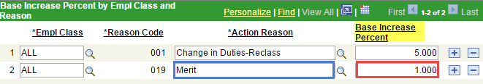

*Output Results – CAT Summary Page*

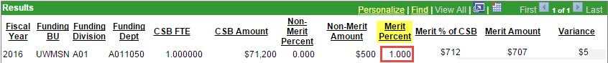

1. **Merit % of CSB**

* Description: **Merit % of CSB** represents the **CSB Amount** multiplied by the **Merit Percent**.
* Formula: *CSB Amount * Merit Percent = Merit % of CSB*
* Example:

*Output Results – CAT Summary Page*

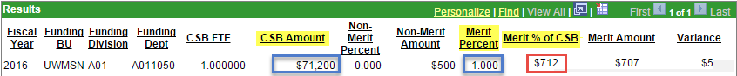

1. **Merit Amount**

* Description: The **Merit Amount** represents the sum of all employee’s merit compensation **Change Amounts ($)** defined on the ***CAT Page.***
* Example:

*Input Value(s) – CAT Page*



*Output Results – CAT Summary Page*

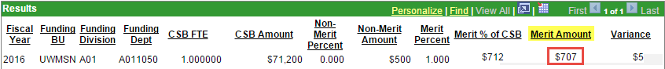

1. **Variance**

* Description: Calculated by subtracts the **Merit % of CSB** from **Merit Amount** to identify fund **Variance.**
  + ***Positive*** amount represents *remaining available money* for merit increases
  + ***Negative*** amount represents *amount over allotted Merit Percent*
* Formula: *Merit % of CSB – Merit Amount = Variance*

*Output Results – CAT Summary Page*

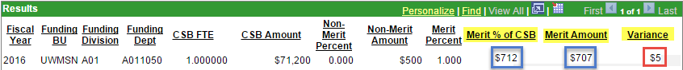

# Procedure Steps

1. Navigate to *Main Menu > Workforce Administration > UW External HR Systems > Compensation Admin Tool > Summary Reporting Page.*
2. Enter desired **Fiscal Year**
   * This field will default to the latest fiscal year setup in the CAT



1. Click the **Run** button 
2. Review the **Results**
   * Results return one string of information for the defined Fiscal Year



1. Next, select the **Drill Down** radio button next to **Funding Business Unit**



1. Click the **Run** button C:\Users\malbers\AppData\Local\Temp\SNAGHTML1c2ad9bf.PNG
2. Review the **Results**, which will return a totals row for each **Funding Business Unit**
   * Note: Funding Business Units returned may be limited based on security permissions

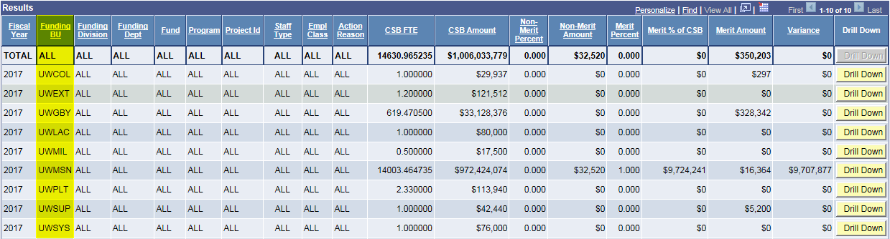

1. Select one of the yellow **Drill Down** button  on the right-hand side of the **Results** to view **Funding Division** totals for a particular **Funding Business Unit**
   * The following should occur in the “Search Criteria”
     1. **Funding Business** **Unit** auto-populates
     2. “Uncheck” corresponding **Roll Up** box
     3. **Drill Down** button selected for Funding Division

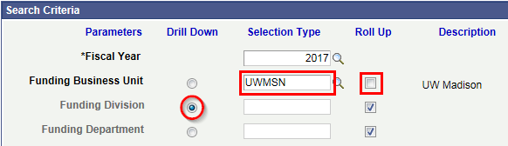

1. Click the **Run** button C:\Users\malbers\AppData\Local\Temp\SNAGHTML1c2ad9bf.PNG
2. Review the **Results** which will return a totals row for each **Funding Division** within the **Funding Business Unit**

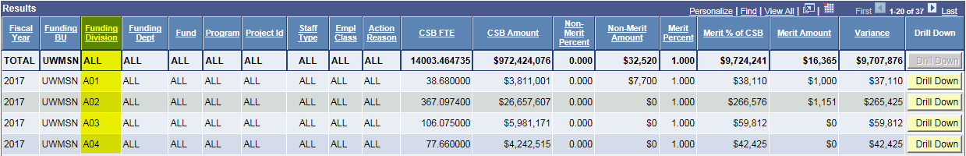

1. Select one of the yellow **Drill Down** button  on the right-hand side of the **Results** to view **Funding Department** totals within a particular **Funding Division**
   * The following should occur in the “Search Criteria”
     1. **Funding Division** auto-populates
     2. “Uncheck” corresponding **Roll Up** box
     3. **Drill Down** button selected for Funding Department

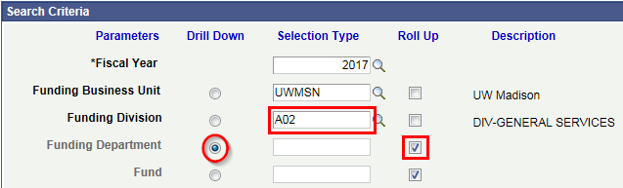

1. Click the **Run** button C:\Users\malbers\AppData\Local\Temp\SNAGHTML1c2ad9bf.PNG
2. Review the **Results**
   * **Results** section will show all **sub-departments** on individual strings.
   * Note that **Funding Business Unit**, **Funding Division**, and **Funding Department** function in a hierarchy in which the user must specify the parameters in order as they move from unit to department.

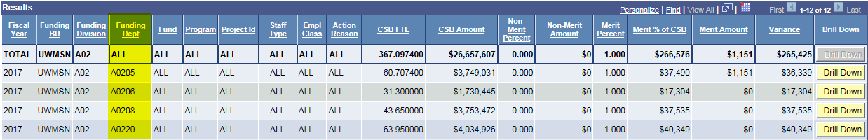

1. Click the **Reset All** button 
2. Click the **Drill Down** button for the empty **Funding Division** field.
   * Notice that this will prompt an error message. Fiscal Year, Funding Business Unit, Funding Department, and Funding Division involve a hierarchy that must be filled in in order. Therefore, the user cannot drill down to Funding Division without first defining Funding Business Unit.

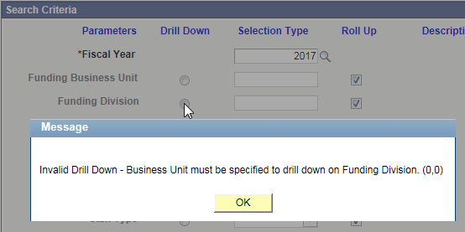

# Tables

|  |  |
| --- | --- |
| **CAT Summary Page** | |
| **Table 1: Search Criteria** | |
| **Column** | **Description** |
| Parameters | The optional fields for searching. Only Fiscal Year is required. Funding Business Unit, Funding Division, and Funding Department have to be searched together as the user moves down. |
| Drill Down | The parameter for which the results will organize each option as its own string. |
| Selection Type | The editable fields to set up the search. The user can either specify a particular parameter or Roll Up all possibilities into the search. |
| Roll Up | The option to include all items for that particular parameter in the search. |
| Description | The full expression for the abbreviated selection type specified. |
|  | |
| **Field Name** | **Description** |
| *Fiscal Year | The desired year to search by. Required. |
| Funding Business Unit | The specific UW Institution. |
| Funding Division | The desired Funding Division within the Funding Business Unit. |
| Funding Department | The desired Funding Department within the Funding Division and Funding Business Unit. |
| Fund | The specific UW Fund codes. |
| Program | The specific UW Program codes. |
| Project Id | The specific UW Project Id. |
| Staff Type | The specific UW Staff Type. Given as a drop-down menu. |
| Employee Class | The specific class of employee. |
| Action Reason | The reason for the given compensation change. |
|  | |
| **Buttons** | **Description** |
| Drill Down | Organizes each individual item in the given parameter by its own string. |
| Search Tool | Opens the search box for the user to find a specific item for the parameter. |
| Roll Up | Includes all items in the given parameter in the search. |
| Run | Runs the search. Results displayed in the Results box. |
| Clear Drill Down | Clears any Drill Down button selected in the Search Criteria section. |
| Reset All | Returns all fields to their default: Fiscal Year as 2018, all empty parameters set to Roll Up, no parameters set to Drill Down. |

|  |  |
| --- | --- |
| **Table 2: Results** | |
| **Column** | **Description** |
| Fiscal Year | The specified year from the Search Criteria section. |
| Funding BU | ALL/specified Funding Business Unit(s) from the Search Criteria section. |
| Funding Division | ALL/specified Funding Division(s) from the Search Criteria section. |
| Funding Dept | ALL/specified Funding Department(s) from the Search Criteria section. |
| Fund | ALL/specified UW Fund code(s) from the Search Criteria section. |
| Program | ALL/specified UW Program code(s) from the Search Criteria section. |
| Project Id | ALL/specified UW Project Id(s) from the Search Criteria section. |
| Staff Type | ALL/specified UW Staff Type(s) from the Search Criteria section. |
| Empl Class | ALL/specified UW Employee Class(es) from the Search Criteria section. |
| Action Reason | ALL/specified reason(s) for given compensation change from the Search Criteria section. |
| CSB FTE | This column will displays sum of the FTE for ONLY employees identified as being in the Continuing Staff Base |
| CSB Amount | Displays sum for all employees identified as being in the Continuing Staff Base |
| Non-Merit Percent | Displays all other compensation increases (excluding Merit 019) for ONLY employees identified as being in the Continuing Staff Base |
| Non-Merit Amount | Non-Merit % will only display when Employee Class and Action Reason input parameters are specified or Action Reason is set to “Drill Down” |
| Merit Percent | Displays Merit compensation increase % (Merit 019) for ONLY employees identified as being in the Continuing Staff Base |
| Merit Amount | Displays all Merit compensation increases (Merit 019) for ONLY employees identified as being in the Continuing Staff Base |
| Merit % of CSB | Calculate by Merit % x CSB |
| Variance | Calculated by: Merit % of Base - Merit |

|  |  |
| --- | --- |
|  | |
| **Buttons** | **Description** |

|  |  |
| --- | --- |
| Personalize | Allows the user to reorder, hide, or freeze columns in the Results section. |
| Find | Allows the user to search for keywords within the Results section. |
| View All | Defaults to inaccessible unless the user uses the Personalize or Find buttons. View All returns the Results section to all results. It will then give change to View 20, which if clicked, will return to the inaccessible View All. |
| Zoom - Results | Prompts a pop-up window of just the results box. |
| Download | Allows the user to download the Results section. |
| First | Navigates to the first page of results. |
| Last | Navigates to the last page of results. |
| [Any Column Header] | Organizes the Results section by the chosen field. |