KB – CAT Position Report
Table of Contents
Purpose and Overview 1
Process Inputs 1
Process Outputs 1
Procedure Steps 1
Tables 8

Purpose and Overview
The Position Report is a pull of key information on all positions (CAT Records) and Vacant/Bud Adjustment rows (Additional Adjustments Page records) based on selected run control criteria.
This report allows users of CAT to view all records that exist in the CAT and the AAP. Users will review this report to get a complete picture of their budgeted positions. They may also distribute it to other users who may not have access to the CAT/AAP, but need to see the data that it houses.

Process Inputs
- Fiscal Year
- Business Unit
- Division
- Dept ID
- Employee Class

Process Outputs
- Excel document with a population that meet the run control criteria and have records in CAT or the AAP.

Procedure Steps
- Navigate to Workforce Administration > UW External HR Systems > Compensation Admin Tool > CAT Reports > HRS to CAT Position Report.
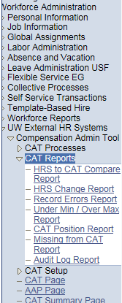
- Click Search under the Find an Existing Value tab to select a previously created Run Control ID, or create a new Run Control ID by selecting Add a New Value. To create a new Run Control ID, assign a unique identifier as the Run Control ID (eg. initials_date_etc.) into the Run Control ID box and select Add.
- Note: Run Control ID sets the report parameters. Users can create one ID, and use it to process multiple reports/processes, or create a new ID for each report/process.
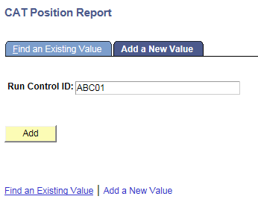
- Enter parameters to define criteria for the CAT Position Report.
  - Select the upcoming Fiscal Year used for CAT budgeting planning purposes. This field will default to the latest fiscal year setup in the CAT.
  - Select a Business Unit.
  - If desired, select a Division.
  - If desired, select a Department.
    - If available, the Department field will become editable when the user selects a Division from the search tool or enters one manually and presses the tab button out of the field.
  - If desired, select a Fund Code.
  - Check the Include Addl Adj. checkbox to include records from the AAP in the output.
  - Click Select Values in the employee class box if you wish to exclude certain employee classes from the report. The default is for all employee classes to be included. Employee classes that are not included in the CAT will not pull onto CAT reports.
  - Click Save in the bottom left to save the parameters for the report.
  - Click Run in the top right to run the report.
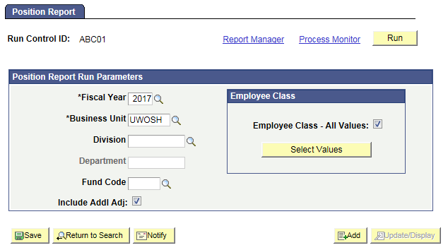
- User will be automatically directed to the Process Scheduler Request page. From this page, select OK.
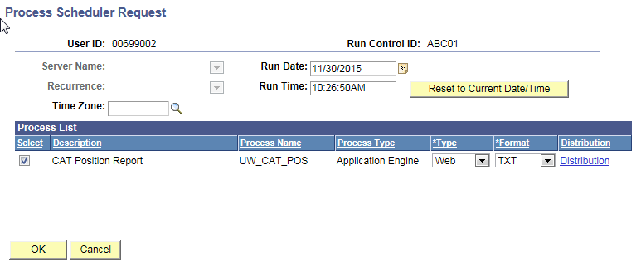
- Note the Process Instance number under the Process Monitor link. This designates the specific instance of the report run.
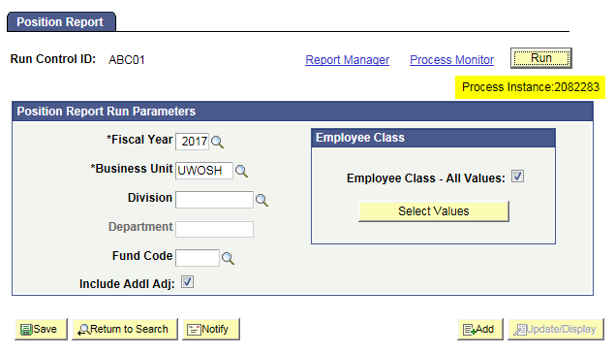
- Click Process Monitor at the top right of the window.
- Search for your process instance number under Process List, which will indicate the status of the report generation. When the report is complete, Run Status will be “Success” and Distribution Status will be “Posted”.
  - If Run Status is “Queued,” it indicates that the report generation is waiting to start.
  - If Run Status is “Processing,” it indicates that the report generation is processing.
  - Click Refresh at the top right of the window to refresh the status of the document.
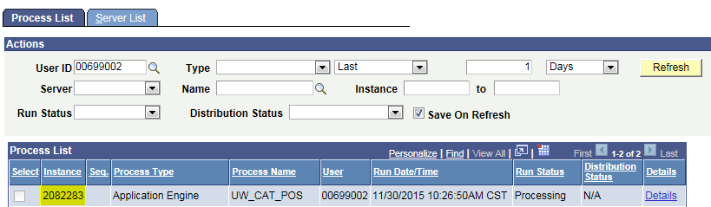
- Once the Run Status hits “Success” and the Distribution Status hits “Posted,” download the output.
  - Click Details.
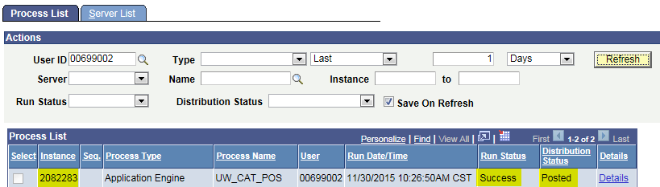
  - Click View Log/Trace at the bottom right of the window.
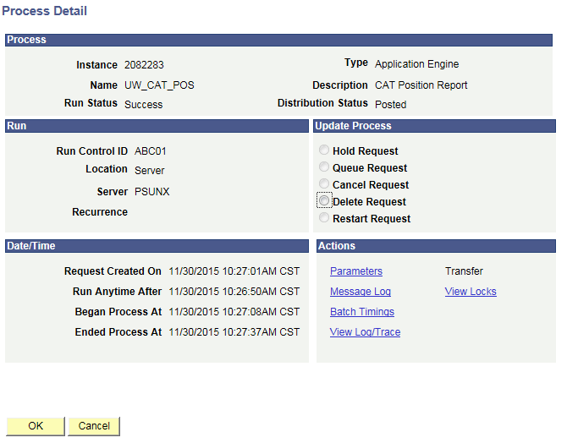
  - Under File List, click the file with the .xls extension to download the output. Note: you may have two .xls outputs if you have any additional splits.
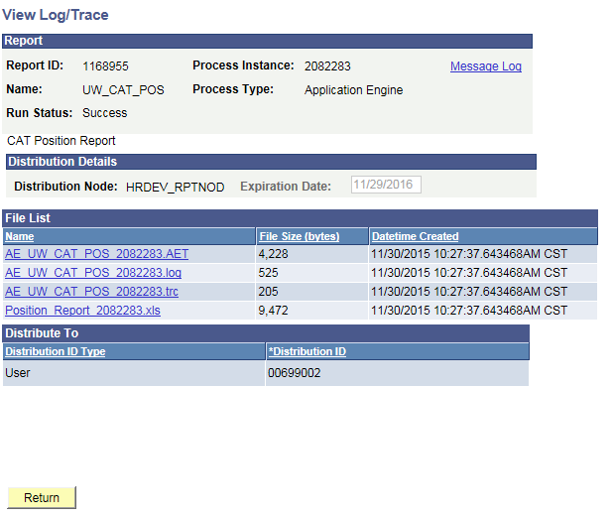
  - When opening the file, if an error message appears indicating that “The file you are trying to open…is in a different format than specified by the file extension,” click Yes.
  - Note that different internet browsers may have different opening processes.
- Review the report.
  - Open the downloaded Excel file.
    - A screenshot of the output file is below.
    - A description of the different header fields of the output is below.
  - Funding splits should list as rows beneath each empl record
  - Job and Demographic data will repeat for all funding split rows
  - Jobs from the CAT should be listed first, then vacant positions, then budgeted adjustments.
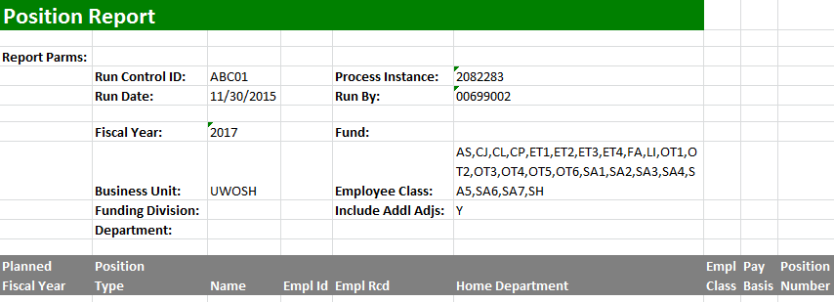

Tables
Table 1: Output Header Fields
Report Parameters
Field Name | Description
Run Control ID | The run control identification entered when report was created.
Run Date | The date the report was created.
Fiscal Year | The effective date of the CAT you wish to compare against in HRS.
Business Unit | The Business Unit selected in the run control.
Funding Division | The Division (if any) selected in the run control.
Department | The Department (if any) selected in the run control.
Process Instance | The number assigned by PeopleSoft for each process.
Run By | The user ID of the user who ran the report.
Fund | The Fund Code (if any) selected in the run control
Employee Class | The employee classes included on the report’s run control.
Include Additional Adjustments | Y if the ‘Include Additional Adjustments’ checkbox was selected on the run control.

Report Columns
Field Name |  | Description
Planned Fiscal Year |  | Fiscal Year field value from CAT for empl records that exist in the CAT and meet the run control criteria. If Include Additional Adjustments is checked, Pull Fiscal Year field value from the AAP for vacant positions that exist in the AAP and meet the run control criteria.
Position Type (AAP Label) |  | If Include Additional Adjustments is checked, pull value for Position Type (either Vacant or Bud Adj.) for records that exist in the AAP and meet the run control criteria.
Name |  | Employee First & Last name from HRS for empl records that exist in the CAT and meet the run control criteria.  If Include Additional Adjustments is checked this field will be blank for AAP positions.
EmplID |  | EmplID from HRS for empl records that exist in the CAT and meet the run control criteria.  If Include Additional Adjustments is checked this field will be blank for AAP positions.
Empl Rcd |  | Empl Record from HRS for empl records that exist in the CAT and meet the run control criteria.  If Include Additional Adjustments is checked this field will be blank for AAP positions.
Home Dept/ Funding Dept for Additional Adjustments |  | Home Dept from HRS for empl records that exist in the CAT and meet the run control criteria.  If Include Additional Adjustments is checked this field will be populated by the funding deptid for AAP positions.
Empl Class |  | Empl Class from HRS for empl records that exist in the CAT and meet the run control criteria. If Include Additional Adjustments is checked this field will be blank for AAP positions.
Pay Basis |  | Pay Basis from HRS for empl records that exist in the CAT and meet the run control criteria. If Include Additional Adjustments in checked this field will be blank for AAP Positions.
Position Number |  | The Position Number from CAT for empl records that exist in the CAT and meet the run control criteria.  If include Additional Adjustments is checked pull position number field value from the AAP for vacant positions that exist in the AAP and meet the run control criteria (and who have position number entered).
Adjustment Type |  | IF include Additional Adjustments is checked, Pull Adjustment Type field value from the AAP for AAP positions that exist in the AAP and meet the run control criteria.
Job Code |  | Job Code from CAT for empl records that exist in the CAT and meet the run control criteria.  If include Additional Adjustments is checked pull job code field value from the AAP for vacant positions that exist in the AAP and meet the run control criteria (and who have job code entered).
Title |  | Title from CAT for empl records that exist in the CAT and meet the run control criteria.
Planned Title |  | Planned Title from CAT for empl records that exist in the CAT and meet the run control criteria.  If include Additional Adjustments is checked pull Title field value from the AAP for vacant positions that exist in the AAP and meet the run control criteria.
Total Planned FTE |  | Planned FTE field from the CAT for empl records that exist in the CAT and meet the run control criteria.  If include Additional Adjustments is checked pull FTE field value from the AAP for vacant positions that exist in the AAP and meet the run control criteria.
Base Compensation Rate |  | The Base Compensation Rate from the CAT for empl records that exist in the CAT and meet the run control criteria.  If Include Additional Adjustments is checked this field will be blank for AAP positions.
Increase 1 Action Reason |  | The Action Reason associated with the first non-merit comp increase from the CAT empl records that exist in the CAT and meet the run control criteria. If no additional increases have been entered this field will appear blank.  If Include Additional Adjustments is checked this field will be blank for AAP positions
Increase 1 $ Amount |  | The comprate change amount associated with the first non-merit comp increase from the CAT for empl records that exist in the CAT and meet the run control criteria. If no additional increases have been entered this field will appear blank.  If Include Additional Adjustments is checked this field will be blank for AAP positions
Increase 1 % Amount |  | The comprate change percentage associated with the first non-merit comp increase from the CAT for empl records that exist in the CAT and meet the run control criteria. If no additional increases have been entered this field will appear blank.  If Include Additional Adjustments is checked this field will be blank for AAP positions
Increase 2 Action Reason |  | The Action Reason associated with the second non-merit comp increase from the CAT empl records that exist in the CAT and meet the run control criteria. If no additional increases have been entered this field will appear blank.  If Include Additional Adjustments is checked this field will be blank for AAP positions
Increase 2 $ Amount |  | The comprate change amount associated with the second non-merit comp increase from the CAT for empl records that exist in the CAT and meet the run control criteria. If no merit has been entered this field will appear blank.  If Include Additional Adjustments is checked this field will be blank for AAP positions
Increase 2 % Amount |  | The comprate change percentage associated with the second non-merit comp increase from the CAT for empl records that exist in the CAT and meet the run control criteria. If no merit has been entered this field will appear blank.  If Include Additional Adjustments is checked this field will be blank for AAP positions
Increase 3 Action Reason |  | The Action Reason associated with the third non-merit comp increase from the CAT empl records that exist in the CAT and meet the run control criteria. If no additional increases have been entered this field will appear blank.  If Include Additional Adjustments is checked this field will be blank for AAP positions
Increase 3 $ Amount |  | The comprate change amount associated with the third non-merit comp increase from the CAT for empl records that exist in the CAT and meet the run control criteria. If no merit has been entered this field will appear blank.  If Include Additional Adjustments is checked this field will be blank for AAP positions
Increase 3 % Amount |  | The comprate change percentage associated with the third non-merit comp increase from the CAT for empl records that exist in the CAT and meet the run control criteria. If no merit has been entered this field will appear blank.  If Include Additional Adjustments is checked this field will be blank for AAP positions
Pre-Merit Adjusted Comprate |  | The UW_CAT_COMPRATE field plus all non-merit increases from the CAT for empl records that exist in the CAT and meet the run control criteria. If no non-merit increases have been entered this field will appear blank.  If Include Additional Adjustments is checked this field will be blank for AAP positions
Merit $ Amount |  | The comprate change amount associated with the Action Reason Merit from the CAT for empl records that exist in the CAT and meet the run control criteria. If no merit has been entered this field will appear blank.  If Include Additional Adjustments is checked this field will be blank for AAP positions
Merit % Amount |  | The comprate change percentage associated with the Action Reason Merit from the CAT for empl records that exist in the CAT and meet the run control criteria. If no merit has been entered this field will appear blank.  If Include Additional Adjustments is checked this field will be blank for AAP positions
Chancellor’s Discretionary $ |  | The comprate change amount associated with the Action Reason Chancellor’s discretionary from the CAT for empl records that exist in the CAT and meet the run control criteria. If no Chancellor’s discretionary increase has been entered this field will appear blank.  If Include Additional Adjustments is checked this field will be blank for AAP positions
Chancellor’s Discretionary % |  | The comprate change percentage associated with the Action Reason Chancellor’s discretionary from the CAT for empl records that exist in the CAT and meet the run control criteria. If no Chancellor’s discretionary increase has been entered this field will appear blank.  If Include Additional Adjustments is checked this field will be blank for AAP positions
Final Comprate |  | The UW_CAT_COMPRATE field plus all increases from the CAT (UW_CAT_COMPRATE+ UW_CAT_CHANGE_AMT) for empl records that exist in the CAT and meet the run control criteria. If no non-merit increases have been entered this field will appear blank.  If Include Additional Adjustments is checked this field will be blank for AAP positions
Adjusted Base Salary (Based on Planned FTE) |  | Derive Adjusted Base salary based on Base CAT compensation rate, entered increases, and FTE (UW_CAT_COMPRATE+ UW_CAT_CHANGE_AMT)*Planned FTE
GLBU |  | For CAT jobs, the GLBU of this empl record from the account code in the CAT  If Include Additional Adjustments is checked, the GLBU of this position from the account code in the AAP
Fund |  | For CAT jobs, pull the Fund of this empl record from the account code in the CAT  If Include Additional Adjustments is checked, the fund of this position from the account code in the AAP
DeptID |  | For CAT jobs, pull the DeptID of this empl record from the account code in the CAT  If Include Additional Adjustments is checked, the DepID of this position from the account code in the AAP
Program |  | For CAT jobs, pull the Program of this empl record from the account code in the CAT  If Include Additional Adjustments is checked, the Program of this position from the account code in the AAP
ProjectID |  | For CAT jobs, pull the ProjectID of this empl record from the account code in the CAT  If Include Additional Adjustments is checked, this field will be blank for AAP positions.
Distribution % |  | For CAT jobs, pull distribution percentage of second funding split of empl record with error from the CAT  If Include Additional Adjustments is checked, this field will be blank for AAP positions.
Budgeted Amount |  | For CAT jobs, pull budgeted amount of second funding split of empl record with error from the CAT  If Include Additional Adjustments is checked, pull final budgeted amount from the AAP.
Budgeted FTE |  | For CAT jobs, pull budgeted FTE of second funding split of empl record with error from the CAT  If Include Additional Adjustments is checked, pull FTE from the AAP (if that field is populated)
Repeat Fund, DeptID, Program and Project ID for all funding splits this emplid/emplrcd combo has.
If Include Additional Adjustments is checked, Vacant and Budget Adjustment positions will only have one funding string.
Comments | The Comments field for CAT jobs, Pull the description field for Vacant/Budget adj positions from the AAP.

