KB – BSUM
Table of Contents
Purpose and Overview 1
How Do CAT and BSUM Interact? 1
Reconciling CAT to BSUM 5
Compare the CAT Position Report to BSUM 5
CAT Position Report 5
BSUM 5
Possible Reasons Why CAT and BSUM Do Not Reconcile 6

Purpose and Overview
The purpose of this KB is to illustrate the relationship between the CAT and the BSUM pages in the 3270 system. BSUM is the system query tool used for budget development. With the implementation of CAT, many of the functional pages of BSUM will be eliminated. Data will be pulled instantly from the CAT and populate the appropriate fields on the remaining pages of 2, 3, 5, 6, 26, and 27 of BSUM. Any employee class (including Student Help and LTE) can be loaded to or entered in the CAT Page, and will be included in FTE calculation in BSUM.

Users will now make all changes in CAT that were previously done in BDGT, BADJR and BRATE. Users will refer to BSUM for reporting purposes to gather salary, budget, and allocation totals.

How Do CAT and BSUM Interact?
- Data is pulled from the CAT in the Funding Change section of the CAT Page and sent to BSUM.
  - GL Business Unit on the CAT Page is the same as the letter indicator for Summary For on BSUM. This is entered into the UDDS field in BSUM.
  - Fund on the CAT Page is the same as Fund in BSUM.
  - Department on the CAT Page is the same as the number indicator for Summary For in BSUM. This is entered into the UDDS field in BSUM.
  - Project on the CAT Page is the same as Project in BSUM.
  - Budgeted FTE and Budgeted Amount from the CAT Page are pulled into the totals in BSUM.
- BSUM will not populate Distribution Percentage or Full Time Rate reflected in the CAT page.
- If the employee exists in the CAT Page, then that data will reflect in BSUM. The ‘Load to HRS’ checkbox will not prevent this data from being sent to BSUM.
- Each institution will be responsible for monitoring FTE calculations in BSUM, and determining if Student Help and LTE should be entered in the CAT page. If the institution decides these employee classes should not be included, they can delete the employee record from the CAT page.
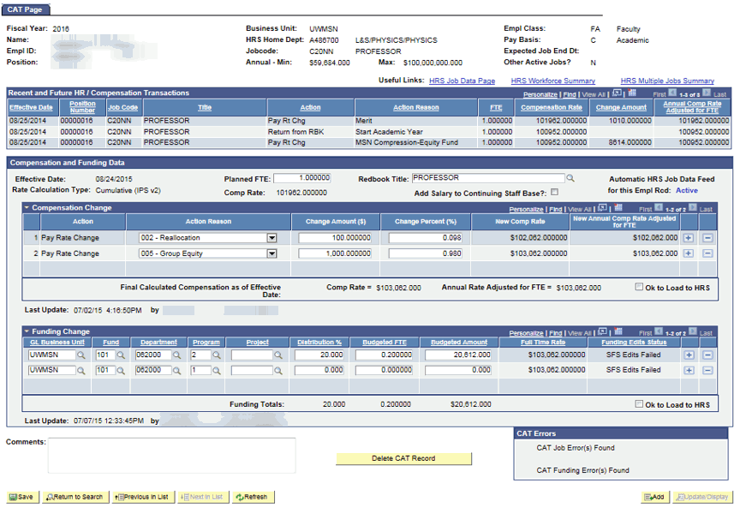

Page 2 of BSUM is used for Record Totals and Total Salary and Wages information.
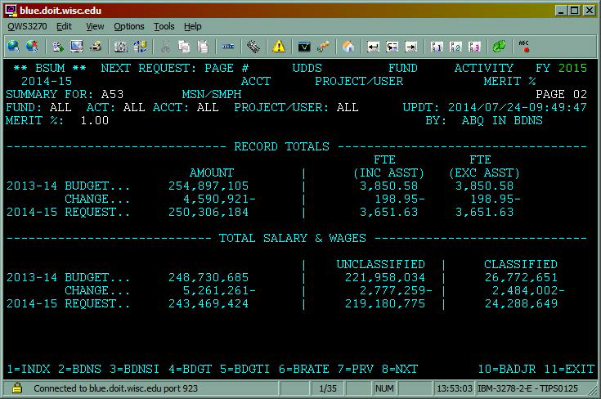
Page 3 of BSUM is used for budgeting information for Supplies and Expense, Sales Credit, Capital, Aids to Individuals, Fringe Benefits, and Special Purposes.
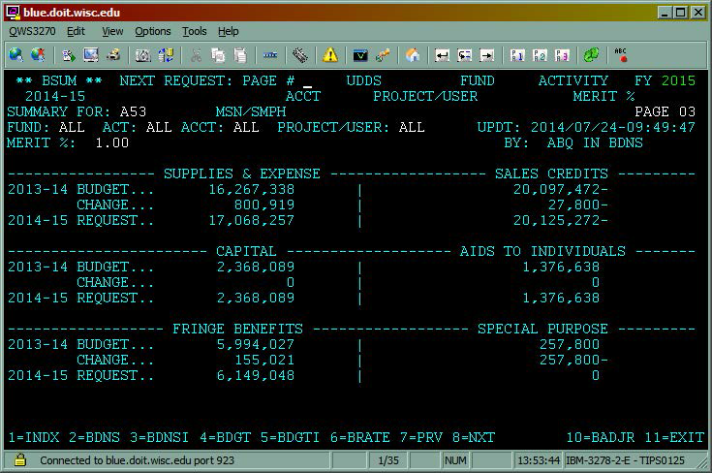
Page 5 of BSUM is used for Graduate Assistants and Classified Totals.
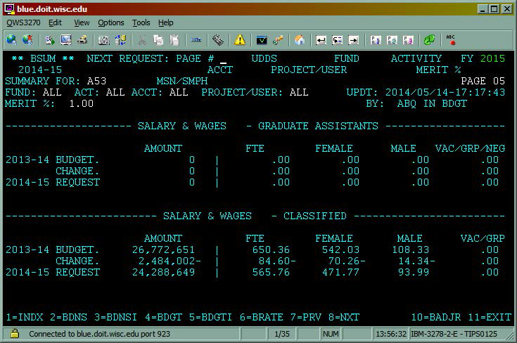
Page 6 of BSUM is used for Student Help and LTE data.
- Institutions will be responsible for monitoring FTE calculations, and determining if SH and LTE should be entered in the CAT. If not, they can delete the employee from the CAT.
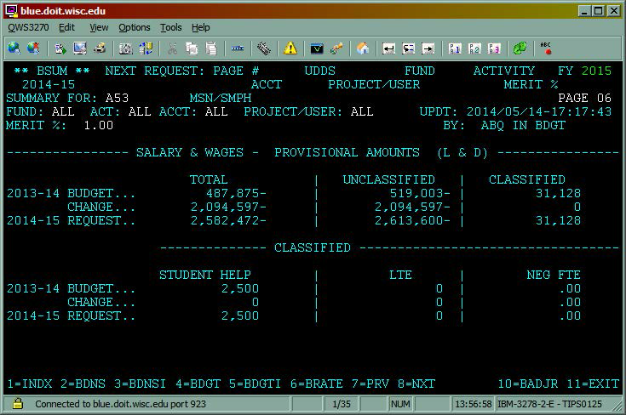
Page 26 of BSUM is used for Allocated Amounts, Salaries, Non-Salary, and Fringes.
- The General Program Revenue (or GPR) allocation has to tie to the budget.
- The user cannot compare allocation and budget amounts on CAT reports and must refer to BSUM here.
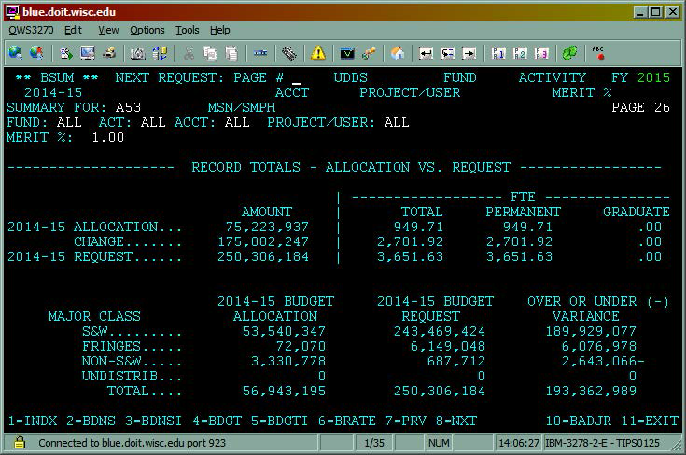
Page 27 of BSUM is used for Activity Totals for Allocations and Requests.
- The user cannot compare allocation and budgeting on CAT reports and must refer to BSUM here.
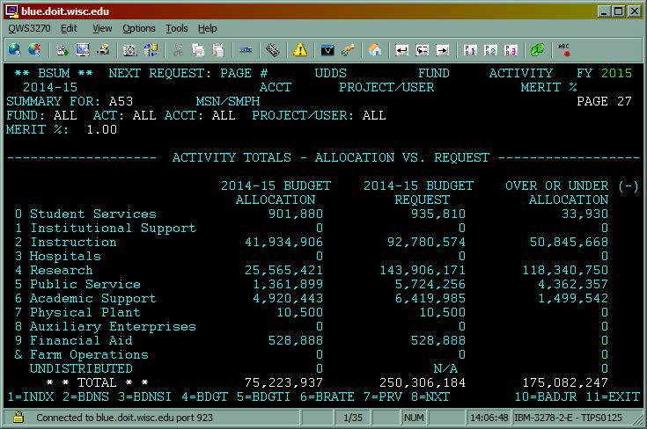

Reconciling CAT to BSUM

Compare the CAT Position Report to BSUM

CAT Position Report
- Run the CAT Position Report
  - Please refer to the CAT Position Report KB for instructions on running the report.
- Once the Position Report has processed and has been downloaded into Excel:
  - Apply a filter to row 13.
  - Convert columns AL (Budgeted Amt $) & AM (Budgeted FTE) to number
  - Add a subtotal to columns AL (Budgeted Amt $) & AM (Budgeted FTE)
    - i.e. cells AL11 and AM11
    - The formula for sum subtotal is: =subtotal(9, beginning cell:end cell)
    - Example: =subtotal(9,AL14:AL1332)
  - NOTE: The CAT Position Report pulls a complete picture of a position across institutions. If an institution shares employees with another institution, filter column AF (GL Business Unit) to the user’s institution. (“Blanks” should also be included in the filter as these represent the AAP transactions.) Likewise, if a Department or Division share employees, filter column AH (Dept) for the Department or Division the user is reconciling.

BSUM
- Configure BSUM.
  - Enter the Page # on BSUM (recommend starting with page 2).
  - Enter UDDS to match what was entered in the Position Report run control for Business Unit, Division and/or Department.
  - Enter Fund and/or Activity if reconciling to that level.
    - Note that if reconciling to Fund and/or Activity, the position report should be filtered to that fund and activity as well.
  - Compare “Total Salary & Wages” request total to Position Report column AL (Budgeted Amt $) subtotal. These totals should match.
  - Compare “Record Totals, FTE (Inc Asst)” request total to Position Report column AM (Budgeted FTE) subtotal. These totals should match.
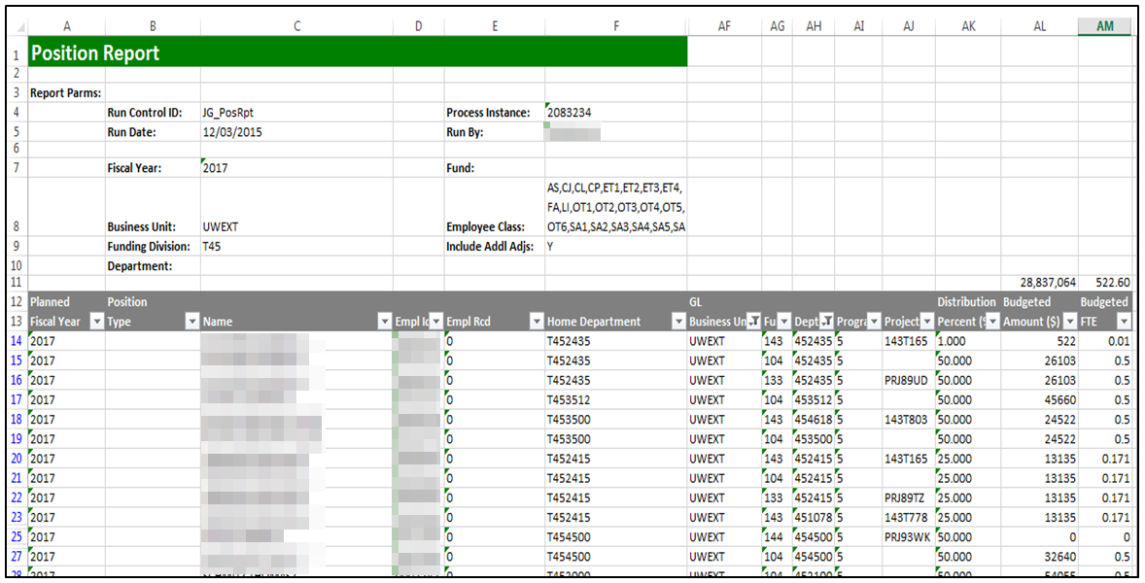
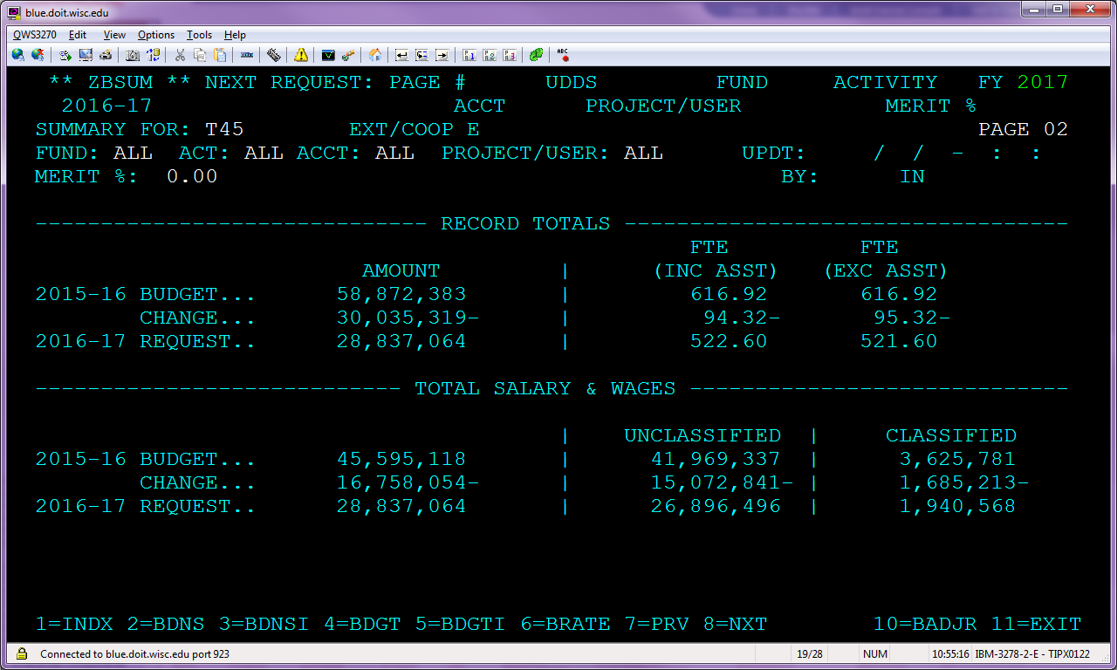

Possible Reasons Why CAT and BSUM Do Not Reconcile
- There are funding edit errors.
  - Run the Record Errors report and check for funding edit errors that need to be corrected. A funding line must have the GL Business Unit, Fund, Dept and Program fields all complete for the line to be included in BSUM. An incomplete funding line will show on the Position Report but will not be included in BSUM.
- Check the filters in the Position Report. Ensure the filters include and exclude all data that they should.
- Check your subtotal formulas. Ensure the formulas are capturing all cells.

