KB – Audit Log Report

Table of Contents

Purpose and Overview 1

Process Inputs 1

Process Outputs 1

Procedure Steps 2

Tables 10

# Purpose and Overview

The Audit Log Report will display which users have edited and saved particular CAT, Vacant Position and Budget Adjustment records.

The Audit Log Report pulls records separately from the Audit Log tables for CAT, Vacant Positions and Budget Adjustments, and will therefore output three unique reports. The user will select the desired report output on the run control.

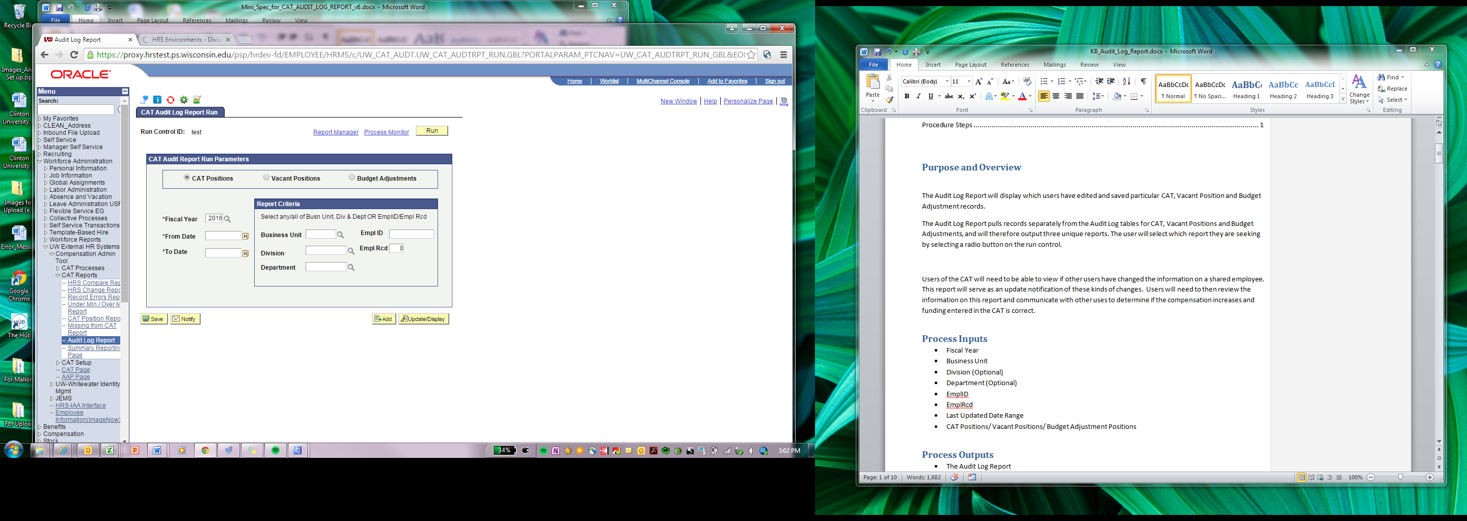

Users of the CAT will need to view if other users have changed the information on a shared employee. This report will serve as an update notification of these kinds of changes. Users will need to then review the information on this report and communicate with other uses to determine if the compensation increases and funding entered in the CAT is correct.

## Process Inputs

* Fiscal Year
* Business Unit
* Division (Optional)
* Department (Optional)
* EmplID
* EmplRcd
* Last Updated Date Range
* CAT Positions/ Vacant Positions/ Budget Adjustment Positions

## Process Outputs

* Excel document with a population that meets the run control criteria and have been changed by a user of the CAT or AAP

# Procedure Steps

1. Navigate to **Workforce Administration > UW External HR Systems > Compensation Admin Tool > CAT Reports > Audit Log Report.**

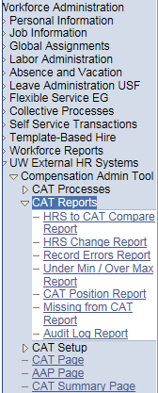

1. Click Search under the Find an Existing Value tab to select a previously created Run Control ID, or create a new Run Control ID by selecting **Add a New Value**. To create a new Run Control ID, assign a unique identifier as the Run Control ID (eg. initials_date_etc.) into the Run Control ID box and select **Add**.
2. *Note: Run Control ID sets the report parameters. Users can create one ID, and use it to process multiple reports/processes, or create a new ID for each report/process.*

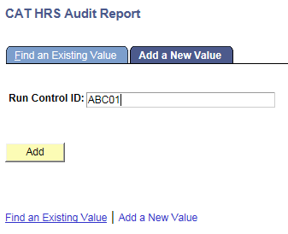

1. Enter parameters to define criteria for the Record Errors Report.
   1. Select the radio button for the desired **Report Output Type** (CAT Positions, Vacant Positions or Budget Adjustments):
      1. CAT Positions requires either a **Business Unit** OR **EmplID**.
         1. When one is edited, the other will become uneditable.
         2. If using Business unit:
            1. If desired, select a **Division**.
            2. If desired, select a **Department**.
         3. If using EmplID:
            1. If desired, select an **Empl Rcd**. It is not required and will default to zero.
      2. Vacant and Budget Adjustments require **Business Unit**.
         1. If desired, select a **Division**.
         2. If desired, select a **Department**.
         3. Note that EmplID and Empl Rcd will become invisible.
   2. Select the upcoming **Fiscal Year** used for CAT budgeting planning purposes. This field will default to the latest fiscal year setup in the CAT.
   3. Select a **From Date** and a **To Date** to establish the range of dates for which you would like to see changes to CAT/AAP.
   4. Click **Save** in the bottom left to save the parameters for the report.
   5. Click **Run** in the top right to run the report.

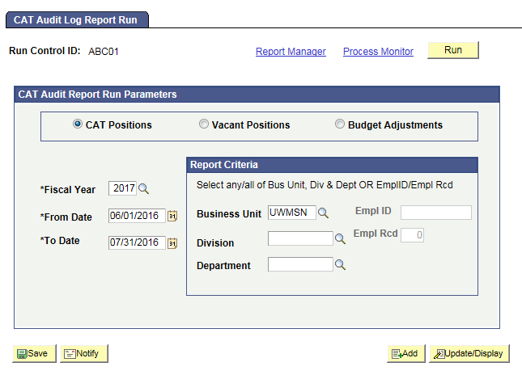

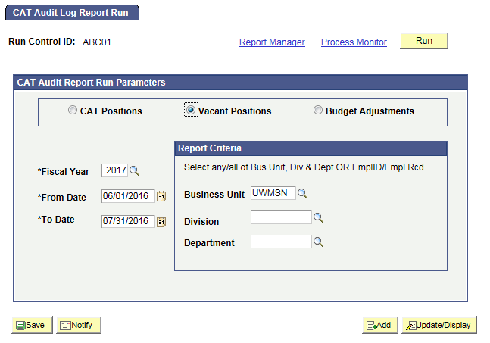

1. User will be automatically directed to the Process Scheduler Request page. From this page, select **OK**.

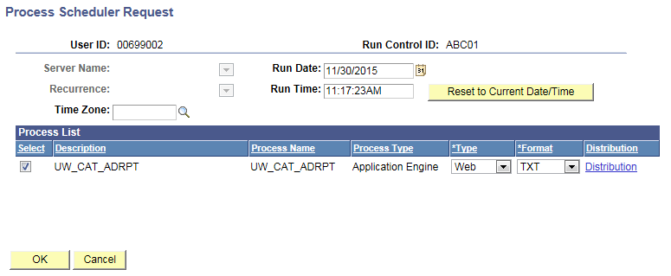

1. Note the Process Instance number under the Process Monitor link. This designates the specific instance of the report run.

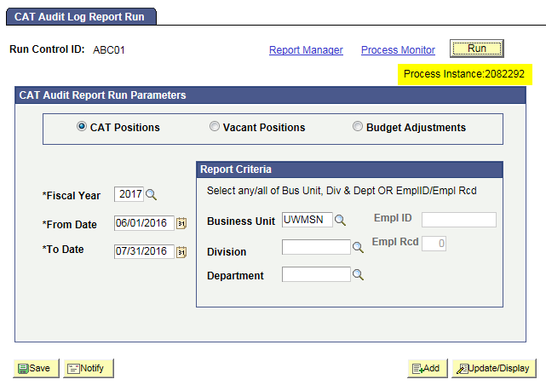

1. Click **Process Monitor** at the top right of the window.
2. Search for your process instance number under Process List, which will indicate the status of the report generation. When the report is complete, Run Status will be “Success” and Distribution Status will be “Posted”.
   1. If Run Status is “Queued” or “Initiated,” it indicates that the report generation is waiting to start.
   2. If Run Status is “Processing,” it indicates that the report generation is processing.
   3. Click **Refresh** at the top right of the window to refresh the status of the document.

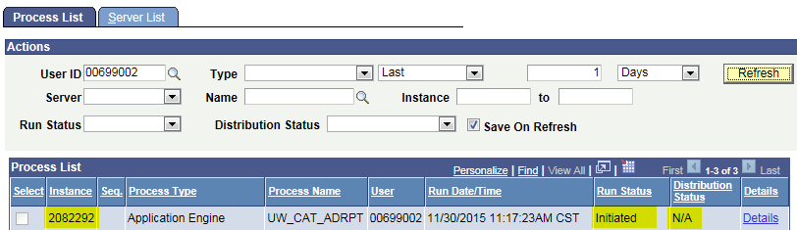

1. Once the Run Status hits “Success” and the Distribution Status hits “Posted,” download the output.
   1. Click **Details**.

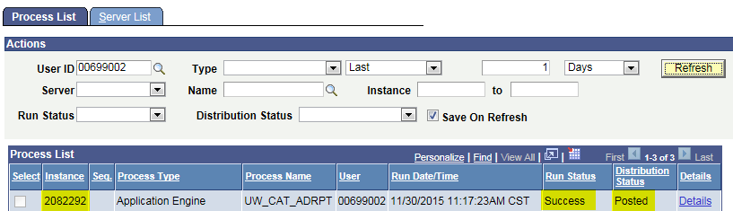

* 1. Click **View Log/Trace** at the bottom right of the window.

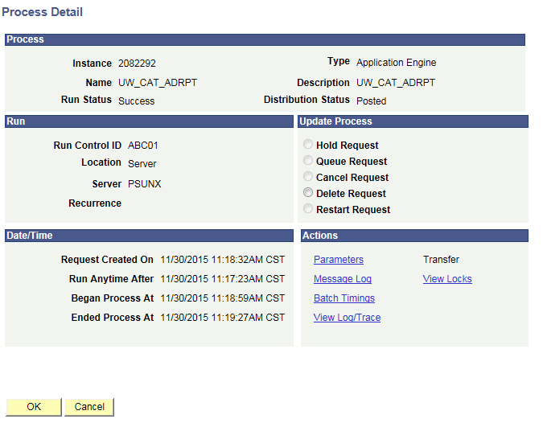

* 1. Under File List, click the file with the .xls extension to download the output.

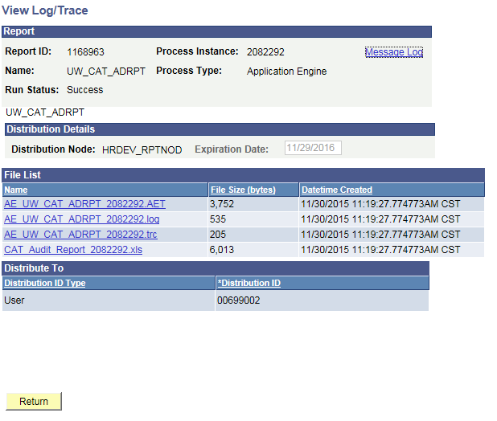

* 1. When opening the file, if an error message appears indicating that “The file you are trying to open…is in a different format than specified by the file extension,” click **Yes.**

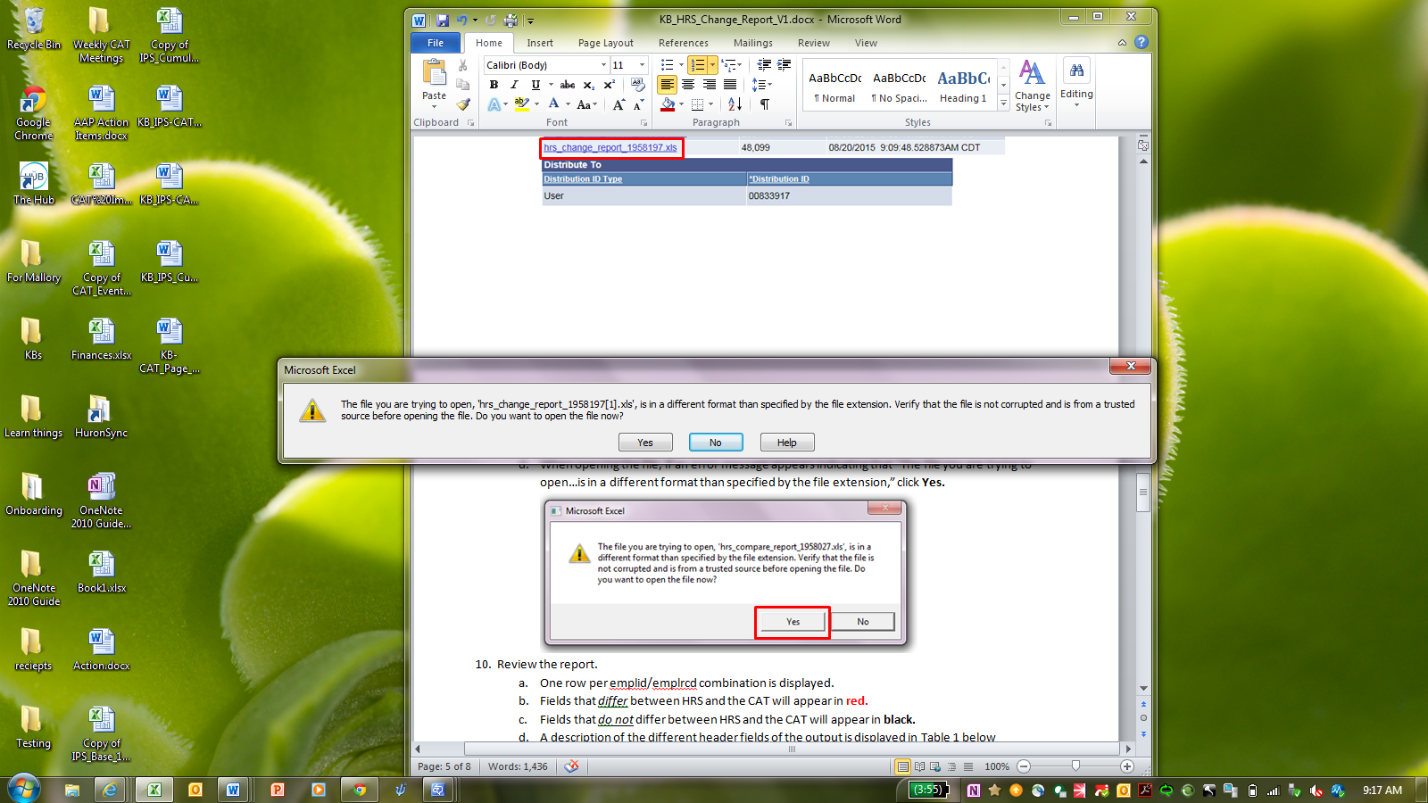

* 1. Note that different internet browsers may have different opening processes.

1. Review the report.
   1. Open the downloaded Excel file.
      1. The outputs for CAT Positions, Vacant Positions and Budget Adjustments are all pictured below.
      2. Reference **Tables 1-4** for output field descriptions.

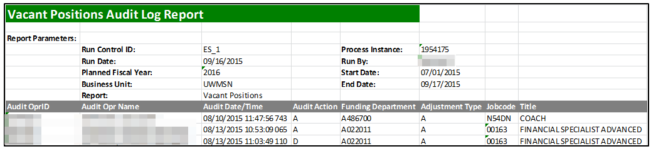

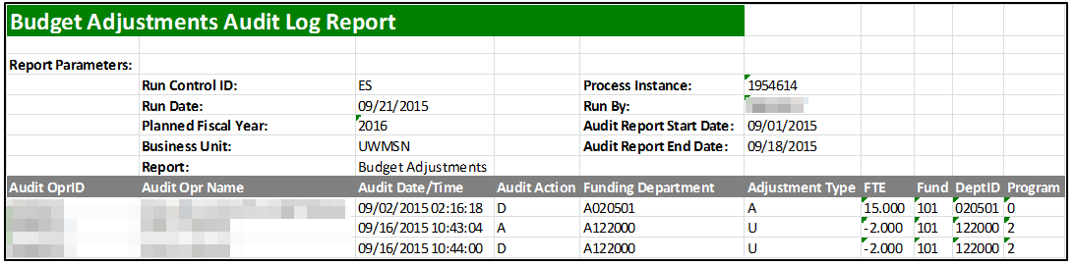

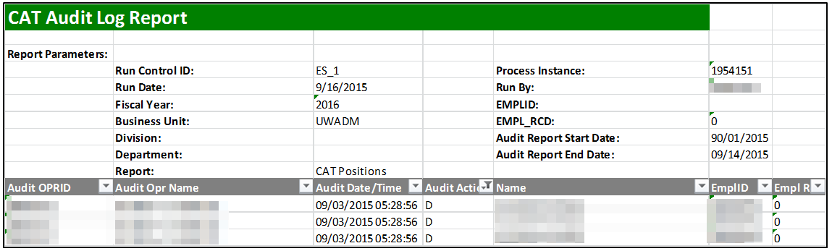

* 1. If an emplid/emplrcd (from the CAT) or a position (from the AAP) has had more than one change in the defined period, they will appear multiple times on the report.
  2. The Audit Action Column pulls the action code associated with the change made in the CAT or AAP
     1. A – Row inserted
     2. D – Row deleted.
     3. K – Row updated, snapshot before update.
     4. N – Row updated, snapshot after update.
     5. When any change is made to an existing compensation or funding row in CAT, two new rows (K and N) will populate the report.
     6. Changes made to job, compensation and funding data appear as separate rows on the output for CAT Positions, even if they were made at the same time. The ‘Source Table’ field specifies which type has occurred.
     7. For example, if Deborah Briggs is deleted from CAT three new rows will appear on the Audit Log Report.
     8. Fields Audit OPRID-EmplRCD will repeat for each row. Each row will have Audit Action D.

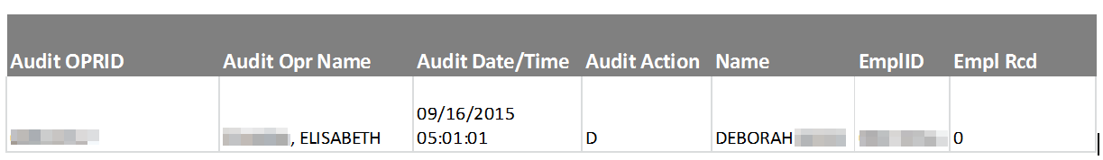

* + 1. The fields Home Dept-Base Comp Rate will only populate for the first row, where the source table is ‘CAT Job Data Change’



* + 1. The fields Action-Adjusted CAT Annual Salary will only populate for the second row, where the source table is ‘CAT Rate Data Change’



* + 1. The fields for Fund-Budgeted Amount will only populate for the third row, where the source table is ‘CAT Job Data Change’

|  |  |  |  |  |  |
| --- | --- | --- | --- | --- | --- |
| **Fund** | **DeptID** | **Program** | **Project** | **Distribution Percentage** | **Budgeted Amount** |
| 101 | 530200 | 6 |  | 100 | 300000.000 |

# Tables

|  |  |
| --- | --- |
| **Table 1: Report Parameters** | |
| **Field Name** | **Description** |
| Run Control ID | The run control identification entered when report was created. |
| Run Date | The date the report was created. |
| Fiscal Year | The Fiscal year selected in the run control. |
| Business Unit | The Business Unit selected in the run control. |
| Division | The Division (if any) selected in the run control. |
| Department | The Department (if any) selected in the run control. |
| Report | The report type specified in the run control (CAT Positions, Additional Adjustments or Budget Adjustments) |
| Process Instance | The number assigned by PeopleSoft for each process. |
| Run By | The user ID of the user who ran the report. |
| EMPLID | The EmplID selected in the run control. This can only be entered if the **CAT Position** radio button is selected. |
| Empl_Rcd | The Emplrcd of the employee selected in the run control. This can only be entered if the **CAT Position** radio button is selected. |
| Audit Report Start/End Date: | The time range for which you would like to see record changes. |
| Table 2: Output Header Fields for CAT Positions | |
| Field Name | **Description** |
| Audit OPRID | The Oprid associated with the audit log row (user who made the change) from the CAT audit log tables, based on the run control criteria selected. |
| Audit Opr Name | The Name associated with the audit log row (user ID who changed it) from the cat audit log table, based on the run control criteria selected. |
| Audit Date/Time | The timestamp associated with the audit log row (time the change was made) from the CAT audit log tables, based on the run control criteria selected. |
| Audit Action | The Action code associated with the audit log row from the CAT audit log tables, based on the run control criteria selected.   * A – Row inserted * D – Row deleted. * K – Row updated, snapshot before update. * N – Row updated, snapshot after update   When any change is made to an existing row in CAT, two new rows (K and N) will populate the report |
| Name | The employee First & Last name from HRS for CAT audit log rows that meet the run control criteria selected. |
| Empl ID | The EmplID from CAT Audit log for empl records that exist in the CAT and meet the run control criteria selected. |
| Empl Rcd | The EmplRcd from CAT Audit log for empl records that exist in the CAT and meet the run control criteria selected. |
| Source Table | Displays the CAT table that was edited   * CAT Job Change * Rate Change * Funding Change |
| Home Dept (DEPTID) | The Home Deptid from CAT Audit log for empl records that exist in the CAT and meet the run control criteria selected. Format; A072600 |
| Position Number | The Position Number from the CAT audit log for rows that match the run control criteria. |
| Job Code | The Job Code from the CAT audit log for rows that match the run control criteria. |
| Title | The Job Code Descr from the CAT audit log for rows that match the run control critiera |
| Empl Class | The Empl Class from CAT Audit log for empl records that exist in the CAT and meet the run control criteria selected. |
| Pay Basis | The Pay Basis from the CAT audit log for rows that match the run control criteria. |
| Total Planned FTE | The Planned FTE field from the CAT audit log for rows that match the run control criteria. |
| Redbook Title | The Redbook Title field from the CAT audit log for rows that match the run control criteria |
| CSB Flag | The ‘Add Salary to CSB’ indicator from the CAT audit log for rows that match the run control criteria. |
| Base Compensation Rate | The Base Compensation Rate from the CAT audit log for rows that match the run control criteria. |
| Annual Salary | The Adjusted base salary based on Base Comprate * Planned FTE (for A & C Basis) and Comprate*2080*Planned FTE (for H basis). |
| Action | The Action associated with the first non-merit comp increase from the CAT audit log for rows that match the run control criteria. |
| Action Reason | The Action Reason associated with the first non-merit comp increase from the CAT audit log for rows that match the run control criteria. |
| Change Amount | The comprate change amount associated with the Action Reason from the CAT audit log for rows that match the run control criteria. |
| Change Percent | Pull the comprate change percentage associated with the Action Reason from the CAT audit log for rows that match the run control criteria. |
| Rate Ok to Load |  |
| Bus Unit GL | The Business Unit GL from the CAT audit log for rows that match the run control criteria. |
| Fund | The Fund of this empl record from the CAT audit log |
| DeptID | The DeptID of this empl record from the CAT audit log |
| Program | The Program of this empl record from the CAT audit log |
| Project | The ProjectID of this empl record from the audit log |
| Distribution Pct | The Distribution % of this empl record from the audit log |
| Budgeted FTE | Budgeted FTE of this empl record from the audit log |
| Budgeted Amt | The Final CAT Budget Amount from the CAT audit log |
| Funding Ok to Load |  |
| SFS Edit |  |
| Comments |  |
| **Formatting Consideration:** The Home Dept 🡪 Base Compensation Rate will only populate for rows whose source table is Funding Data Change. | |
| **Formatting Consideration:** The Action Reasons 🡪Adjusted CAT Annual Salary columns will only populate for rows whose source table is Rate Data Change. | |
| **Formatting Consideration:** The Fund🡪Budgeted Amount columns will only populate for rows whose source table is Funding Data Change. | |

|  |  |
| --- | --- |
| **Table 3: Output Header Fields for Vacant Positions** | |
| **Field Name** | **Description** |
| Audit OPRID | The Oprid associated with the audit log row (user who made the change) from the vacant audit log table, based on the run control criteria selected. |
| Audit Opr Name | The Name associated with the audit log row (user ID who changed it) from the vacant audit log table, based on the run control criteria selected. |
| Audit Date/Time | The timestamp associated with the audit log row (time the change was made) from the vacant audit log table, based on the run control criteria selected. |
| Audit Action | The Action code associated with the audit log row from the vacant audit log tables, based on the run control criteria selected.   * A – Row inserted * D – Row deleted. * K – Row updated, snapshot before update. * N – Row updated, snapshot after update   When any change is made to an existing row in AAP, two new rows (K and N) will populate the report |
| Funding Department (DEPTID) | The funding deptid from the vacant audit log for rows that exist in the audit log and meet the run control criteria. |
| Staff Type | The Adjustment Type (LI/AS/FA, Univ Staff, Grad, SH, LTE) from the vacant audit table for rows that match the run control criteria. |
| Job Code | The Job Code from the vacant audit log for rows that match the run control criteria (and have a job code entered). |
| Title | The Job Code Description from the vacant audit log for rows that match the run control criteria. |
| Pay Basis | The Pay Basis from the vacant audit log for rows that exist in the audit log and meet the run control criteria. |
| Position Number | The Position number from the vacant audit log for rows that match the run control criteria (and have a position number entered). |
| Business Unit | The Business Unit from the vacant audit log for rows that match the run control criteria |
| Fund | The Fund of this empl record from the vacant audit log table |
| Deptid | The DeptID of this empl record from the vacant audit log table |
| Program | The Program of this empl record from the vacant audit log table |
| Project | The ProjectID of this empl record from the vacant audit log table |
| FTE | FTE from the vacant audit log for positions that exist in the vacant audit log and meet the run control criteria. |
| Budgeted Amount | The Total Budgeted amount from the vacant audit table. |
| Description | The Comments/Description field from the vacant audit table for rows that exist in the vacant audit log table. |
| **Table 4: Output Header Fields for Budget Adjustments** | |
| **Field Name** | **Description** |
| Audit OPRID | The Oprid associated with the audit log row (user who made the change) from the budget adjustment audit log table, based on the run control criteria selected. |
| Audit Opr Name | The Name associated with the audit log row (user ID who changed it) from the budget adjustment audit log table, based on the run control criteria selected. |
| Audit Date/Time | The timestamp associated with the audit log row (time the change was made) from the budget adjustment audit log table, based on the run control criteria selected. |
| Audit Action | The Action code associated with the audit log row from the budget adjustment audit log tables, based on the run control criteria selected.   * A – Row inserted * D – Row deleted. * K – Row updated, snapshot before update. * N – Row updated, snapshot after update   When any change is made to an existing row in AAP, two new rows (K and N) will populate the report |
| Staff Type | The Adjustment Type (LI/AS/FA, Univ Staff, Grad, SH, LTE) from the budget adjustment audit table for rows that match the run control criteria. |
| Business Unit | The Business Unit from the vacant audit log for rows that match the run control criteria |
| Fund | The Fund of this empl record from the budget adjustment audit log table |
| Funding Department (DEPTID) | The funding deptid from the budget adjustment audit log for rows that exist in the audit log and meet the run control criteria. |
| Program | The Program of this empl record from the budget adjustment audit log table |
| Project | The ProjectID (if entered) of this empl record from the budget adjustment audit log table |
| FTE | FTE from the budget adjustment audit log for positions that exist in the budget adjustment audit log and meet the run control criteria. |
| Budgeted Amount | The Total Budgeted amount from the budget adjustment audit table. |
| Description | The Comments/Description field from the budget adjustment audit table for rows that exist in the budget adjustment audit log table. |