KB – Annual Setup Page
Contents
Purpose and Overview 1
Procedure Steps 2
Annual Set Up 2
Fiscal year Update/View Status 4
CAT Rate Calculation Type 5
SFS Ledger for Budget Edits 6
Calculation Method and Continuing Staff Base by Reason 6
Base Increase Percent by Empl Class and Reason 9
Data Freeze 10
User Access Set Up 11

This procedure outlines the process for setting up a new fiscal year for each institution in the CAT to prepare for the Compensation Administration Business Process.

Purpose and Overview

This KB describes a variety of annual setup and close out activities that take place throughout the Compensation Administration Cycle. Those activities include certain configuration parameters for each institution, the ‘freezing’ or turning off of the automatic feed from HRS, and the activating/locking out of individual CAT users. It will be set up on a yearly basis to meet the needs of each institution.

Annual Set Up
The first tab of annual set up parameters include annual items such as, Overall CAT Rate Calculation type, Action Reason Rate Calculation Type (Flat Dollar Amount vs. Percentage), and Base Increase percent. This is completed annually for each Business Unit by the UW System CAT Administrator.

The second tab of annual set up parameters is called “Data Freeze” and is used to stop the automatic data feed from HRS from updating the fields at the top of the CAT page (Business Unit, Home Dept, Empl Class, Pay Basis, Job Code, FTE, Comprate). This can be set at the divisional level. During set up, this data feed is defaulted to ON for all business units and divisions.

Lock Users
A separate page within the Comp Admin Tool. The first tab of the Lock Users page is intended to manage institutional user access, which is turned on and off throughout the comp admin cycle in order to close out the budget, and when new users are activated/deactivated. At the beginning of each Comp Admin Cycle, the UW Central CAT Admin will need to visit this page and Unlock all CAT users. When a new user is given a CAT security role, the institutional Central CAT Admin will need to visit this page and uncheck the Lock Users box to activate their access.

The second tab on the Lock Users page lists the different security roles associated with the CAT.

Procedure Steps

Annual Set Up
- The UW System CAT Administrator will send a survey or an email, requesting information from each Institution to complete the different Annual Set Up parameters for the next fiscal year.
- After the first year using the CAT, this set up configuration will roll over from the previous years’ set up.
- Go to Workforce Administration > UW External HR System > Compensation Administration Tool > CAT Set Up > Annual Set Up.

- Create a new run control.
  - The Run Control ID is a unique identifier that saves different values for the run control criteria. Both the update and overwrite methods for the same file will use the same run control.
  - While there is no set format for the Run Control ID, a potential suggested format is Initials + next available number (e.g. “ABC01”).
  - Click either the “Find and Existing Value” or “Add a New Value” tab depending on what you would like to do.
  - Enter the desired Fiscal Year and Business Unit.
  - Click either “Search” or “Add.”
  - If you are searching for a run control and it does not exist, you will have the option to create a new run control.
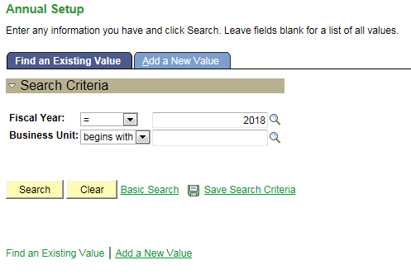

- User will be routed to Annual Setup page.
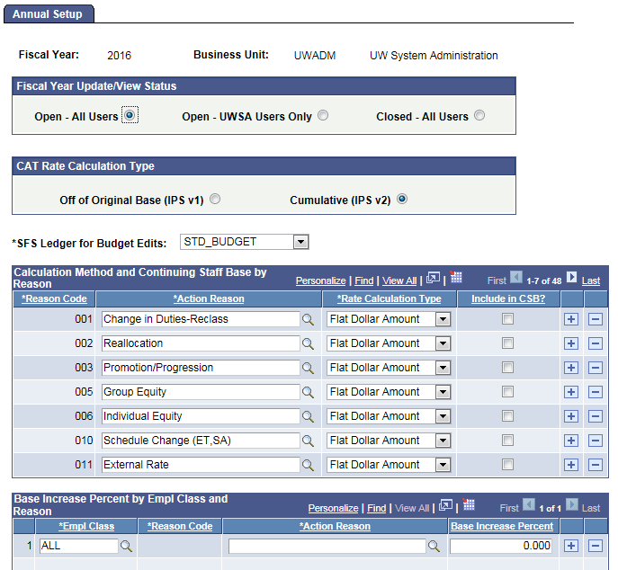

Fiscal year Update/View Status
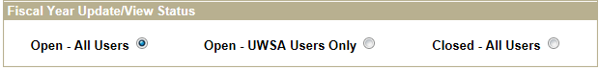
- From the Fiscal Year Update/View Status box select “Open – All Users”, “Open – UWSA Users Only” or “Closed – All Users” to determine the access settings for all users.

  - Open – All Users: Select this option at the beginning of each comp admin cycle. This setting provides access to everyone who has been assigned a CAT security role.
  - Open – UWSA Users Only: Select this option at the end of the comp admin cycle, when all institutions have submitted their final CAT and all users/divisions have been locked. This setting only provides update access to UW System users (with the TEC HR CAT Universal Update & Config role), so that UWSA may complete final reconciliation activities.
  - Closed – All Users: Select this option once the comp admin cycle has closed at the UW System Level. In this setting, CAT data for this fiscal year is no longer available to any users. This setting will provide read only access to UW System users (with Universal CAT role) for what is now considering ‘historical’ CAT data. This option is what the Lookup looks to, to pull in the Fiscal Year to the run control.

CAT Rate Calculation Type
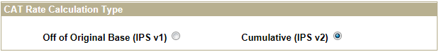
- Select either “Off of Original Base (IPS v1)” or “Cumulative (IPS v2)” from the CAT Rate Calculation Type box based on the rate calculation method used at a particular institution. This will match the version of the IPS that a particular institution uses.
  - Off of Original Base (IPS v1): All compensation increases are calculated off the original comprate (original comprate shown in red square below). If this option is selected, Merit should be row 1, but otherwise order does not matter.
    - In the example below, the first row of 1.002% is multiplied by the original comprate of $34.22 to get the change amount and new comprate. The second row of 2.00% is also multiplied by the original comprate to get the final amount.
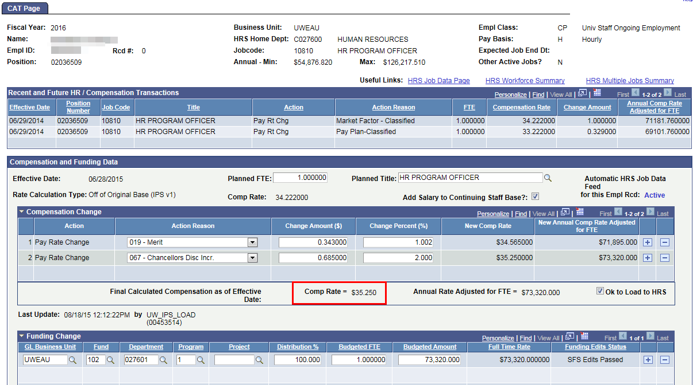

  - Cumulative (IPS v2): All compensation increases are cumulative (calculated off the most recent, updated comprate).
    - In the example below, the first row of 1.00% is multiplied by the original comprate of $104,050 to get the change amount and new comprate. The second row of .2% is then multiplied by the new comprate of the row above it ($105,091) to get the final comprate.
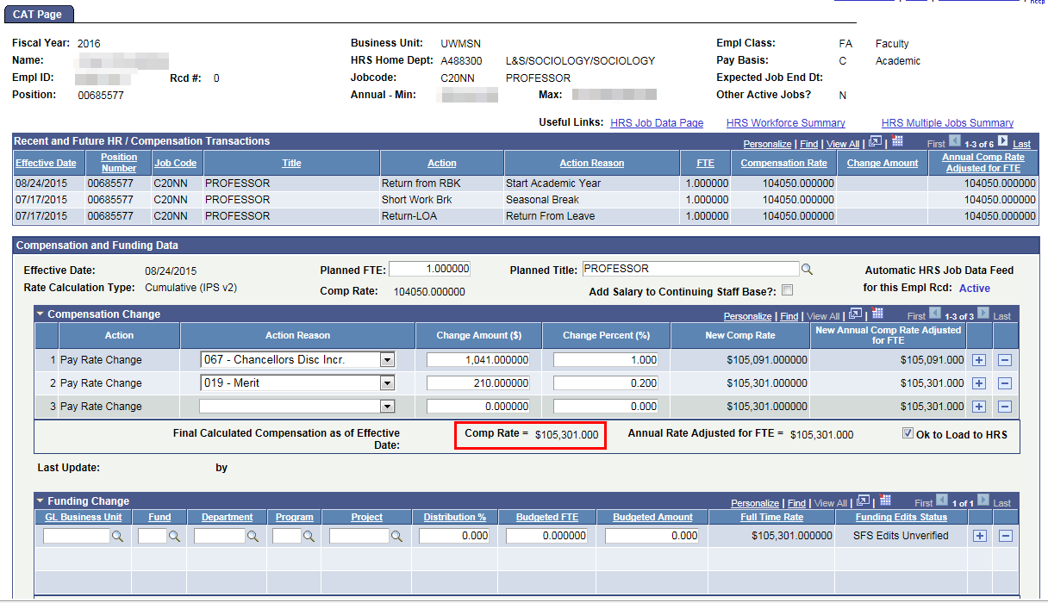

SFS Ledger for Budget Edits
- The SFS Ledger for Budget Edits dropdown is what the Unchecked OK to Load funding splits look to, to decide which set of edits should be running for a particular business unit.
  - The two options are:
    - Actuals (SFS Edits)
    - CAT (Standard Budget minus SCENARIO and PROJECT)
  - The CAT Edits have less edits and allow more flexibility with the funding splits.
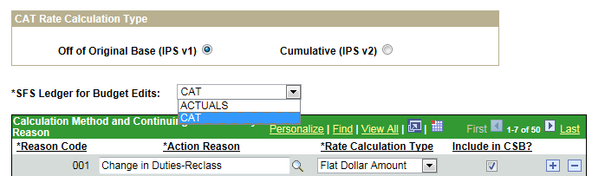

Calculation Method and Continuing Staff Base by Reason
- In the Calculation Method and Continuing Staff Base by Reason table, institutions can select which Action Reasons should appear in the CAT drop down and the “Rate Calculation Type” can be selected for each Action Reason.
  - The view for this table will default to the first seven action reasons, ordered by reason code. Select view all to see all action reasons available in HRS.
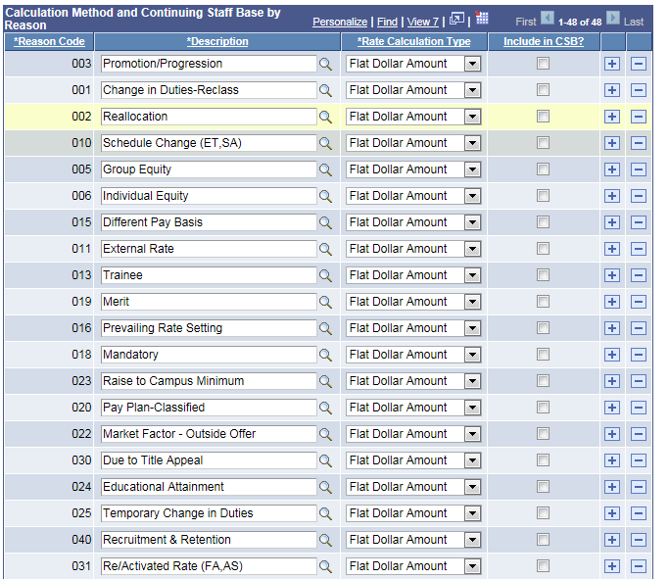

  - Institutions must first select if they would like to remove any action reasons from the list. To do so, select the minus button next to that action reason.
  - The two choices for Rate Calculation Type are “Flat Dollar Amount” and “Percentage”. It is important to set these, so the CAT updated compensation rate (after all increases) recalculates correctly if a change in comprate is pushed from HRS to the CAT.
    - When a new comprate is entered in HRS during the comp admin cycle that change is pushed to the CAT.
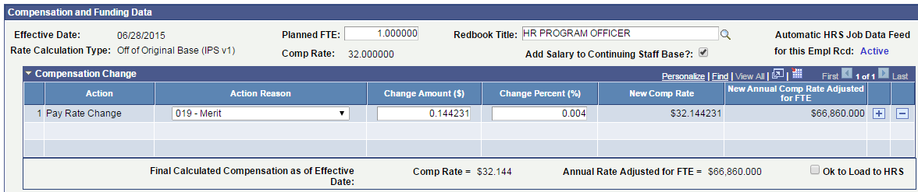

    - In order to recalculate the updated comprate, either $ or % must stay the same, while the other value recalculates based on the new base comprate from HRS.
    - This logic will also hold true for institutions that use the Cumulative setting and insert compensation rows above/between existing compensation rows.
    - In the below example Douglas D’s comprate increases, due to a promotion, which has been recorded in HRS. This new comprate ($97,743.00) from HRS is pushed into the CAT. In this example, the action reason Merit has been set to maintain the original percentage increase in these scenarios, so the merit dollar amount changes from $977.00 to $1007.43, recalculating to 1% of the new comprate. Similarly, the action reason Chancellor’s Discretionary has been set up to maintain the dollar amount in this scenario. So, the “Chancellor’s Discretionary” increase stays at $1250 and recalculates the percentage amount to 1.23%.
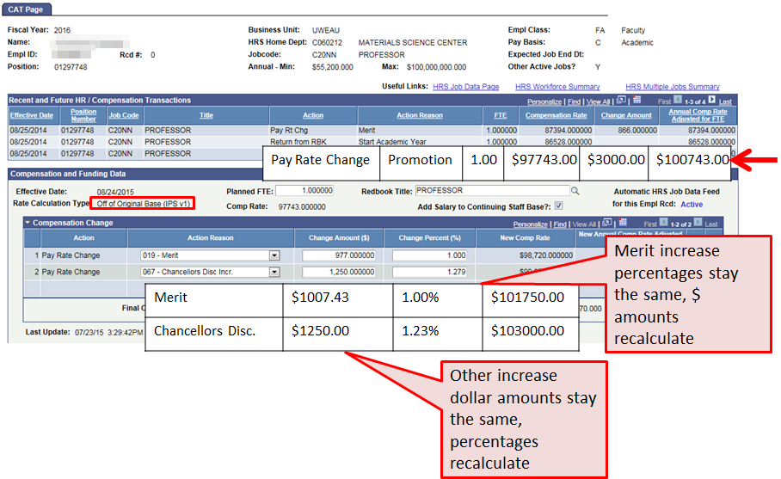

  - All action reasons default to the Rate Calculation Type of Flat Dollar Amount except for 019 Merit which defaults to Percentage.

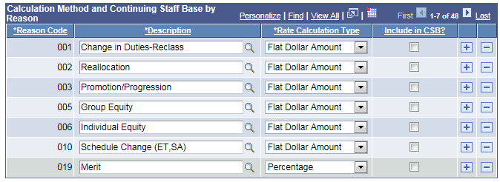

  - The “Include in CSB” indicator determines whether or not a particular action reason is included when calculating the sum of all salaries for the Continuing Staff Base. This parameter is important for the CAT summary page which tracks against a unit’s Continuing Staff Base and merit allocation.
    - If the formula for calculating the Continuing Staff Base is: Sum off the salaries of all eligible employees before all rate increases, then the ‘Include in CSB’ checkbox should remain unchecked for all action reasons.
    - If the formula for calculating the Continuing Staff Base is: Sum of the salaries of all eligible employees after all rate increases except merit, then the ‘Include in CSB’ checkbox should remain checked for all action reasons except for Merit.
    - The CSB checkbox next to the Action Reason Merit should always be unchecked

Base Increase Percent by Empl Class and Reason
- This section is used to reflect pay plan guidelines for a set Merit (or other action reason) percentage. Enter “the Action Reason” and “Base Increase Percent” into Base Increase Percent based on the Board of Regent or institutional Pay Plan Guidelines. This will be used in the CAT Summary report to track Merit Available vs. Merit Allocated.
  - Description is the long name of the Action Reason Code (i.e. Merit)
  - Employee Class can be specified if the pay plan guidelines indicate specific percentages for specific employee classes.

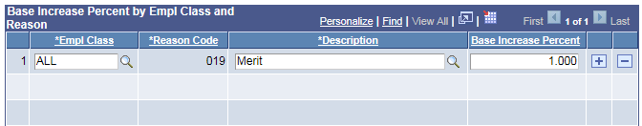

- Select “Save” followed by “Add” at the bottom of the page to add the system parameters for the selected Business Unit and Fiscal Year.

- Users SHOULD NOT change any section of the set up after the initial set up (during the comp admin cycle). To do so could alter employees’ final compensation rates.

Data Freeze
- When the time comes to perform final reconciliation, each institution will select a date to turn off the automatic job data feed from HRS.
- To turn the data feed off, to finalize your CAT numbers, navigate to Workforce Administration > UW External HR Systems > CAT Set Up > Annual Set Up > Find or Add a New Value > Data Freeze.
- Select the Data Feed Stopped? Checkbox to turn the automatic feed off.
- This can be executed at the Divisional level, or for an entire institution at once.

User Access Set Up

This page is used to ‘lock’ users, especially towards the end of the budgeting cycle. When a user is locked, their access is switched to View Only. When a user is unlocked, their access is switched to Update (if they have that role). If a user only has the View only role, they will remain view only regardless of if they are locked or unlocked. At the beginning of each Comp Admin year and when a new user is given a CAT security role, the UW System CAT Admin must visit this page and unlock them in order for the new user to be given their full access.

- Go to Workforce Administration > UW External HR System > Compensation Administration Tool > CAT Set Up > Lock Users.

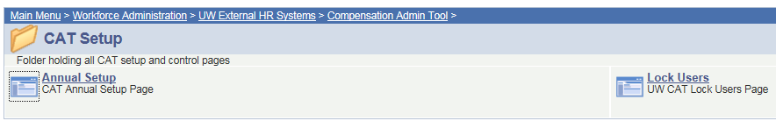

- Enter “HR Deptid” and “Row Level Security” in search criteria.

- Click the magnifying glass beside the “HR Deptid” and “Row Level Security” fields to display a list of all available options for the selected field.
- Optional to enter “Security Role”, “Last Name”, “Employee ID” and “Access Status” in order to narrow search criteria.

- Select Search to pull results based on search criteria entered.

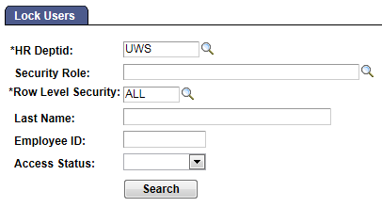

- In the CAT Users Table check the “Lock User” box to change user access from view to update.

  - Boxes that are unchecked are unlocked (users have full access to the CAT).

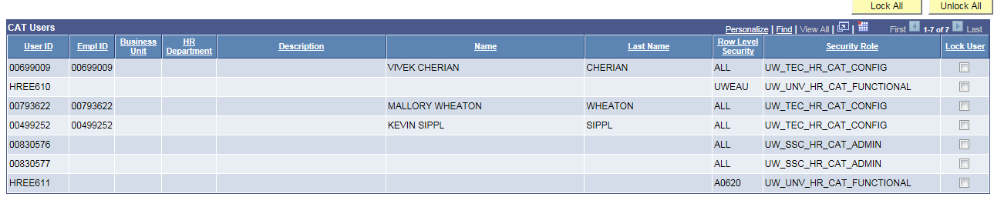

- Select save to enact all changes made.
  - If the Lock User checkbox is checked, Kevin Sippl will be switched to “Read Only” access, even though he has a full UWSA Universal Security Role assigned.

