University of Wisconsin System
Compensation Administration Tool
Business Process Workbook
CAT Transfers
CAT – SYSBP 1.3

Table of Contents
1. OBJECTIVE 2
2. OVERVIEW 2
3. DESCRIPTION 3
4. SCOPE 3
5. BUSINESS PROCESS FLOW DIAGRAM 4
6. PROCESS NARRATIVE 6
7. ASSUMPTIONS 9
8. ROLES 9
9. DOCUMENT CHANGE CONTROL 9

OBJECTIVE
The objective of this document is to provide a step-by-step guide to the actions that may be completed when employee terminations are identified during the annual compensation administration process for administering compensation and funding changes for FA/AS/LI, employees-in-training, and university staff. A transfer occurs when the “Transfer” Action Reason is entered in the CAT and a Position Number is changed in HRS for an existing active Employee Record.
The business process and corresponding PeopleSoft CAT pages and reports outlined in this document are applicable to all UW institutions. The Transfers Business Process, like all other business processes associated with the CAT for administering compensation and funding, is a collaborative effort coordinated between the institutional HR and Budget officers.

OVERVIEW
- Number: CAT – SYSBP 1.3
- Name: CAT Transfers Business Process
- KB Link: TBD
- Related JIRA: HRS-41171
- Key Terminology and Acronyms:
  - Initialization Report (IR)
  - Institutional Planning Spreadsheet (IPS)
  - Compensation Administration Tool (CAT)
  - Additional Adjustments Page (AAP)
  - Human Resource System (HRS)
  - Commitment Accounting (CA)
  - Departmental Planning Spreadsheet (DPS)
  - Human Resources (HR)
  - Continuing Staff Base (CSB)
  - Extraordinary Salary Range (ESR)
  - Expected Job End Date (EJED)

DESCRIPTION
The Transfer Business Process includes activities that may be performed by institutional HR and Budget officers during the annual budgeting cycle, where compensation and funding changes are proposed for the next fiscal year, and an employee transfers have been identified. The CAT – SYSBP 1.3 Business Process covers the overall process flow for identifying transferred employees and confirming that their most recent Position Numbers are appropriately entered into the CAT.

The Position Number field is not automatically pushed from HRS to the CAT. A change in Position Number in HRS will be identified on the HRS to CAT Compare Report and must be manually updated in the CAT by deleting the entire CAT record and re-added the record using the new Position Number. This process ensures that compensation increases in the CAT cannot be accidentally passed to HRS for an old position.

These actions are designed for use with the new PeopleSoft HRS CAT bolt-on. For more details on the overall End-to-End Compensation Administration Process please refer to CAT – SYSBP 1.0.

SCOPE
The scope of the CAT – SYSBP 1.3 Transfers Business Process covers the activities that must occur when a transfer is entered into HRS during the normal budgeting cycle.

Activities included in the scope of this business process are as follows:
- Generating validation reports to identify transferred employees
- Entering transferred employees into the CAT for budgeting purposes
- Verifying the deletion of a transferred employee from the CAT with old Position Number and all corresponding changes from their former division
- Verifying the addition of a transferred employee to the CAT with new Position Number and all corresponding changes for their new division
- Confirming the successful entry of the new Vacant Position on the AAP (as applicable)
Activities excluded from the scope of this business process are as follows:
- Performing non-budget-related transfer activities
- Performing appropriate termination transfer into HRS
- Performing activities related to any Transfers that do not have a Position Number change
  - Title changes will be automatically pushed to existing CAT records
- Performing activities related to any Transfers that use a new Employee Record, or a previously inactive Employee Record
  - These situations will be treated as New Hires, for which new Employee IDs and Empl Records will need to be added to the CAT and the old Employee IDs and Empl Records should be evaluated and potentially deleted from the CAT

BUSINESS PROCESS FLOW DIAGRAM
The flow diagram below can be used in conjunction with the Initialization Report (IR), Institutional Planning Spreadsheet (IPS), the Compensation Administration Tool (CAT) and the Additional Adjustments Page (AAP).

The Transfers Business Process includes:
- Running CAT reports at various points during the compensation administration cycle to identify transfers in HRS that require action in the CAT
- Deleting Employee Records with old Position Numbers from the CAT
- Adding positions with Employee IDs, Employee Records, and new Position Numbers into the CAT
The Process Narrative associated with the flow diagram below is located in the section following the Business Process Visio.
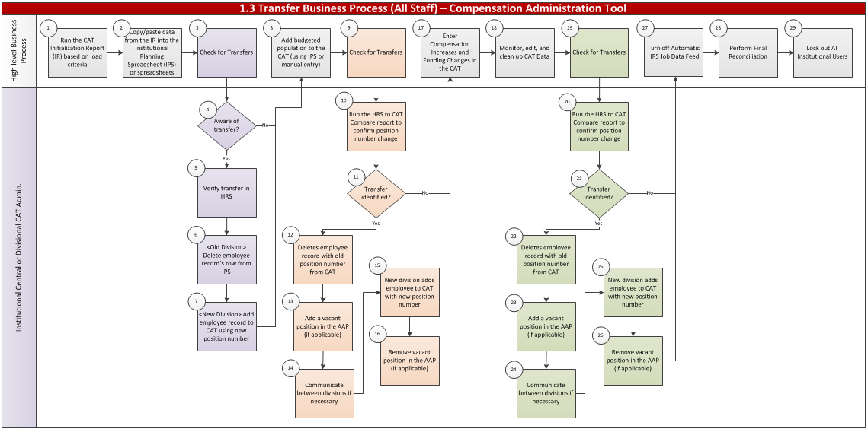

PROCESS NARRATIVE
The Process Narrative below details the step-by-step actions in Section 5 - Business Process Flow Diagram for the 1.3 Transfers Business Process.

For high-level business process details, please refer to the 1.0 End-to-End Compensation Administration Budget Business Process workbook.

# | Flow Diagram Swimlane Title | Swimlane Title Description
1 | High-Level Business Process | High-level explanation of the detailed 1.0 End-to-End Business Process steps conducted during the course of the transfer process, provided to give context to the transfer-specific steps in the swim lanes below
2 | Institutional Central CAT Admin or Institutional Divisional CAT Admin | Actions specific to transfer identification that must be executed throughout the compensation administration cycle by either an Institutional Central CAT Admin or an Institutional Divisional CAT Admin

Step | Owner | Step | Step Description/Details | KB
1 | High-Level Business Process | Run the CAT Initialization Report (IR) based on Load Criteria | High-level business process – please refer to the 1.0 End-To-End Business Process Workbook for specific details of step.  Two Initialization Report output files will be created:  - Employees with 5 or fewer funding splits  - Employees with 6 or more funding splits | - Initialization Report  - Institutional Planning Spreadsheet
2 | High-Level Business Process | Copy Data from the IR and Paste into the Institutional Planning Spreadsheet (IPS) | High-level business process – please refer to the 1.0 End-To-End Business Process Workbook for specific details of step.  Using the two output files created:  - Employees with 5 or fewer funding splits  - Employees with 6 or more funding splits Note that it may be easier to enter these employees directly on the CAT Page. | - Initialization Report  - Institutional Planning Spreadsheet
3 | High-Level Business Process | Check for Transfers | After generating an IPS, review to see if there are any Employee Records that may have had a Position Number change (or will be transferring before the next Fiscal Year) | - HRS to CAT Compare Report
4 | Institutional Central CAT Admin or Institutional Divisional CAT Admin | Aware of Transfer? | CAT administrators should run the IPS and note Employee Records believed to be transferred (i.e. had a change in Position Number) | N/A
5 | Institutional Central CAT Admin or Institutional Divisional CAT Admin | Verify Transfer in HRS | CAT administrators should check HRS Job Data to confirm that those Employee Records identified in Step 4 are indeed terminated. | N/A
6 | Institutional Central CAT Admin or Institutional Divisional CAT Admin | Delete Employee Record Row from IPS | If HRS confirms the employee’s transfer, answer “No” for Question 1: Load Employee to the CAT? on their row on the IPS to effectively delete that employee from the data set | - Institutional Planning Spreadsheet
7 | Institutional Central CAT Admin or Institutional Divisional CAT Admin | Add Employee Record to the CAT Using New Position Number | Using the Add a Value page in the CAT, re-add the Employee Record to the CAT by entering the Fiscal Year, Empl ID and Empl Record | - CAT Page
8 | High-Level Business Process | Add Budgeted Population to the CAT | Upload the IPS to the CAT for all Madison divisions or manually enter budgeted population to the CAT | - IPS Upload to CAT
9 | High-Level Business Process | Check for Transfers | After loading or entering a population of employee records in the CAT, admins should again check for Position Number changes (transfers). | - HRS to CAT Compare Report
10 | Institutional Central CAT Admin or Institutional Divisional CAT Admin | Run the HRS to CAT Compare Report to Confirm Position Number Change | Run the HRS to CAT Compare Report and sort for employee records that have had Position Number changes by filtering the column header row, selecting either the HRS Position Number or the CAT Position Number columns, and unchecking the box next to “blanks” | - HRS to CAT Compare Report
11 | Institutional Central CAT Admin or Institutional Divisional CAT Admin | Transfer Identified? | If No, proceed to Step #17  If Yes, proceed to Step #12 | - HRS to CAT Compare Report
12 | Institutional Central CAT Admin or Institutional Divisional CAT Admin | Delete Employee Record with Old Position Number from CAT | If it has been confirmed that an employee has had a Position Number change, the old division will delete the employee’s entire CAT record. | - CAT Page
13 | Institutional Central CAT Admin or Institutional Divisional CAT Admin | Add a Vacant Position in the AAP (if applicable) | If needed, add a Vacant Position on the Additional Adjustments Page to replace the salary line that was removed from the CAT | - CAT AAP
14 | Institutional Central CAT Admin or Institutional Divisional CAT Admin | Communicate Between Divisions if Necessary | It is important for the old division to communicate to the new division once they have removed the CAT record with the old Position Number. | N/A
15 | Institutional Central CAT Admin or Institutional Divisional CAT Admin | New Division Adds Employee to CAT with New Position Number | The an admin from the division associated with the new Position Number will use the Add a Value tab on the CAT and add a new Employee Record to the CAT by entering the Fiscal Year, Empl ID and Empl Record | - CAT Page
16 | Institutional Central CAT Admin or Institutional Divisional CAT Admin | Remove Vacant Position In The AAP (if applicable) | Delete any Vacant Position in the AAP held for this position once the new salary line has been added to the CAT | - CAT AAP
17 | High-Level Business Process | Enter Compensation Increases and Funding Changes in the CAT | High-level business process – please refer to the 1.0 End-To-End Business Process Workbook for specific details of step.  Continue to review CAT population and make changes as necessary. | - CAT Page
18 | High-Level Business Process | Monitor, Edit, and Clean Up CAT Data | High-level business process – please refer to the 1.0 End-To-End Business Process Workbook for specific details of step.  Continue to review CAT population and make changes as necessary. | - CAT Page
19 | Institutional Central CAT Admin or Institutional Divisional CAT Admin | Perform Rebalancing If Needed | After adding/removing a CAT record and/or adding/removing a Vacant Position, rebalance Merit and FTE allocations to the budget. | - CAT Summary Page
20 | Central CAT Admin | Turn Off Automatic HRS Job Data Feed | Turn off automatic feed between HRS and the CAT by institution or division. | - CAT Annual Setup
21 | High-Level Business Process | Perform Final Reconciliation | Confirm that planning allocations match budget request amounts for funds with allocated funding and/or FTE target amounts using BSUM, the CAT Position Report, and/or the Budget to Allocated Comparison Report. | - BSUM  - CAT Position Report
22 | Central CAT Admin | Lock Out All Institutional Users | Switch all users/divisions to Read Only access. | - CAT Annual Setup

ASSUMPTIONS
- All transfers will first be made in HRS Job Data following standard business processes. Transfers will then subsequently have their employee records deleted from the CAT by their old division and re-added to the CAT by their new division to reflect the changes made in HRS. No transfers should be made in the CAT until they are made and confirmed in HRS.
- It is best practice to re-use existing Employee Records when transferring an employee instead of creating a new Employee Record.

ROLES
The following are CAT security roles assigned to each individual user.
CAT Role | Role Name in OIM | Approvers | Functions
Admin | HR CAT Admin User Update | UWSA Service Center/Budget Office | - Lock out functional users and control job data feed  - Make changes to all transactional pages  - Run all processes and reports within the CAT
Update | HR CAT Func User Update | Institutional HRS Approvers | - Make changes to all transactional pages  - Run all processes and reports within the CAT
Read Only | HR CAT Func User Read Only | Institutional HRS Approvers | - Search and view records within the CAT  - Run reports within the CAT
EPM | EPM HR CAT Query Non Sensitive | Institutional HRS Approvers | - Query CAT data views through EPM  - View current and historical CAT comp/funding data
IR EPM  (Hyperion or  Studio) | IR EPM HR CAT Query Non Sensitive  (Most Commonly Used) | Institutional HRS Approvers | - Query CAT data views through EPM and Interactive Reporting  - View current and historical CAT comp/funding data

DOCUMENT CHANGE CONTROL
Version | Author | Date | Comments
1.0 | Catherine Ayres | 6/24/15 | Original document
2.0 | Mallory Wheaton | 8/26/15 | Added detailed content to each step
3.0 | Maura Kelly | 1/20/16 | Final revision after go-live and training

