University of Wisconsin System
Compensation Administration Tool
Business Process Workbook
CAT Terminations
CAT – SYSBP 1.2

Table of Contents
1. OBJECTIVE 3
2. OVERVIEW 3
3. DESCRIPTION 4
4. SCOPE 4
5. BUSINESS PROCESS FLOW DIAGRAM 4
6. PROCESS NARRATIVE 7
7. ASSUMPTIONS 9
8. ROLES 9
9. DOCUMENT CHANGE CONTROL 10

OBJECTIVE
The objective of this document is to provide a step-by-step guide to the actions that may be completed when employee terminations are identified during the annual compensation administration process for administering compensation and funding changes for FA/AS/LI, employees-in-training, and university staff. The business process and corresponding PeopleSoft CAT pages and reports outlined in this document are applicable to all UW institutions. The Terminations Business Process, like all other business processes associated with the CAT for administering compensation and funding, is a collaborative effort coordinated between the institutional HR and Budget officers.

OVERVIEW
- Number: CAT – SYSBP 1.2
- Name: Terminations Business Process
- KB Link: TBD
- Related JIRA: HRS-41171
- Key Terminology and Acronyms:
  - Initialization Report (IR)
  - Institutional Planning Spreadsheet (IPS)
  - Compensation Administration Tool (CAT)
  - Additional Adjustments Page (AAP)
  - Human Resource System (HRS)
  - Commitment Accounting (CA)
  - Departmental Planning Spreadsheet (DPS)
  - Human Resources (HR)
  - Continuing Staff Base (CSB)
  - Extraordinary Salary Range (ESR)
  - Expected Job End Date (EJED)

DESCRIPTION
The Terminations Business Process includes activities that may be performed by institutional HR and Budget officers during the annual budgeting cycle, where compensation and funding changes are proposed for the next fiscal year and employees that have been entered into the CAT are terminated in HRS. The CAT – SYSBP 1.2 Business Process covers the overall process flow for identifying terminated employees, confirming that those employees are terminated in HRS, and deleting them from the CAT. These actions are designed for use with the new PeopleSoft HRS CAT bolt-on. For more details on the overall End-To-End Compensation Administration Process please refer to CAT – SYSBP 1.0.

SCOPE
The scope of the CAT – SYSBP 1.2 Terminations Business Process covers the activities that must occur when a termination is entered into HRS during the normal budgeting cycle.

Activities included in the scope of this business process are as follows:
- Identifying and entering terminations into the CAT for budgeting purposes
- Generating validation reports to identify terminated employees
- Validating the employee’s termination in HRS
- Verifying the terminated employee’s deletion from CAT
- Entering a Vacant Position on the AAP for the terminated employee (as appropriate)

Activities excluded from the scope of this business process are as follows:
- Performing non-budget-related termination activities
- Performing appropriate termination entries into HRS
- Conducting off-boarding processes (e.g. employee exit interviews, etc.)

BUSINESS PROCESS FLOW DIAGRAM
The flow diagram below can be used in conjunction with the Initialization Report (IR), Institutional Planning Spreadsheet (IPS), the Compensation Administration Tool (CAT) and the Additional Adjustments Page (AAP).

The Terminations Business Process includes:
- Running CAT reports at various points during the compensation administration cycle to identify terminations in HRS that require action in the CAT
- Deleting terminated employees from the CAT
- Using error reports to validate data in the CAT
The Process Narrative associated with the flow diagram below is located in the section following the Business Process Visio.
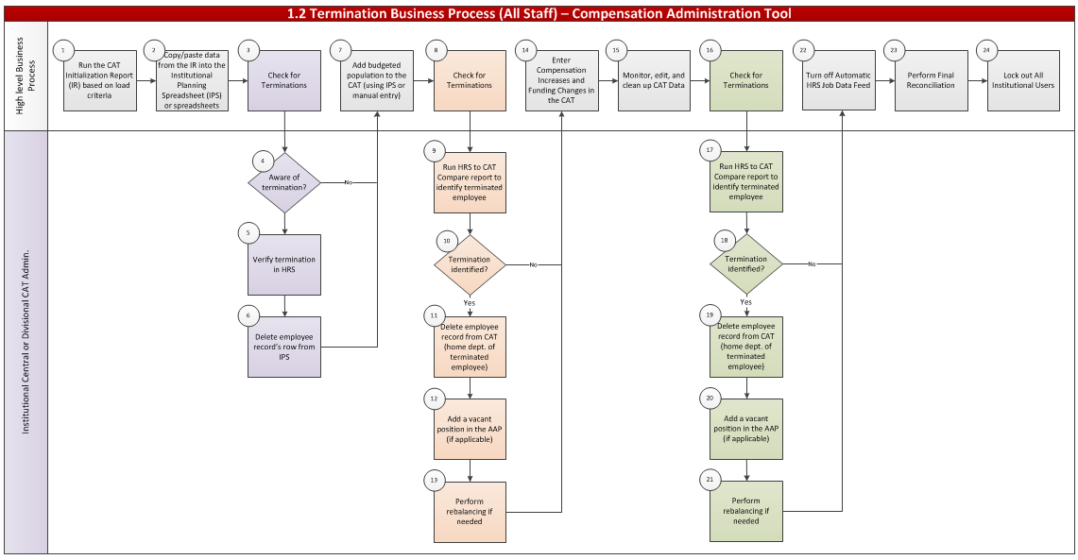

PROCESS NARRATIVE
The Process Narrative below details the step-by-step actions in Section 5 - Business Process Flow Diagram for the 1.2 Terminations Business Process.

For high-level business process details, please refer to the 1.0 End-to-End Compensation Administration Budget Business Process workbook.

# | Flow Diagram Swimlane Title | Swimlane Title Description
1 | High-Level Business Process | High-level explanation of the detailed 1.0 End-To-End Business Process steps conducted during the course of the termination process, provided to give context to the termination-specific steps in the swim lanes below
2 | Institutional Central CAT Admin or Institutional Divisional CAT Admin | Actions specific to termination identification that must be executed throughout the compensation administration cycle by either an Institutional Central CAT Admin or an Institutional Divisional CAT Admin

Step | Owner | Step | Step Description/Details | KB
1 | High-Level Business Process | Run the CAT Initialization Report (IR) based on Load Criteria | High-level business process – please refer to the 1.0 End-To-End Business Process Workbook for specific details of step.  Two Initialization Report output files will be created:  - Employees with 5 or fewer funding splits  - Employees with 6 or more funding splits | - Initialization Report  - Institutional Planning Spreadsheet
2 | High-Level Business Process | Copy Data from the IR and Paste into the Institutional Planning Spreadsheet (IPS) | High-level business process – please refer to the 1.0 End-To-End Business Process Workbook for specific details of step.  Using the two output files created:  - Employees with 5 or fewer funding splits  - Employees with 6 or more funding splits Note that it may be easier to enter these employees directly on the CAT Page. | - Initialization Report  - Institutional Planning Spreadsheet
3 | High-Level Business Process | Check for Terminations | After generating an IPS, review to see if there are any employee records that may be terminated (or terminating before the next Fiscal Year) | N/A
4 | Institutional Central CAT Admin or Institutional Divisional CAT Admin | Identify Terminations | Note any employee records believed to be terminated | N/A
5 | Institutional Central CAT Admin or Institutional Divisional CAT Admin | Verify Terminations in HRS | CAT administrator should check HRS Job Data to confirm those employee records are indeed terminated | N/A
6 | Institutional Central CAT Admin or Institutional Divisional CAT Admin | Delete Employee Record Row from IPS | If HRS confirms the employee’s termination, (or they are terminating before the next fiscal year), answer “No” for Question 1: Load Employee to the CAT? on their row on the IPS to effectively delete that employee from the data set | - Institutional Planning Spreadsheet
7 | High-Level Business Process | Add Budgeted Population to the CAT | Upload the IPS to the CAT for all Madison divisions or manually enter budgeted population to the CAT | - IPS Upload to CAT
8 | High-Level Business Process | Check For Termination | After loading or entering a population of employee records in the CAT, admins should again check for terminations | - HRS to CAT Compare Report
9 | Institutional Central CAT Admin or Institutional Divisional CAT Admin | Run the HRS to CAT Compare Report to Identify Terminated Employee | The HRS to CAT Compare Report contains a Terminated? Y/N column. Sort for “Y” to identify employee records that exist in the CAT and have been terminated in HRS. | - HRS to CAT Compare Report
10 | Institutional Central CAT Admin or Institutional Divisional CAT Admin | Delete Employee Record From CAT (Home Dept. Of Terminated Employee) | Home department should be responsible for removing any terminations identified in the HRS to CAT Compare Report from the CAT. Click the “Delete From CAT” button at the bottom of that employee’s CAT Page. | - HRS to CAT Compare Report  - CAT Page
11 | Institutional Central CAT Admin or Institutional Divisional CAT Admin | Add a Vacant Position in the AAP (if applicable) | If needed, add a Vacant Position on the Additional Adjustments Page to replace the terminated employee. | - CAT AAP
12 | High-Level Business Process | Enter Compensation Increases and Funding Changes in the CAT | High-level business process – please refer to the 1.0 End-To-End Business Process Workbook for specific details of step.  Continue to review CAT population and make changes as necessary. | - CAT Page
13 | High-Level Business Process | Monitor, Edit, and Clean Up CAT Data | High-level business process – please refer to the 1.0 End-To-End Business Process Workbook for specific details of step.  Continue to review CAT population and make changes as necessary. | - CAT Page
14 | Institutional Central CAT Admin or Institutional Divisional CAT Admin | Perform Rebalancing If Needed | After removing a CAT record and/or adding a Vacant Position, rebalance Merit and FTE allocations to the budget. | - CAT Summary Page
15 | Central CAT Admin | Turn Off Automatic HRS Job Data Feed | Turn off automatic feed between HRS and the CAT by institution or division. | - CAT Annual Setup
16 | High-Level Business Process | Perform Final Reconciliation | Confirm that planning allocations match budget request amounts for funds with allocated funding and/or FTE target amounts using BSUM, the CAT Position Report, and/or the Budget to Allocated Comparison Report. | - BSUM  - CAT Position Report
17 | Central CAT Admin | Lock Out All Institutional Users | Switch all users/divisions to Read Only access. | - CAT Annual Setup

ASSUMPTIONS
All terminations will first be made in HRS Job Data following standard business processes. Terminations will then subsequently be adjusted in the CAT to reflect the changes made in HRS. No terminations should be made in the CAT until they are made and confirmed in HRS.

ROLES
The following are CAT security roles assigned to each individual user.
CAT Role | Role Name in OIM | Approvers | Functions
Admin | HR CAT Admin User Update | UWSA Service Center/Budget Office | - Lock out functional users and control job data feed  - Make changes to all transactional pages  - Run all processes and reports within the CAT
Update | HR CAT Func User Update | Institutional HRS Approvers | - Make changes to all transactional pages  - Run all processes and reports within the CAT
Read Only | HR CAT Func User Read Only | Institutional HRS Approvers | - Search and view records within the CAT  - Run reports within the CAT
EPM | EPM HR CAT Query Non Sensitive | Institutional HRS Approvers | - Query CAT data views through EPM  - View current and historical CAT comp/funding data
IR EPM  (Hyperion or  Studio) | IR EPM HR CAT Query Non Sensitive  (Most Commonly Used) | Institutional HRS Approvers | - Query CAT data views through EPM and Interactive Reporting  - View current and historical CAT comp/funding data

DOCUMENT CHANGE CONTROL
Version | Author | Date | Comments
1.0 | Catherine Ayres | 6/24/15 | Original document
2.0 | Mallory Wheaton | 8/26/15 | Added detailed content to each step
3.0 | Maura Kelly | 1/20/16 | Final revision after go-live and training

