University of Wisconsin System
Compensation Administration Tool
Business Process Workbook
CAT New Hires
CAT – SYSBP 1.1

Table of Contents
1. OBJECTIVE 2
2. OVERVIEW 2
3. DESCRIPTION 2
4. SCOPE 3
5. BUSINESS PROCESS FLOW DIAGRAM 3
6. PROCESS NARRATIVE 5
7. ASSUMPTIONS 8
8. ROLES 8
9. DOCUMENT CHANGE CONTROL 8

OBJECTIVE
The objective of this document is to provide a step-by-step guide for the actions that may be completed when new hires are identified during the annual process for administering compensation and funding changes for FA/AS/LI, employees-in-training, and university staff. The business process and corresponding PeopleSoft CAT pages and reports outlined in this document are applicable to all UW Institutions. The new hire business process, like all other business processes associated with the CAT for compensation and funding administration, is a collaborative effort between the institutional HR and Budget officers.

OVERVIEW
- Number: CAT – SYSBP 1.1
- Name: New Hire Business Process
- KB Link: TBD
- Related JIRA: HRS-41169
- Key Terminology and Acronyms :
  - Initialization Report (IR)
  - Institutional Planning Spreadsheet (IPS)
  - Compensation Administration Tool (CAT)
  - Additional Adjustments Page (AAP)
  - Human Resource System (HRS)
  - Commitment Accounting (CA)
  - Departmental Planning Spreadsheet (DPS)
  - Human Resources (HR)
  - Continuing Staff Base (CSB)
  - Extraordinary Salary Range (ESR)
  - Expected Job End Date (EJED)

DESCRIPTION
The New Hire Business Process includes activities that may be performed by institutional HR and Budget officers during the annual budgeting cycle, where compensation and funding changes are proposed for the next fiscal year and new hires are identified. The CAT – SYSBP 1.1 business process covers the overall process flow from the identification of a new hire to the potential actions needed to confirm that the employee is appropriately identified in HRS and the CAT, thus ensuring the ability to apply compensation and funding updates accordingly. These actions are designed for use within the PeopleSoft HRS CAT bolt-on. For more details on the overall end-to-end compensation administration process please refer to CAT – SYSBP 1.0.

SCOPE
The scope of the CAT – SYSBP 1.1 new hire business process covers the activities that must occur when a new hire is entered into HRS during the normal budgeting cycle.

Activities included in the scope of this business process are as follows:
- Identifying new hires and enter them into the CAT for planning purposes
- Generating validation reports to identify new hires
- Validating new hire entry in the CAT with appropriate funding and compensation information, when needed
Activities excluded from the scope of this business process are as follows:
- Performing non-budget-related new hire activities
- Performing appropriate new hire entry into HRS
- Conducting new hire counseling, onboarding, etc.

BUSINESS PROCESS FLOW DIAGRAM
The flow diagram below can be used in conjunction with the Initialization Report (IR), Institutional Planning Spreadsheet (IPS), the Compensation Administration Tool (CAT) and the Additional Adjustments Page (AAP).

The New Hire business process includes the following high-level steps:
- Running reports from the CAT at various times during the compensation administration cycle to determine if there have been new hires entered into HRS that require action within the CAT.
- Entering new hire job data and funding information in the CAT (when necessary)
The Process Narrative that goes along with the flow diagram below is located in the section following the business process flow diagram.
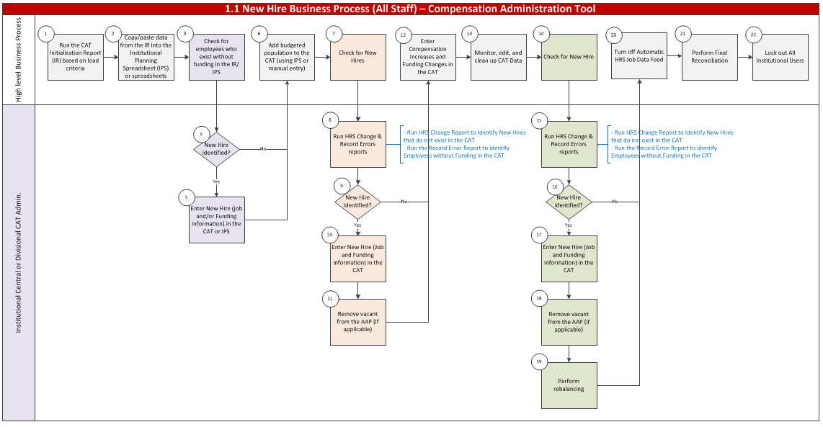

PROCESS NARRATIVE
The process narrative steps detailed below are based on the step-by-step actions in Section 5 - Business Process Flow Diagram for the 1.1 New Hire Business Process. For high level business process details please refer to the 1.0 End-To-End Compensation Administration Budget Business Process workbook.

# | Flow Diagram Swimlane Title | Swimlane Title Description
1 | High-Level Business Process | High-level explanation of the detailed 1.0 End-To-End Business Process steps conducted during the course of the new hire process, provided to give context to the new hire-specific steps in the swim lanes below
2 | Institutional Central CAT Admin or Institutional Divisional CAT Admin | Actions specific to termination identification that must be executed throughout the compensation administration cycle by either an Institutional Central CAT Admin or an Institutional Divisional CAT Admin

Step | Owner | Step | Step Description/Details | KB
1 | High-Level Business Process | Run the CAT Initialization Report (IR) Based on Load Criteria | High-level business process – please refer to the 1.0 End-To-End Business Process Workbook for specific details of step.  Two Initialization Report output files will be created:  - Employees with 5 or fewer funding splits  - Employees with 6 or more funding splits | - Initialization Report  - Institutional Planning Spreadsheet
2 | High-Level Business Process | Copy Data from the IR and Paste into the Institutional Planning Spreadsheet (IPS) | High-level business process – please refer to the 1.0 End-To-End Business Process Workbook for specific details of step.  Using the two output files created:  - Employees with 5 or fewer funding splits  - Employees with 6 or more funding splits Note that it may be easier to enter these employees directly on the CAT Page. | - Initialization Report  - Institutional Planning Spreadsheet
3 | High-Level Business Process | Check for employees who exist without funding in the IR/IPS | Sort for blanks in “GL Business Unit 1” column (Column 77) of the funding section in the IR/IPS.  Note that not all blanks indicate a new hire. | N/A
4 | Institutional Central CAT Admin or Institutional Divisional CAT Admin | New hire identified? | If No, proceed to step #6  If Yes, proceed to step #5 | N/A
5 | Institutional Central CAT Admin or Institutional Divisional CAT Admin | Enter New Hire Job/Funding Information in the CAT or IPS | If a new hire employee record was identified without funding, enter the employee’s funding information in the IPS or in the CAT. | - Institutional Planning Spreadsheet  - CAT Page
6 | High-Level Business Process | Add budgeted population to the CAT | Upload the IPS to the CAT for all Madison divisions or manually enter budgeted population to the CAT. | - IPS Upload to CAT
7 | High-Level Business Process | Check for New Hires | After loading or entering a population of employee records in the CAT, admins should check for new hires. | - Missing from CAT Report
8 | Institutional Central CAT Admin or Institutional Divisional CAT Admin | Run Missing From CAT & Record Error reports | To check for new hires, run the following reports:  - Missing from CAT Report – identifies employees who exist in HRS but not the CAT  - Record Errors Report – identifies employees who do not have funding in the CAT | - Missing from CAT Report  - Record Errors Report
9 | Institutional Central CAT Admin or Institutional Divisional CAT Admin | New hire identified? | If No, proceed to step #12.  If Yes, proceed to step #10. | N/A
10 | Institutional Central CAT Admin or Institutional Divisional CAT Admin | Enter New Hire Job/Funding Information in the CAT | Add Empl ID, Empl Record, compensation data, and funding data in the CAT. | - CAT Page
11 | Institutional Central CAT Admin or Institutional Divisional CAT Admin | Remove Vacant Position from the AAP (if applicable) | If applicable, remove the Vacant Position in the AAP filled by the new hire entered into the CAT. | - CAT AAP
12 | High-Level Business Process | Enter Compensation Increases and Funding Changes in the CAT | High-level business process – please refer to the 1.0 End-To-End Business Process Workbook for specific details of step.  Continue to review CAT population and make changes as necessary. | - CAT Page
13 | High-Level Business Process | Monitor, Edit, and Clean Up CAT Data | High-level business process – please refer to the 1.0 End-To-End Business Process Workbook for specific details of step.  Continue to review CAT population and make changes as necessary. | - CAT Page
14 | High-Level Business Process | Check for New Hires | Throughout the comp admin process, CAT admins should check for new hires. | - Missing from CAT Report
15 | Institutional Central CAT Admin or Institutional Divisional CAT Admin | Perform Rebalancing | After a new hire is added and a vacant position is removed, perform rebalancing as needed. | - CAT Summary Page
16 | Central CAT Admin | Turn Off Automatic HRS Job Data Feed | Turn off automatic feed between HRS and the CAT by institution or division. | - CAT Annual Setup
17 | High-Level Business Process | Perform Final Reconciliation | Confirm that planning allocations match budget request amounts for funds with allocated funding and/or FTE target amounts using BSUM, the CAT Position Report, and/or the Budget to Allocated Comparison Report. | - BSUM  - CAT Position Report
18 | Central CAT Admin | Lock Out All Institutional Users | Switch all users/divisions to Read Only access. | - CAT Annual Setup

ASSUMPTIONS
Appointment-Level funding in Commitment Accounting (CA) should be entered in HRS for new hires, in order for their record to be handled accurately throughout the CAT process. Not having Appointment-Level funding in HRS will result in no funding rows automatically initialized in the CAT and consequently not appropriately interfaced back to HRS for next Fiscal Year. If an employee does not have funding in the CAT, it is best practice to enter appointment-level funding in HRS and in the CAT before entering compensation increases.

ROLES
The following are CAT security roles assigned to each individual user.

CAT Role | Role Name in OIM | Approvers | Functions
Admin | HR CAT Admin User Update | UWSA Service Center/Budget Office | - Lock out functional users and control job data feed  - Make changes to all transactional pages  - Run all processes and reports within the CAT
Update | HR CAT Func User Update | Institutional HRS Approvers | - Make changes to all transactional pages  - Run all processes and reports within the CAT
Read Only | HR CAT Func User Read Only | Institutional HRS Approvers | - Search and view records within the CAT  - Run reports within the CAT
EPM | EPM HR CAT Query Non Sensitive | Institutional HRS Approvers | - Query CAT data views through EPM  - View current and historical CAT comp/funding data
IR EPM  (Hyperion or  Studio) | IR EPM HR CAT Query Non Sensitive  (Most Commonly Used) | Institutional HRS Approvers | - Query CAT data views through EPM and Interactive Reporting  - View current and historical CAT comp/funding data

DOCUMENT CHANGE CONTROL
Version | Author | Date | Comments
1.0 | Catherine Ayres | 6/24/15 | Original version
2.0 | Catherine Ayres | 6/29/15 | Updated Visio/numbering
3.0 | Mallory Wheaton | 8/25/15 | Added detailed content to each step
4.0 | Maura Kelly | 1/20/16 | Final revision after go-live and training

