PlanUW Processes

QUICK REFERENCE GUIDE
Current Year Forecast

Contents

Setting User Variables 4
Current Year Forecast 10
Transfers - Input and Review 11
Salary, Wages & Fringe - Input and Review 17
Non-Compensation - Input and Review 23
Revenue - Input and Review 30
Current Year Forecast Review 36
Current Year Forecast Reports 40
Smart View Visual Reference 44

Revision History

Version | Key Revisions | Modified By | Date
1.0 | Initial Document Creation | Huron Consulting | 2018
2.0 | Added Forecast Section | Huron Consulting | 08/28/2019
3.0 | Updated Current Year Forecast Section | Huron Consulting | 11/13/2020

Setting User Variables

Step 1.
Login to PlanUW: http://
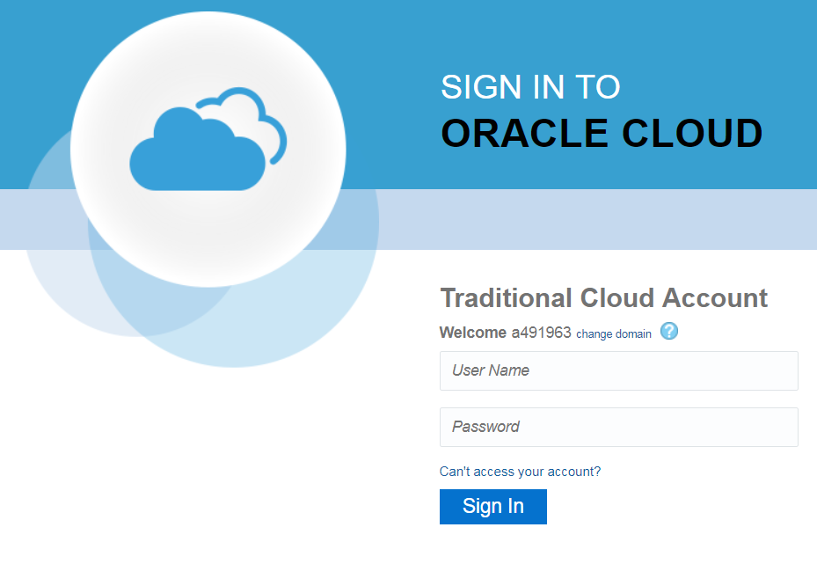

Step 2.
Once in the home page, click on Tools>User Preferences.

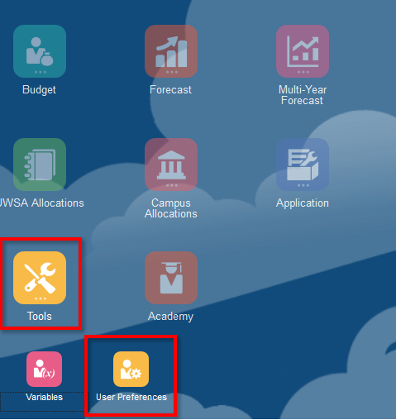

Step 3.
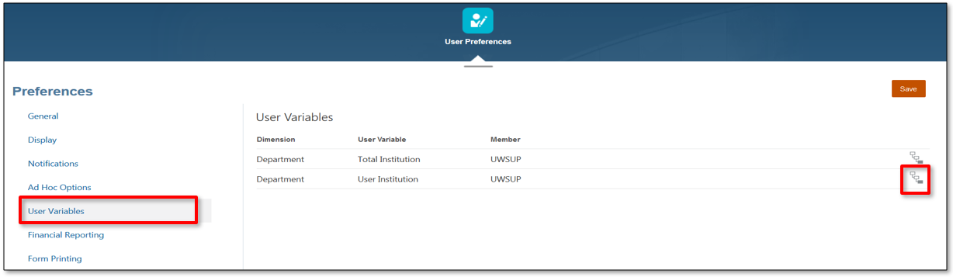
In the Variables page, click on the “User Variables” option first and then click on the drop-down link:
NOTE: When setting User Variables, you only need to select a member for the Organization dimension. Do not edit any of the other dimensions.

Step 4.
Members can be selected in two ways from the Member Selection window: Through the Search Bar, or by selecting Hierarchies. Click OK to save.
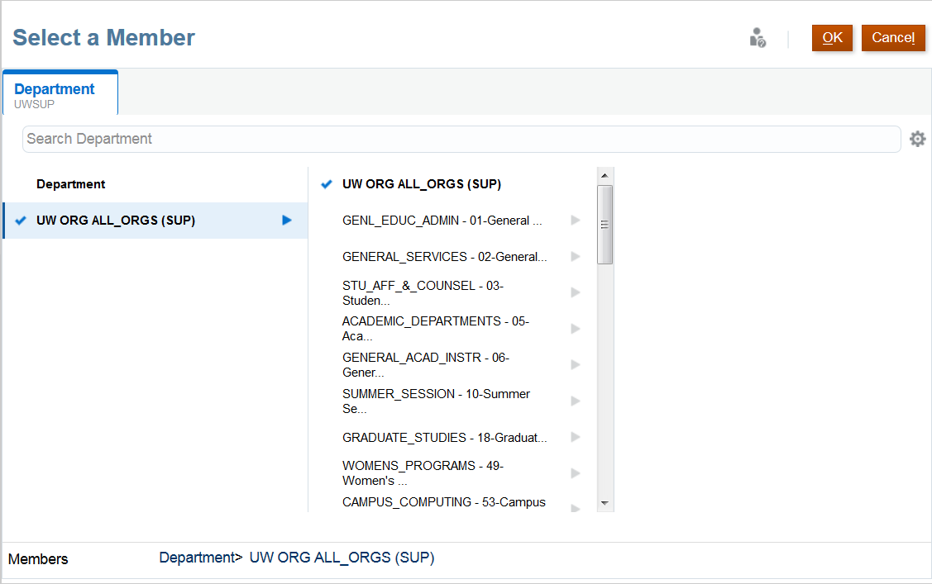

Step 5. – FOR POWER USERS ONLY
To set variables at Total Institution level, follow the same steps described in this section by selecting the Institution at the higher level.
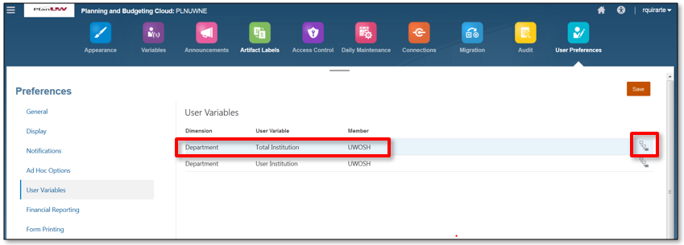
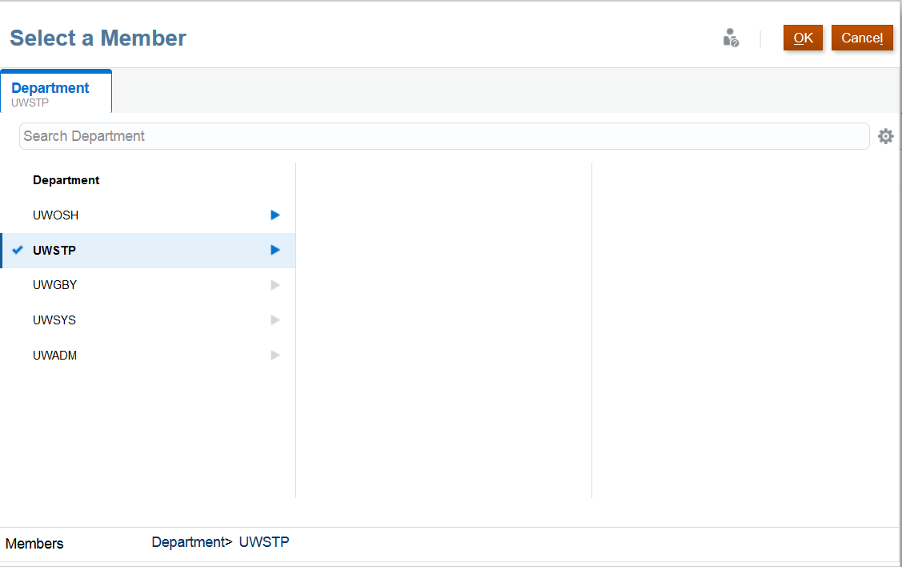

Current Year Forecast

Transfers - Input and Review

Step 1.
Click on the Forecast tile to begin.
Step 2.
Click on Transfers.
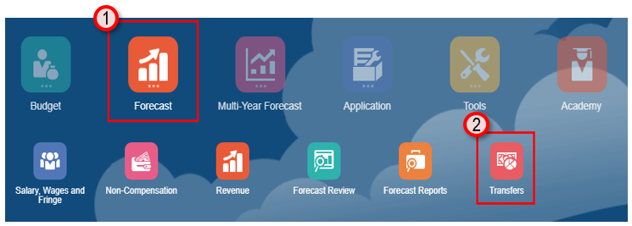

There are 3 input forms and 1 review form to choose from:

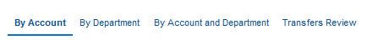

- By Account – Provides forecasting of Transfers by Account in the remaining open months of the budget year. All other cells should be grey. Prior months will be cleared and closed for entry. Select Fund and Department in point of view. Add and adjust Transfers to the months they are expected to occur. Make transfer adjustments across the open months as needed.

- By Department – Provides forecasting of Transfers by Department in the remaining open months of the budget year. All other cells should be grey. Prior months will be cleared and closed for entry. Make transfer adjustments transfers across the open months as needed.

- By Account and Department - Provides forecasting of Transfers by Department and Account in the remaining open months of the budget year. All other cells should be grey. Select Fund in point of view. Add and adjust Transfers to the months they are expected to occur. Make transfer adjustments across the open months as needed.

- Transfers Review - Provides a review of respreads/adjustments done to budget transfers to ensure that they are reflected in the appropriate month they will be hitting to provide an up-to-date and accurate forecast.

Step 3. Selecting Input Forms and POV (All input forms)
1
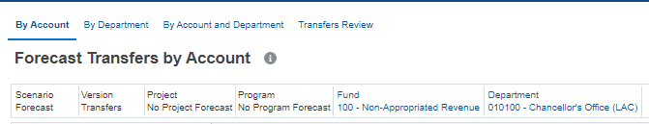
2
1

- Select the desired form by clicking on the form title at the top of the page

- Change the POV (Point of View)

  - by selecting any blue member available in the POV selection area.

  - Or by clicking the pencil icon on the right top corner and selecting members from the drop-down menu

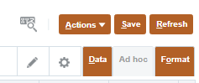
2
- Once member combination is selected, click on the forward arrow icon to commit changes or Apply to save.
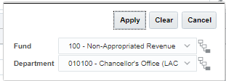

Step 4. Updating Transfers Forecast (All input forms)
- Before adding information, confirm that the form contains the Open Months Columns and Comments column (both white and editable)

- Enter the Forecast information in the Open Months columns and add any comments, if needed, in the Comments column

- Click Save to save the entered information.
3
- Click OK on the pop-up window confirming that the data has been saved to the form.
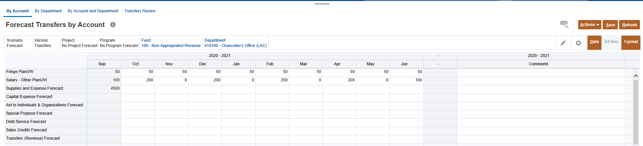
1
2

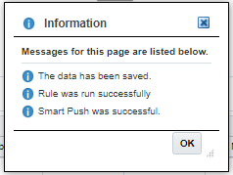
4
Step 5. Reviewing Forecast
1
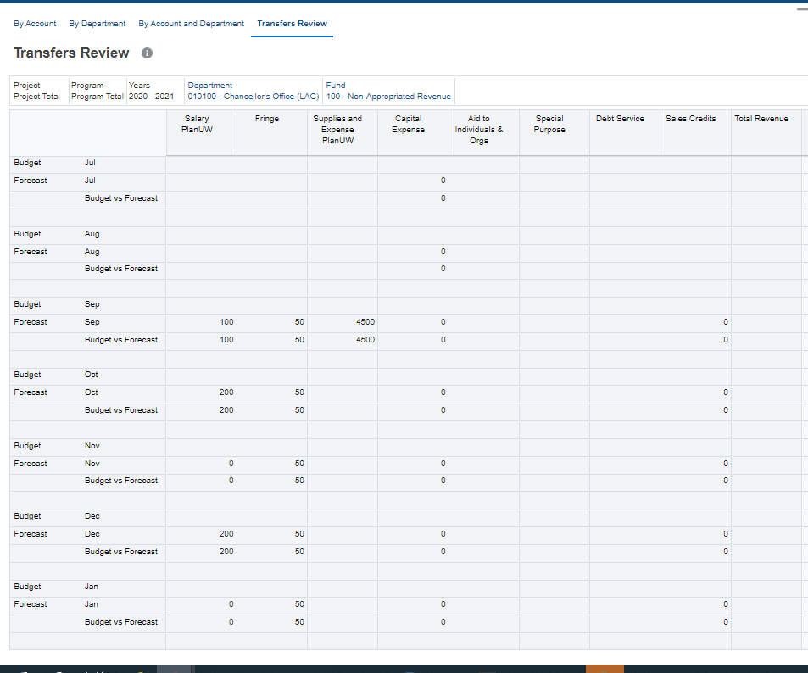
3
2

Begin the process of reviewing the data entered in the input forms:

- Select the Trend Review form at the top of the page.

- Select the POV where data was input or aggregated to.

- Review the high-level Account columns to display updated totals by month where Budget might overwrite previous forecasted Transfers.

- Make additions and adjustments to Transfers in any of the 3 input forms. Return to the Input forms to make updates as needed.

Salary, Wages & Fringe - Input and Review
Step 1.
Click on the Forecast tile to begin.
Step 2.
Click on Salary, Wages and Fringe
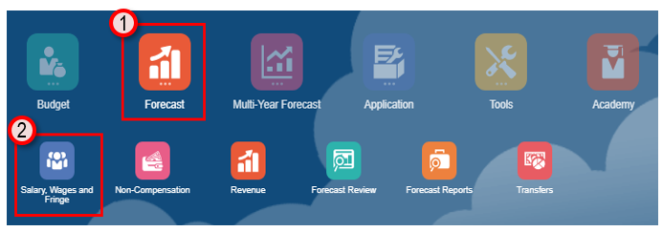
There are 3 Tabs available to choose from for input and review:
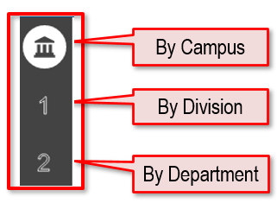
- Campus-Level – Enter forecast amounts at ‘Campus-Level’ using Divisions, in By Account, By Division, By Account and Division Forms and use Campus-Level Review to see total results.

  - By Account - Provides forecasting to a single Division or Department by Fund

  - By Division - Provides forecasting to multiple Divisions by Account and Fund

  - By Account and Division - Provides forecasting to multiple Divisions and Accounts by Fund

  - Campus-Level Review - Provides historical Budget and Actual data, an overview of total forecast, as well as the variance of Forecast vs Budget and CY vs PY Actuals Year to Date.

- Division-Level – Enter forecast amounts at ‘Divisional-Level’ using Divisions, in By Account, By Division, By Account and Division Forms and use Divisional-Level Review to see total results.

  - By Account - Provides forecasting to a single Division by Fund

  - By Division - Provides forecasting to multiple Divisions by Account and Fund

  - By Account and Division - Provides forecasting to multiple Departments and Accounts by Fund

  - Division-Level Review - Provides historical Budget and Actual data, an overview of total forecast, as well as the variance of Forecast vs Budget and CY vs PY Actuals Year to Date.

- Department-Level – Enter forecast amounts at ‘Department-Level’ using Sub-Departments, in By Account, By Department, By Account and Department Forms and use Department-Level Review to see total results.

  - By Account - Provides forecasting to a single Department by Fund

  - By Division - Provides forecasting to multiple Departments by Account and Fund

  - By Account and Division - Provides forecasting to multiple Departments and Accounts by Fund

  - Department-Level Review - Provides historical Budget and Actual data, an overview of total forecast, as well as the variance of Forecast vs Budget and CY vs PY Actuals Year to Date.

Step 3. Selecting Input Forms and POV (All input forms)
NOTE: It is recommended to select one level of entry (by Division or by Department) when entering data in these forms.
2
1

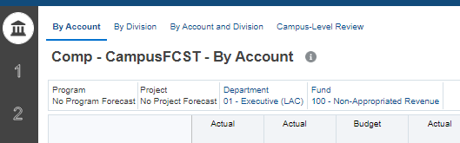
1
3
2

- Select the tab on the left for the level of entry (1-by Campus, 2-by Division, 3-by Department)

- Select the desired form by clicking on the form title at the top of the page

- Change the POV (Point of View)

  - by selecting any blue member available in the POV selection area.

  - Or by clicking the pencil icon on the right top corner and selecting members from the drop-down menu

b.

- Once member combination is selected, click on the forward arrow icon to commit changes or Apply to save.

Step 4. Updating Forecast (All input forms)
- Before adding information, confirm that the form contains the Forecast Adjustment Year Total Column and Forecast Adjustments Comments column (both white and editable)

- Enter the Forecast information on the Year Total column (expandable by open Quarter or by open Month) and add any comments, if needed, in the Comments column

- Click Save to save the entered information.

- Click OK on the pop-up window confirming that the data has been saved to the form.

- Refer to the Budget QRG guide for more detail on Opening and Removing Forecast Accounts.
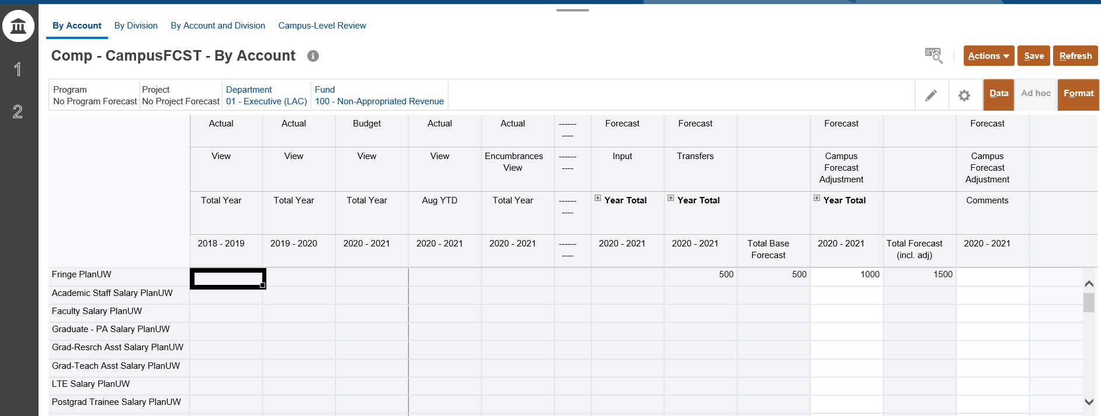
3
1
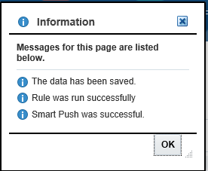
4
2

Step 5. Reviewing Forecast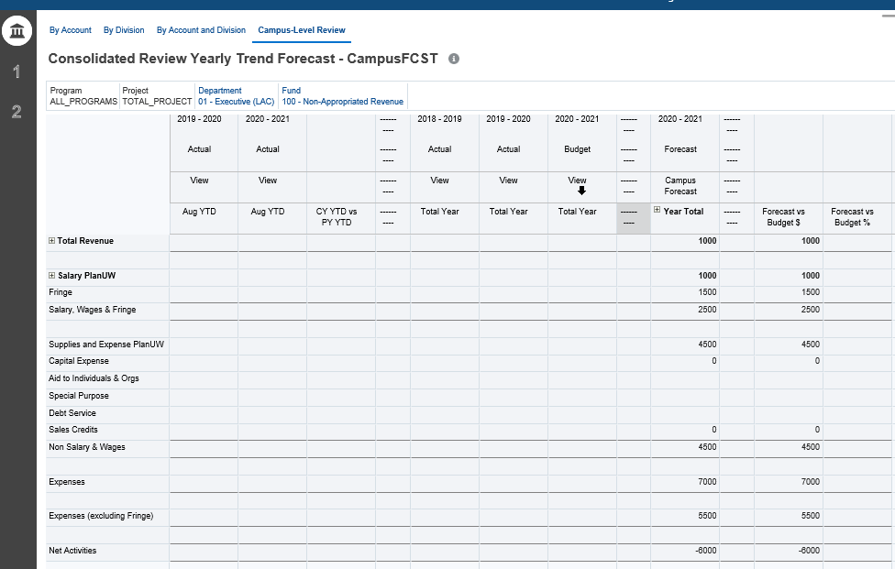
3
2
1

Begin the process of reviewing the data entered in the input forms:

- Select the Campus-Level Review form at the top of the page.

- Select the POV where data was input or aggregated to.

- Review the Campus Forecast Year Total column to display updated totals.

- Return to the Input forms to make updates as needed

Non-Compensation - Input and Review
Step 1.
Click on the Forecast tile to begin.
Step 2.
Click on Non-Compensation
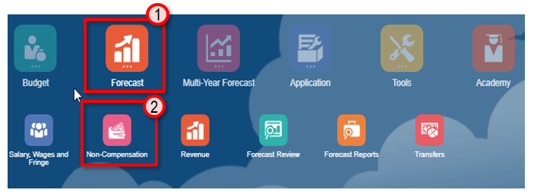
There are 3 Tabs available to choose from for input and review:
- Campus-Level – Enter forecast amounts at ‘Campus-Level’ using Divisions, in By Account, By Division, By Account and Division Forms and use Campus-Level Review to see total results.

- By Account - Provides forecasting to a single Division or Department by Fund

- By Division - Provides forecasting to multiple Divisions by Account and Fund

- By Account and Division - Provides forecasting to multiple Divisions and Accounts by Fund

- Campus-Level Review - Provides historical Budget and Actual data, an overview of total forecast, as well as the variance of Forecast vs Budget and CY vs PY Actuals Year to Date.

- Division-Level – Enter forecast amounts at ‘Divisional-Level’ using Divisions, in By Account, By Division, By Account and Division Forms and use Divisional-Level Review to see total results.

  - By Account - Provides forecasting to a single Division by Fund

  - By Division - Provides forecasting to multiple Divisions by Account and Fund

  - By Account and Division - Provides forecasting to multiple Departments and Accounts by Fund

  - Division-Level Review - Provides historical Budget and Actual data, an overview of total forecast, as well as the variance of Forecast vs Budget and CY vs PY Actuals Year to Date.

- Department-Level – Enter forecast amounts at ‘Department-Level’ using Sub-Departments, in By Account, By Department, By Account and Department Forms and use Department-Level Review to see total results.

  - By Account - Provides forecasting to a single Department by Fund

  - By Division - Provides forecasting to multiple Departments by Account and Fund

  - By Account and Division - Provides forecasting to multiple Departments and Accounts by Fund

  - Department-Level Review - Provides historical Budget and Actual data, an overview of total forecast, as well as the variance of Forecast vs Budget and CY vs PY Actuals Year to Date.

Step 3. Selecting Input Forms and POV (All input forms)
NOTE: It is recommended to select one level of entry (by Division or by Department) when entering data in these forms.
2
1
1
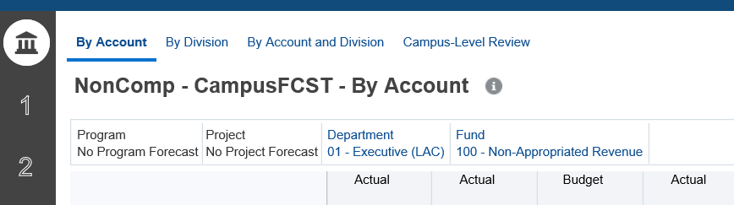
3
2
- Select the tab on the left for the level of entry (1-by Campus, 2-by Division, 3-by Department)

- Select the desired form by clicking on the form title at the top of the page

- Change the POV (Point of View)

  - By selecting any blue member available in the POV selection area.

  - Or by clicking the pencil icon on the right top corner and selecting members from the drop-down menu
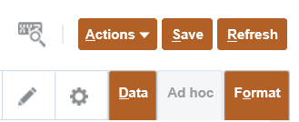
b
- Once member combination is selected, click on the forward arrow icon to commit changes or Apply to save.
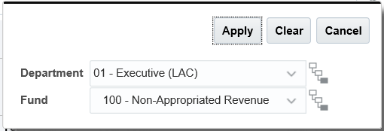

Step 4. Updating Forecast (All input forms)
- Before adding information, confirm that the form contains the Forecast Adjustment Year Total Column and Forecast Adjustments Comments column (both white and editable)

- Enter the Forecast information on the Year Total column (expandable by open Quarter or by open Month) and add any comments, if needed, in the Comments column

- Click Save to save the entered information.

- Click OK on the pop-up window confirming that the data has been saved to the form.

- Refer to the Budget QRG guide for more detail on Opening and Removing Forecast Accounts.

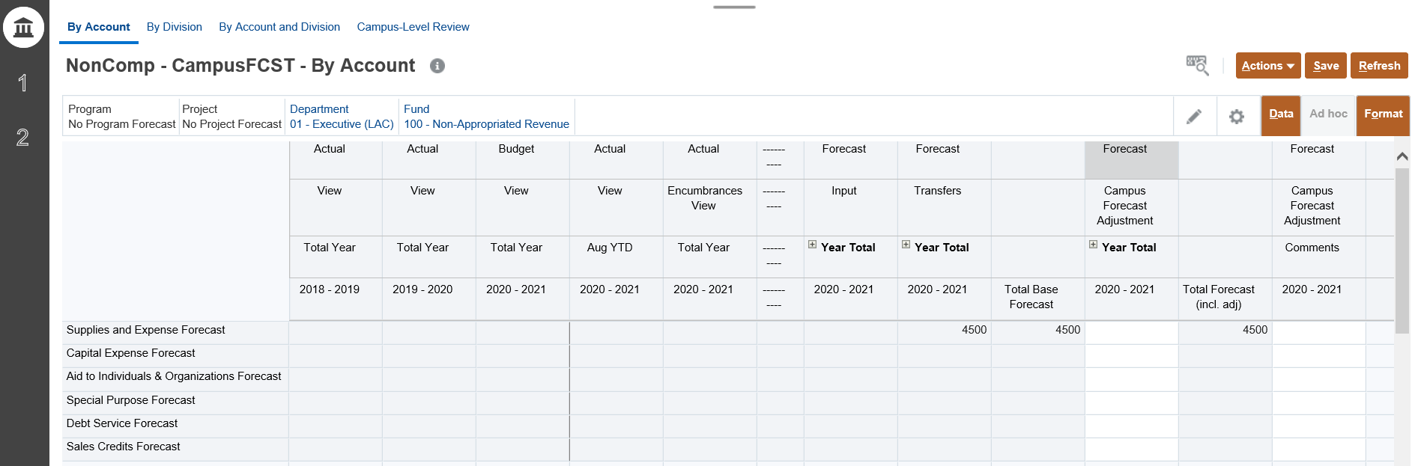
3
1
2
4

Step 5. Reviewing Forecast
1
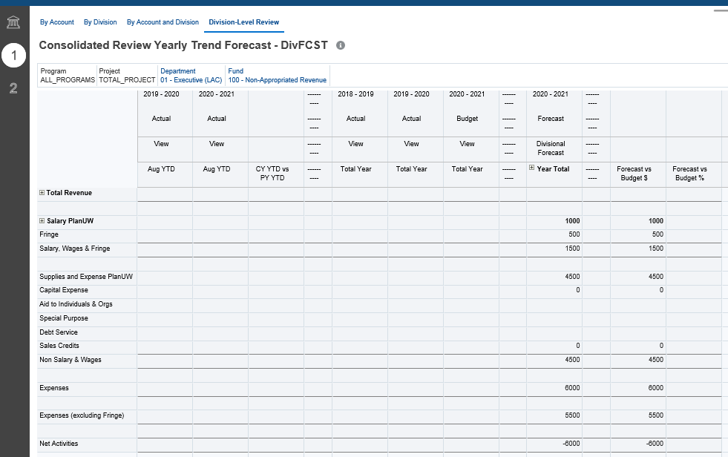
3
2

Begin the process of reviewing the data entered in the input forms:

- Select the XX-Level Review form at the top of the page.

- Select the POV where data was input or aggregated to.

- Review the XX Forecast Year Total column to display updated totals.

- Return to the Input forms to make updates as needed

Revenue - Input and Review
Step 1.
Click on the Forecast tile to begin.
Step 2.
Click on Revenue
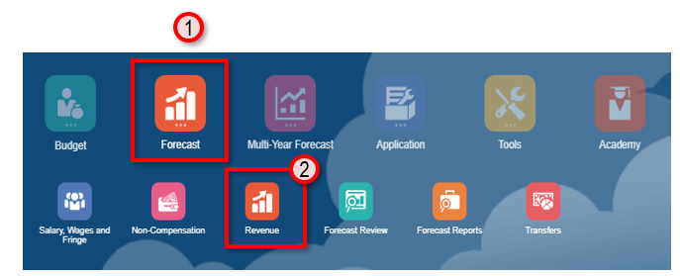
There are 3 Tabs available to choose from for input and review:
- Campus-Level – Enter forecast amounts at ‘Campus-Level’ using Divisions, in By Account, By Division, By Account and Division Forms and use Campus-Level Review to see total results.

- By Account - Provides forecasting to a single Division or Department by Fund

- By Division - Provides forecasting to multiple Divisions by Account and Fund

- By Account and Division - Provides forecasting to multiple Divisions and Accounts by Fund

- Campus-Level Review - Provides historical Budget and Actual data, an overview of total forecast, as well as the variance of Forecast vs Budget and CY vs PY Actuals Year to Date.

- Division-Level – Enter forecast amounts at ‘Divisional-Level’ using Divisions, in By Account, By Division, By Account and Division Forms and use Divisional-Level Review to see total results.

  - By Account - Provides forecasting to a single Division by Fund

  - By Division - Provides forecasting to multiple Divisions by Account and Fund

  - By Account and Division - Provides forecasting to multiple Departments and Accounts by Fund

  - Division-Level Review - Provides historical Budget and Actual data, an overview of total forecast, as well as the variance of Forecast vs Budget and CY vs PY Actuals Year to Date.

- Department-Level – Enter forecast amounts at ‘Department-Level’ using Sub-Departments, in By Account, By Department, By Account and Department Forms and use Department-Level Review to see total results.

  - By Account - Provides forecasting to a single Department by Fund

  - By Division - Provides forecasting to multiple Departments by Account and Fund

  - By Account and Division - Provides forecasting to multiple Departments and Accounts by Fund

  - Department-Level Review - Provides historical Budget and Actual data, an overview of total forecast, as well as the variance of Forecast vs Budget and CY vs PY Actuals Year to Date.

Step 3. Selecting Input Forms and POV (All input forms)
NOTE: It is recommended to select one level of entry (by Division or by Department) when entering data in these forms.
1
2
1
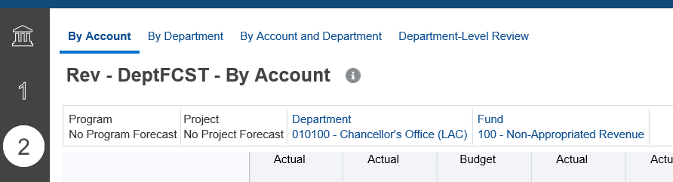
3
2

- Select the tab on the left for the level of entry (by Division or by Department)

- Select the desired form by clicking on the form title at the top of the page

- Change the POV (Point of View)

  - by selecting any blue member available in the POV selection area.

  - Or by clicking the pencil icon on the right top corner and selecting members from the drop-down menu

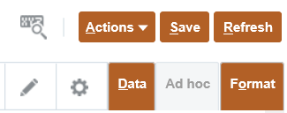
b
- Once member combination is selected, click on the forward arrow icon to commit changes or Apply to save.
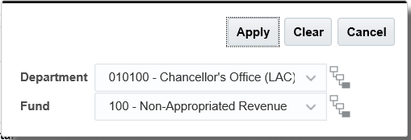

Step 4. Updating Forecast (All input forms)
- Before adding information, confirm that the form contains the XX Forecast Adjustment Year Total Column and Forecast Adjustments Comments column (both white and editable)

- Enter the Forecast information on the Year Total column (expandable by open Quarter or by open Month) and add any comments, if needed, in the Comments column

- Click Save to save the entered information.

- Click OK on the pop-up window confirming that the data has been saved to the form.

- Refer to the Budget QRG guide for more detail on Opening and Removing Forecast Accounts.

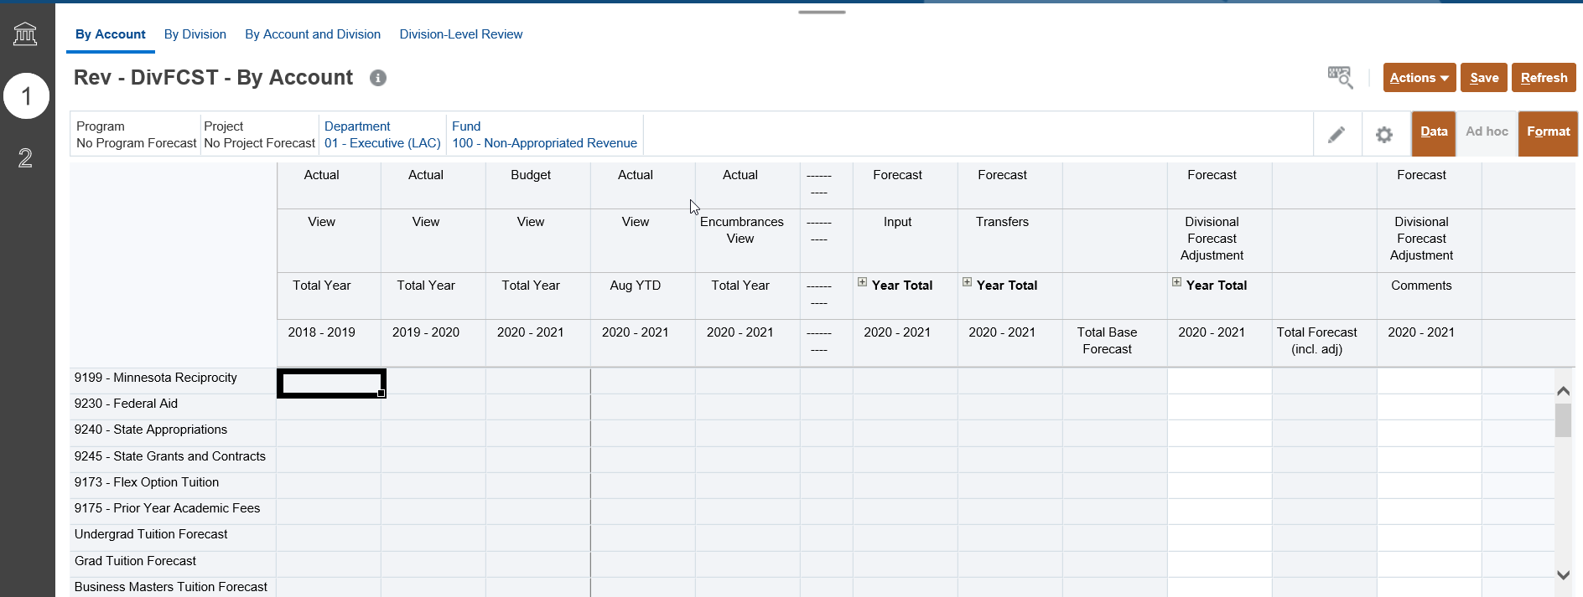
3
1
2
4

Step 5. Reviewing Forecast
3
2
1

Begin the process of reviewing the data entered in the input forms:

- Select the XX-Level Review form at the top of the page.

- Select the POV where data was input or aggregated to.

- Review the XX Forecast Year Total column to display updated totals.

- Return to the Input forms to make updates as needed

Current Year Forecast Review
Step 1.
Click on the Forecast tile to begin.
Step 2.
Click on Forecast Review
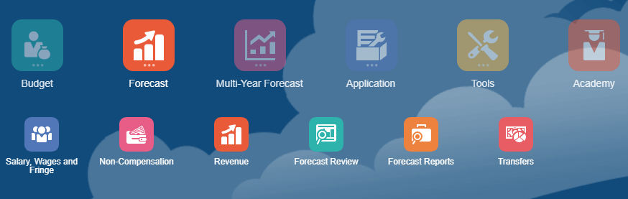
There are 2 Tabs available to choose from for review:

Review
Copy Version Review

- Review forms –These are tools used to review total Forecast data. These Forms can be used to compare Forecast against previous years budget and actuals before copying to different Versions. (The User Variable must be set at the Division (or parent) for the level you are trying to check). Level Check forms provide an overview of data entered at the Campus, Division and Departments that reside below it. Users will be able to see where data was entered at both levels and thus if Forecast is being over calculated

  - Campus-Level Review - Provides historical Budget and Actual data, an overview of total forecast, as well as the variance of Forecast vs Budget and CY vs PY Actuals Year to Date at the Campus level.
  - Division-Level Review - Provides historical Budget and Actual data, an overview of total forecast, as well as the variance of Forecast vs Budget and CY vs PY Actuals Year to Date at the Division level.
  - Department-Level Review - Provides historical Budget and Actual data, an overview of total forecast, as well as the variance of Forecast vs Budget and CY vs PY Actuals Year to Date at the Department level.
  - Working Review - Provides a historical comparison of the summarized Forecast at the Program Total and Project Total level.
  - Working Review by Fund- Provides a different view of Forecast data by high level accounts Fund groupings.
- Copy Version and Status Approval Tracker - Power Users can copy versions of their working Forecast so that it can no longer altered via the Input forms. As you work through data entry, and finish your forecasting process the Forecast Status Tracker provides a snapshot into your progress.
  - Consolidated Version to Working Copy Review – Provides a consolidated view of all Version level Forecasts (Campus, Divisional, and Departmental) next to Working Forecast, Campus Review and Final Forecast, with variances to compare after data has been copied by UWSA Admins.
  - Consolidated Copy Review - Provides a consolidated view of Working Forecast, Campus Review and Final Forecast with variances to ensure accurate data has been copied and submitted.

Step 3. Selecting Forms and POV (All review forms)
2
1
1
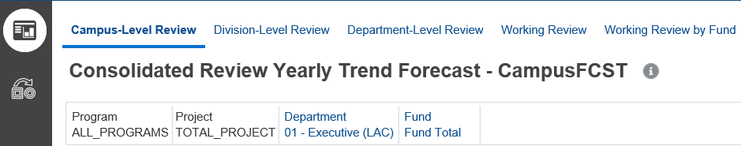
3
2

- Select the Review tab on the left

- Select the desired form by clicking on the form title at the top of the page

- Change the POV (Point of View)

  - by selecting any blue member available in the POV selection area.

  - Or by clicking the pencil icon on the right top corner and selecting members from the drop-down menu

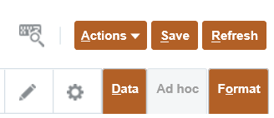
b
- Once member combination is selected, click on the forward arrow icon to commit changes or Apply to save.
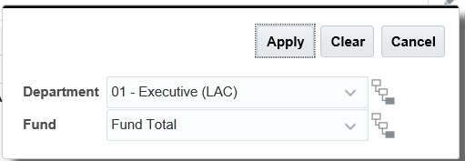

Step 4a. Reviewing Forecast forms
1
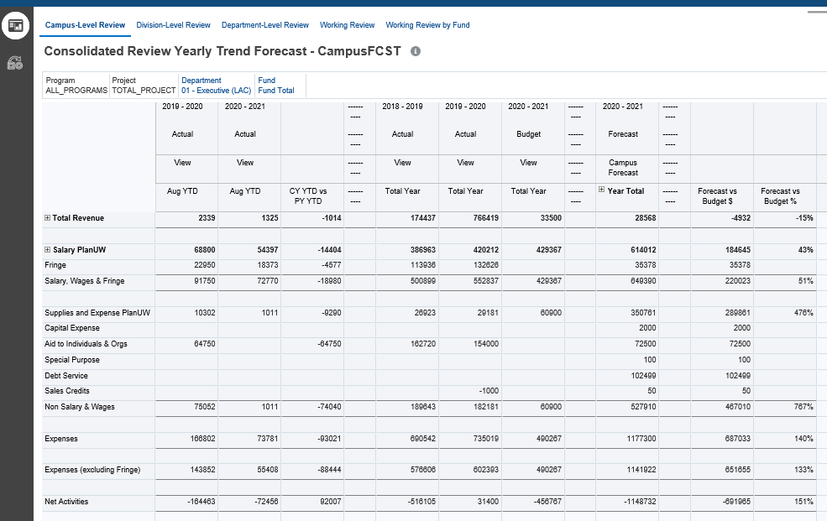
3
2

Begin the process of reviewing the forms:

- Select the form at the top of the page.

- Select the POV where data was input or aggregated to.

- Review the columns to display updated totals.

- Return to the Input forms to make updates as needed

Step 4b. Consolidated Review Version copy
2
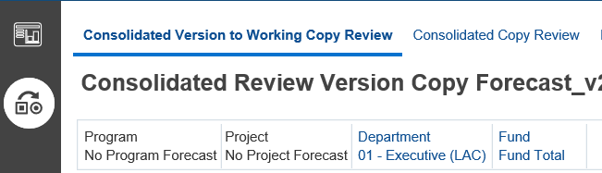
1
3
2

- Select the Copy Version Review tab on the left

- Select the Consolidated Version to Working Copy Review by clicking on the form title at the top of the page

- Change the POV (Point of View) on the selected page by selecting any blue member available in the POV selection area.

- To request data copy from an input Version (Campus-Level, Division-Level or Department-Level) please contact the PlanUW Admin team at planuw@uwsa.com

Current Year Forecast Reports
Step 1.
Click on the Forecast tile to begin.
Step 2.
Click on the Forecast Reports tile.

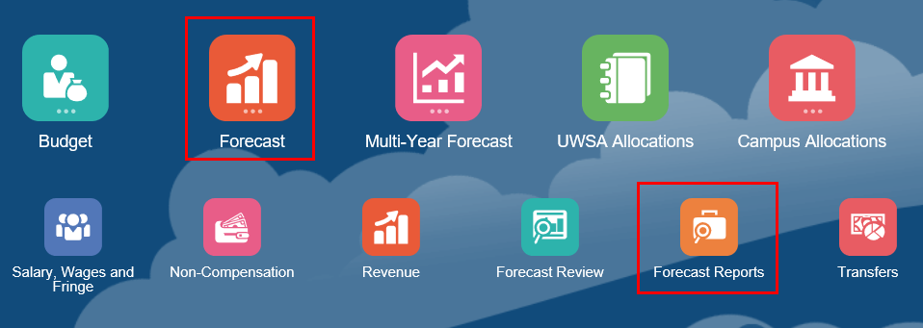

There are 7 reports available for review:

- Forecast Review - Provides historical Actual and Budget Data in addition to current Forecast data. You are able to track the variance between Forecast vs. Budget and Forecast vs. Prior Year Actuals.

- Forecast Review – Detail - Expands the Working Version so that users can see its components: Base, Transfers, and Adjustments. You are still able to view historical Budget and Actuals as well as track the variance between Forecast vs. Budget.

- Forecast Variance Report - Forecast Variance Report provides three variance comparisons: Budget vs. Forecast, Current Year Vs Prior Year YTD Actuals, and Current Forecast vs Prior Forecast of your choice.

- Expense Forecast Report - Expense Forecast Report pulls the top-level Expense accounts to the columns, and the Departments and Funds into the rows. It allows for your data to be viewed by a different breakdown.

- Revenue Forecast Report - Revenue Forecast Report pulls the top-level Revenue accounts to the columns, and the Departments and Funds into the rows. It allows for your data to be viewed by a different breakdown.

- Revenue and Expense Forecast Report - Revenue and Expense Forecast Report pulls the top-level Expense Revenue accounts to the columns, and the Departments and Funds into the rows. It allows for your data to be viewed by a different breakdown.

- Summary by Fund - Forecast Summary by Fund brings the Funds into the columns and accounts into the rows. Users can see data broken down Fund Groupings.

Step 3. Selecting Reports (All Reports)
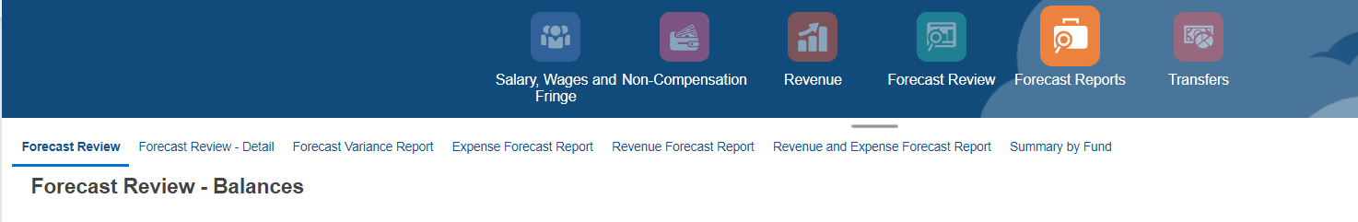
1
- Select the desired Report by clicking on the form title at the top of the page.
3
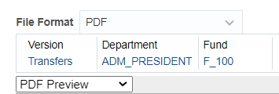
2

- Change the POV (Point of View) by selecting any blue member available on the top left of the form.

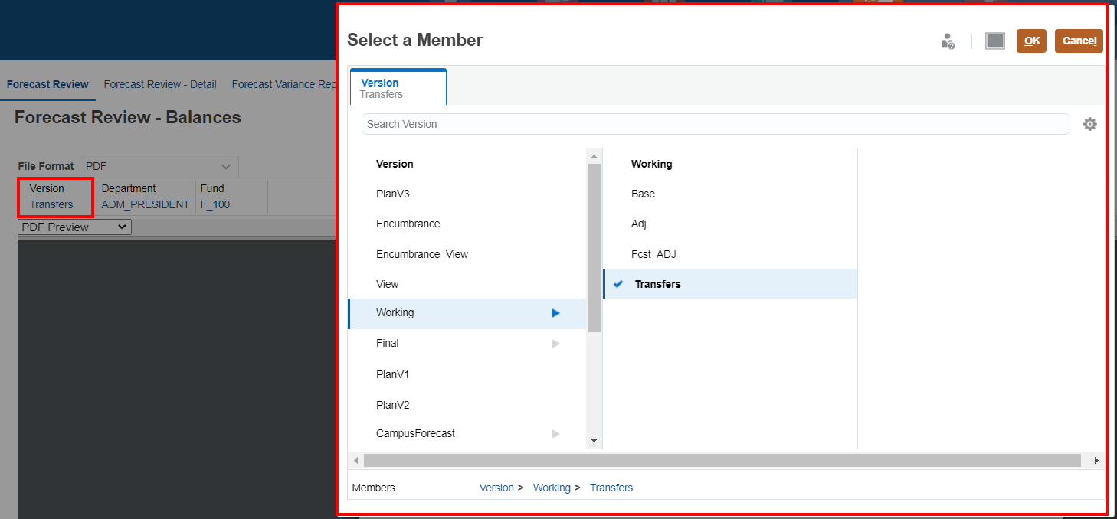

NOTE: When selecting a version, users should remember to always choose the Campus Forecast, Divisional Forecast, Departmental Forecast, Working, Final, or PlanV1 versions. Selecting the other versions may only return partial or no information for the report.
- Select the File Format (PDF, HTML, Excel) in the dropdown menu.
Refer to the Budget QRG guide for more detail on opening reports in HTML format.
Refer to the Budget QRG guide for more detail on opening reports in PDF format.
Refer to the Budget QRG guide for more detail on opening reports in Excel format.

- Review the report in the file format chosen.

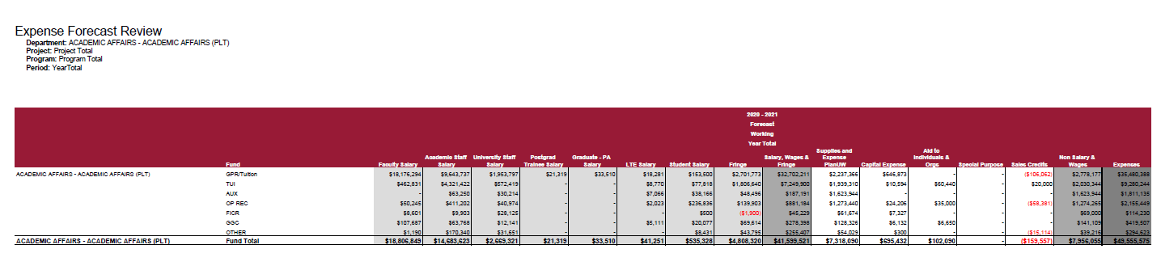

Smart View Visual Reference

SMART VIEW HOME PAGE

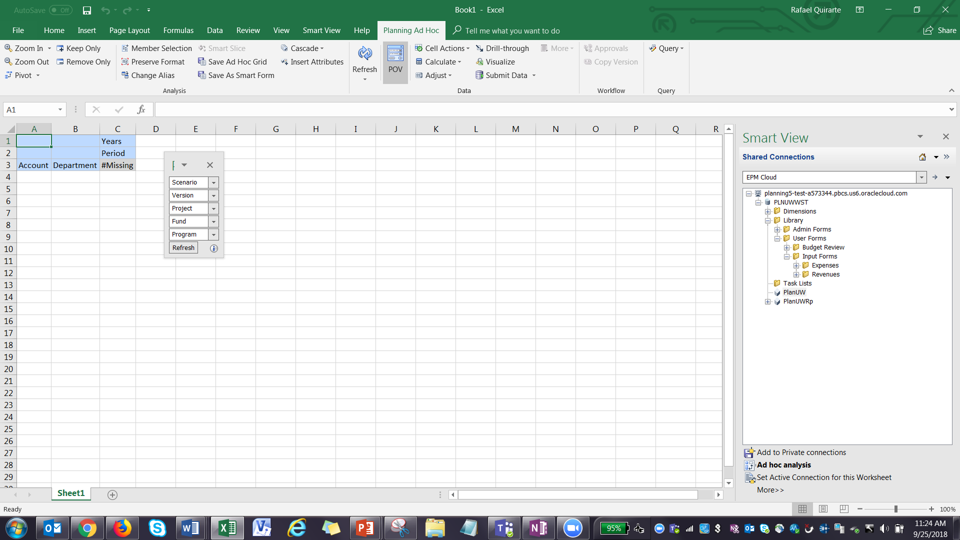

PLANNING TAB ICON DESCRIPTION
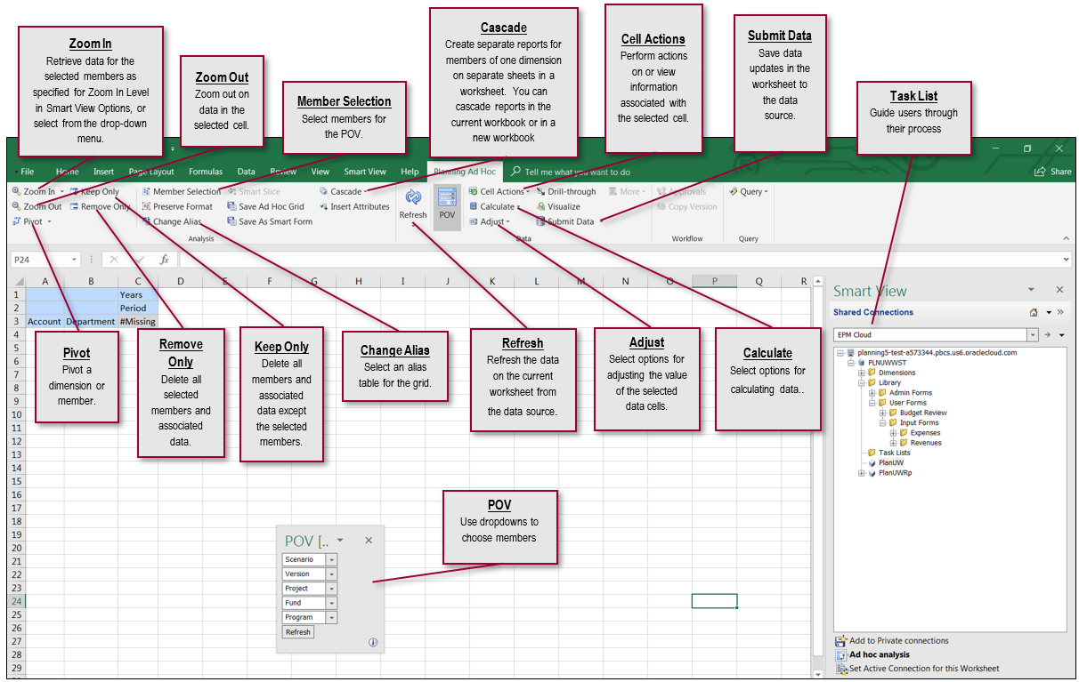

SMART VIEW TAB ICON DESCRIPTION
