University of Wisconsin System
Plan UW
Creating a Report in Smart View Ad Hoc

PART ONE: SETTING UP GRID DIMENSIONALITY

Step 1: Open Excel and navigate to the Smart View Ribbon. Click Options.
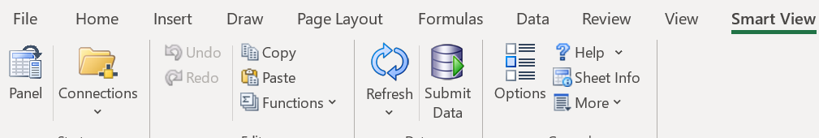
Step 2: A window will appear. Navigate to “Data Options” and uncheck “Suppress Missing Blocks.” Under the Headers “Suppress Rows” and “Suppress Columns” make sure none of the suppression items are checked. We want to start out with an unsuppressed grid so that we can set it up even if there is no data at the starting dimensions.
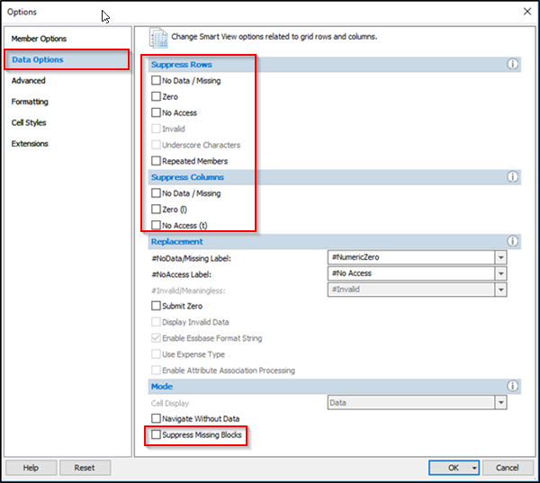
Step 3: Click on the “Advanced” tab. Look at the “Shared Connections URL” and ensure that it displays the correct URL. If needed, copy and paste the URL for your pod from the chart below.
Click “OK” when you are done setting up “Options”. The window will close.
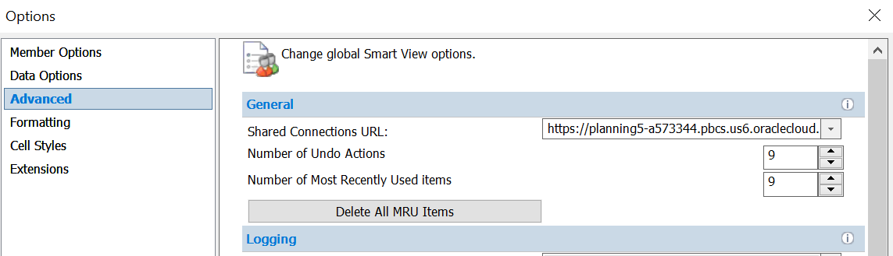
PLNUWNE | https://planning4-a573344.pbcs.us6.oraclecloud.com/workspace/SmartViewProviders
PLNUWALL | https://planning6-a573344.pbcs.us6.oraclecloud.com/workspace/SmartViewProviders
PLNUWMSN | https://planning-a573344.pbcs.us6.oraclecloud.com/workspace/SmartViewProviders
PLNUWMIL | https://planning2-a573344.pbcs.us6.oraclecloud.com/workspace/SmartViewProviders
PLNUWSO | https://planning3-a573344.pbcs.us6.oraclecloud.com/workspace/SmartViewProviders
PLNUWWST | https://planning5-a573344.pbcs.us6.oraclecloud.com/workspace/SmartViewProviders

Step 4: Navigate back to the Smart View tab and click “Panel”. This will prompt the panel to open on the right side.

Step 5: Click “Shared Connections.”
Step 6: If you are not already logged in, a window will appear. Click “Company Sign In” and follow the steps to signing in via Single Sign On (SSO).
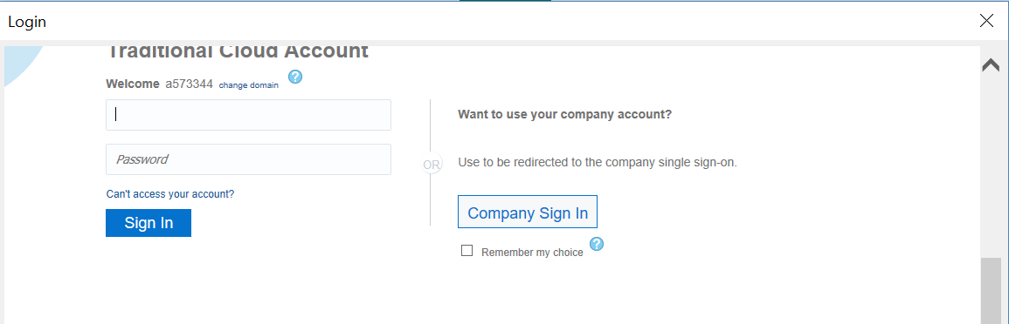

Step 7: Once you are signed in, use the drop-down menu to select “EPM Cloud.”
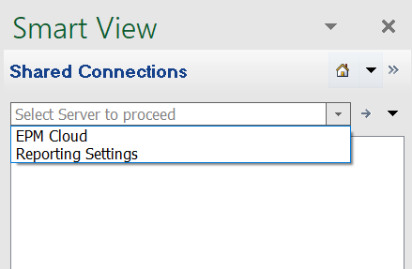
Step 8: Using the plus sign, expand “planningX-a573344…” until you see “PlanUWRp.” Double click on “PlanUWRp” and “Ad Hoc Analysis” appears at the bottom of the right panel.
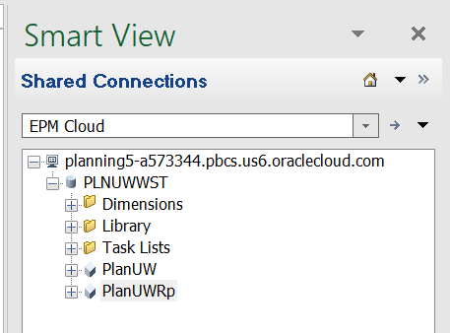
Step 9: Click “Ad hoc Analysis.” This will connect your Excel grid to PlanUW and the dimensions will appear in the grid.
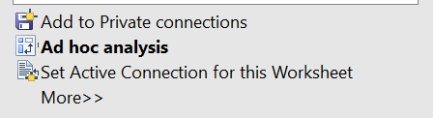

Step 10: A floating box with the POV dimensions will appear. You can drag the POV box to the top of your grid. You can also use the arrow to move the floating box to the top of your grid.
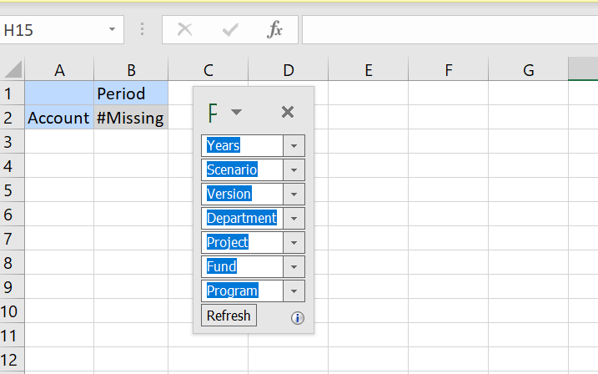

Now that you are connected to your pod, another item that should be set-up is your default style. If the cells do not appear blue (as shown above with Account and Period), you will need to change your “Default Styles” to “Planning”.
Click on Smart View > Options, then on the left, click on “Cell Styles” and using the “Default Styles” dropdown arrow, select “Planning.” If “Planning” exists on the screen, make sure the box is checked next to it. Click OK once you are done.
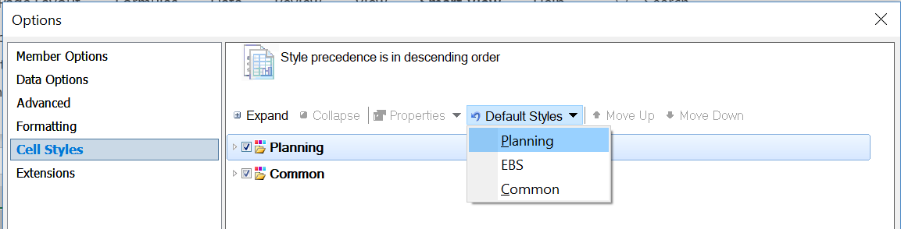

Click “Refresh” – your cells should now be blue.
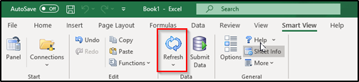

Step 11: Now that we have moved the POV Box and our design style is set, we begin to manipulate the grid. While you can click the arrow next to the dimension and drag it into the grid (Option 1), it requires precise placement. The easiest way to pivot the dimensions is to insert rows and columns and type the dimension name (Option 2). This documentation will show Option 2, so we will begin by first inserting three columns.
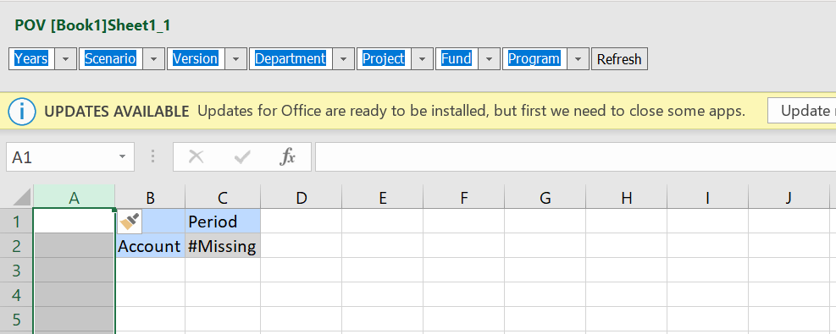
Option 2

Option 1

Step 12: In each column, you will type the name of a dimension. The dimensional names need to be aligned with those that already appear in the grid. In this case they will be adjacent to “Account.” Type “Department”, “Fund”, and “Program” in each of the three columns you previously inserted. You can reference the POV bar for exact spelling and naming of each dimension.
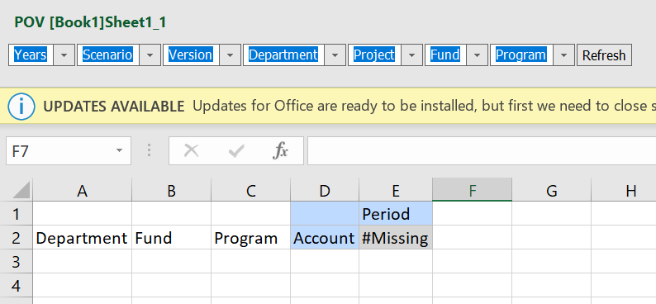
Once you have typed in the dimension names, you will click “Refresh.” This will officially move the dimensions from the POV bar to the Rows in your grid. If you have standard formatting ON, the dimensions you typed into the grid will appear blue and no longer exist in the POV.
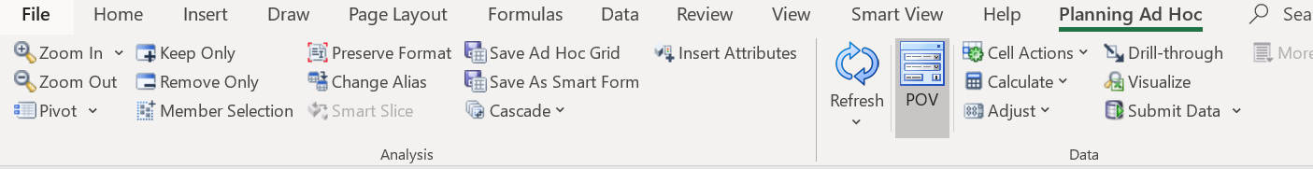

Step 13: Now we will be selecting the members to create a grid that pulls data by all level 0 Departments, Funds, Programs, and Accounts.
For some institutions this is a rather large data set and Excel may not be capable of pulling that large of a data set. If this is the case, in steps 13-23, you will want to select a smaller data set. You can do this by choosing a Division (ex. RVF_General_Education_Admin), a fund grouping (ex. GPR/Tuition), or Program (ex. P_2). This is not an issue with the institution we are using as our example in this documentation.

To begin, click once on the dimension you want to select a member for (Department).
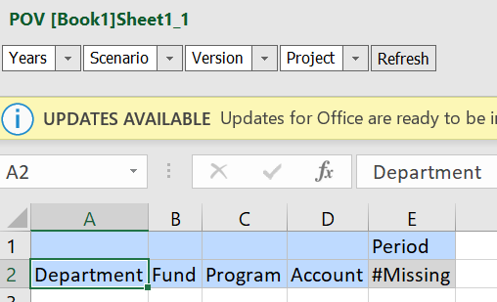
Step 14: In the “Planning Ad Hoc” ribbon, click “Member Selection.”
Step 15: A window will appear titled member selection. On the top left side, you will see the name of the dimension you intend to manipulate. If you do not, use the drop-down menu to select the desired dimension.
Use the check boxes next to the member names to select the member you want. Then you will be using the arrows in the center of the window to move the desired member to the right. In this case, we will be moving department to the left and “Top – Top (RVF)” to the right. This is because we no longer want the top level “Department” member in the grid but rather “Top – Top (RVF).”
The top-level dimensional member isn’t always listed on the right. If this is the case, nothing needs to be moved left.

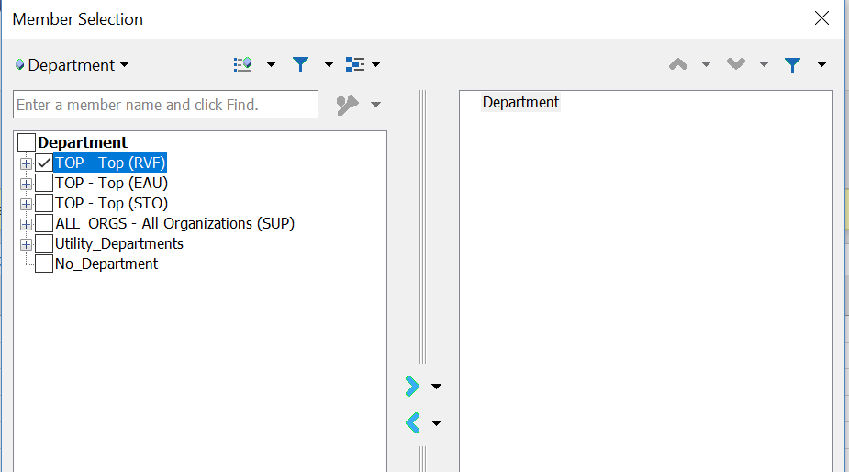
Step 16: Once Step 15 is complete, the window will look like the below image. Click “OK”.
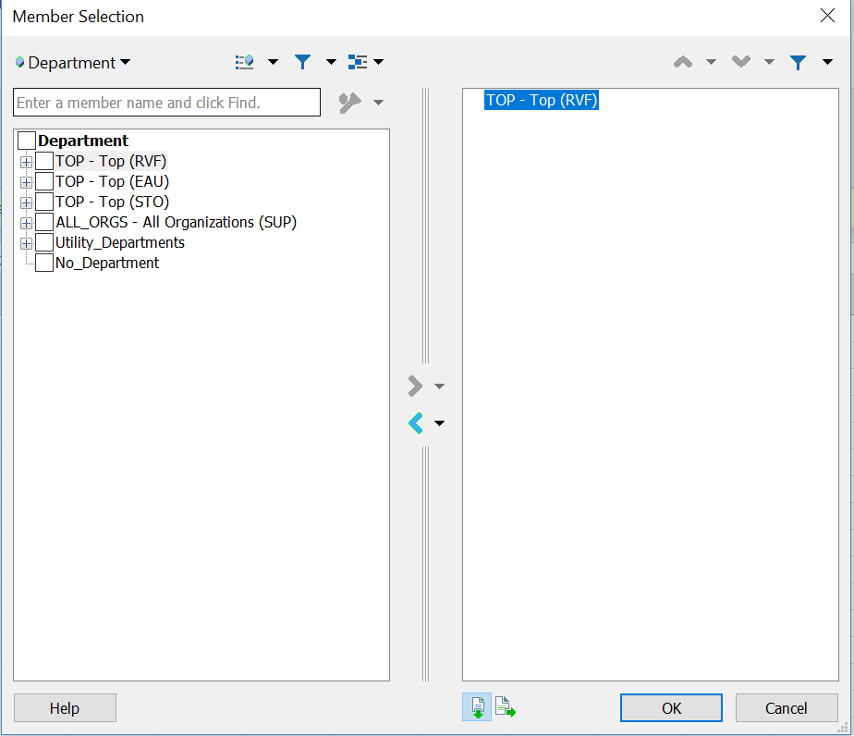
Step 17: We will be repeating the steps taken above, for each of the dimensions in the rows. Click once on the dimension you want to select a member for (Fund). Click “Member Selection” in the “Planning Ad Hoc” ribbon
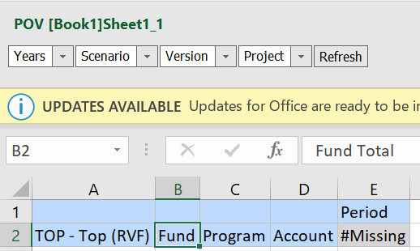
Step 18: On the top left, select the dimension you intend to manipulate from the drop-down menu. Use the check boxes next to the member names to select the member you want. Then you will be using the arrows in the center of the Window to move the desired member to right. In this case, we will be moving Fund to the left and “Fund Total” to the right. This is because we no longer want the top level “Fund” member in the grid but rather “Fund Total.” Click “OK” once your selection is made.
If the top-level dimensional member isn’t listed on the right, nothing needs to be moved left.

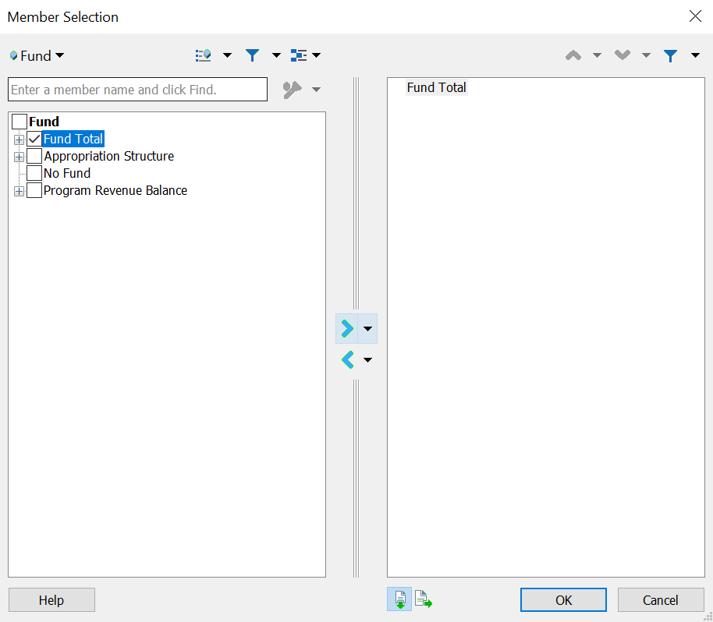
Step 19: Click once on the dimension you want to select a member for (Program). Click “Member Selection” in the “Planning Ad Hoc” ribbon.
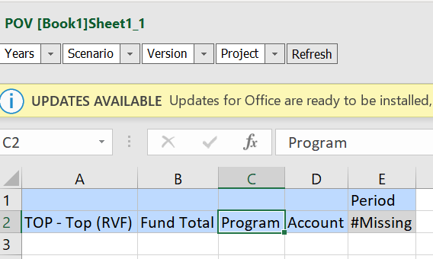

Step 20: On the top left, select the dimension you intend to manipulate from the drop-down menu. Use the check boxes next to the member names to select the member you want. Then you will be using the arrows in the center of the window to move the desired member to right. In this case, we will be moving Program to the left and “Program Total” to the right. This is because we no longer want the top level “Program” member in the grid but rather “Program Total.” Click “OK” once your selection is made.
If the top-level dimensional member isn’t listed on the right, nothing needs to be moved left.

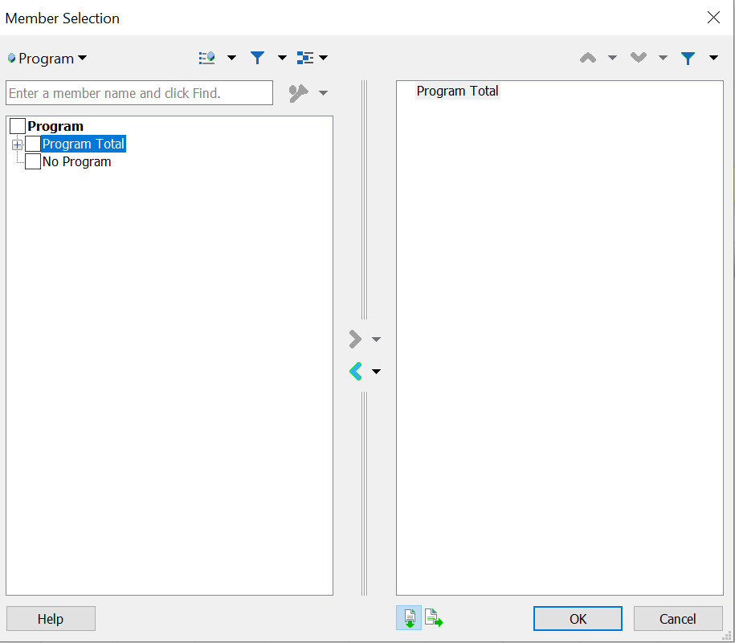

Step 21: Click once on the dimension you want to select a member for (Account). Click “Member Selection” in the “Planning Ad Hoc” ribbon.

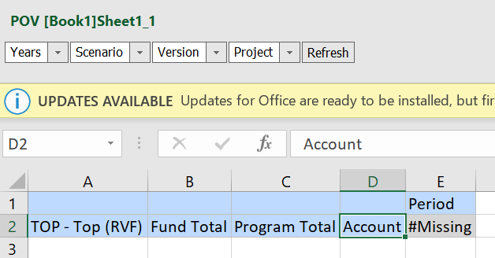

Step 22: On the top left, select the dimension you intend to manipulate from the drop-down menu. Use the check boxes next to the member names to select the member you want. Then you will be using the arrows in the center of the window to move the desired member to right. In this case, we will be moving Account to the left and “Net Activities” to the right. This is because we no longer want the top level “Account” member in the grid but rather “Net Activities.” Click “OK” once your selection is made.
If the top-level dimensional member isn’t listed on the right, nothing needs to be moved left.

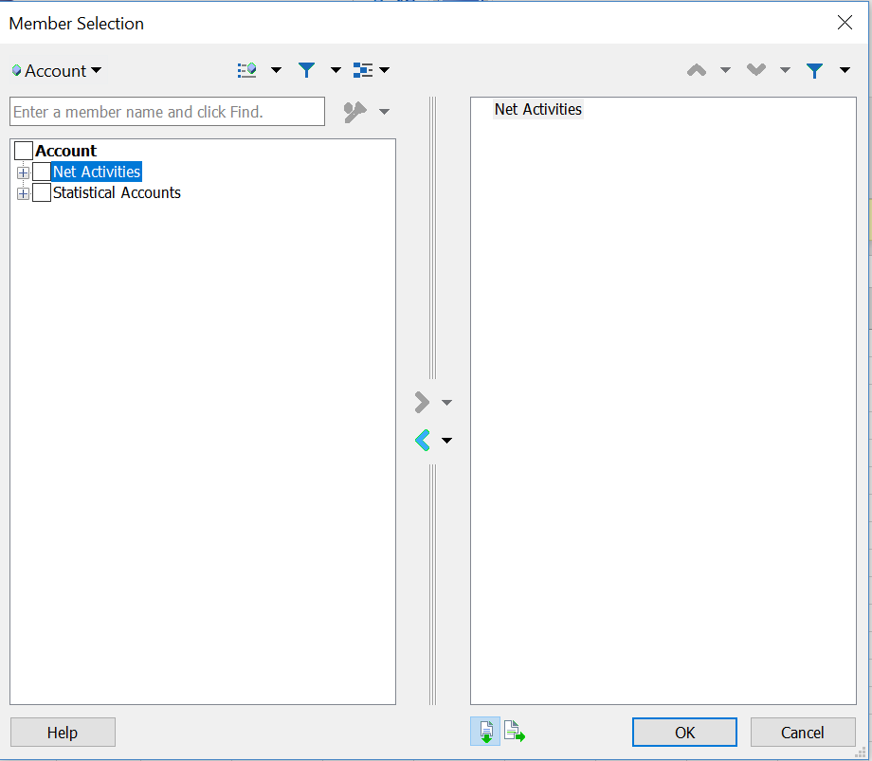
Step 23: Click Refresh once all your row dimensional members have been selected. It is okay to refresh after each member you select. The rule of thumb is refresh often so that you know right away if you have made an error in creating the grid.
Step 24: Next we will be manipulating which dimensions we want to appear in the columns. We will be taking the remaining dimensions in the POV and pivoting them to the column. Like what we did in the rows, we can either click and drag the dimension into the column or insert rows and directly type the member name into the grid.
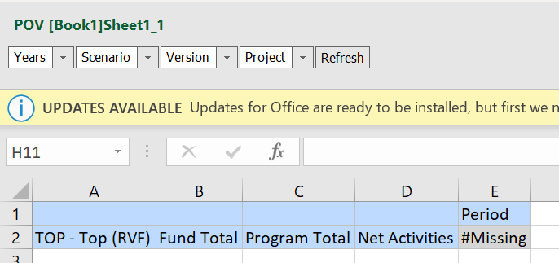
In this documentation, we will be typing in the Dimensions into the grid. Insert four blank rows at the top, and type in the remaining four dimensions so that they are stacked above Period. You can reference the POV for exact spelling of each dimension.
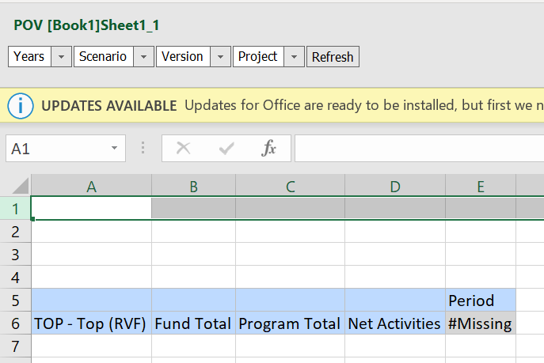

Step 25: Once you have typed “Years,” “Scenario,” “Version,” and “Project,” it will look like the below image. Click Refresh.
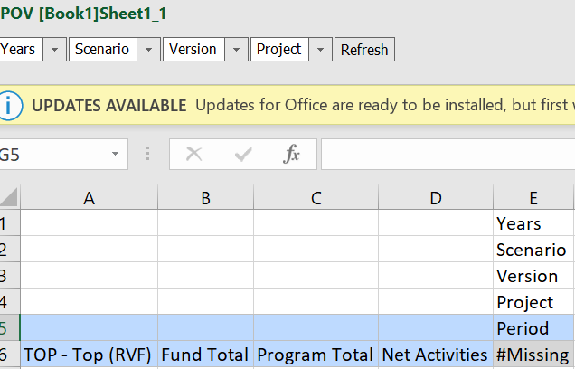

Step 26: If you have standard formatting ON, the dimensions you typed into the columns will appear blue. They will also no longer appear in the POV bar.
Click once on the dimension you want to select a member for (Period). Click “Member Selection” in the “Planning Ad Hoc” ribbon.
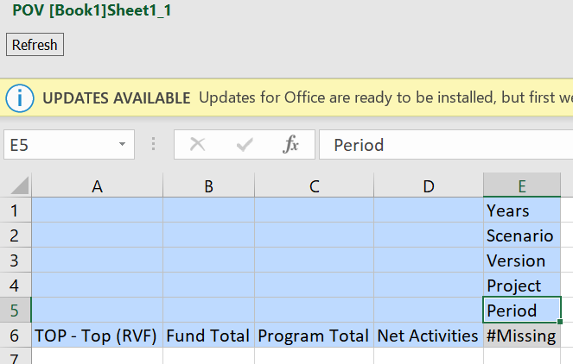

Step 27: Ensure that the desired dimension is selected in the top left. Use the check boxes next to the member names to select the member you want. Then you will be using the arrows in the center of the window to move the desired member to right. In this case, we will be moving Period to the left and “Year Total” to the right. This is because we no longer want the top level “Period” member in the grid but rather “Year Total.” Click “OK” once your selection is made.
If the top-level dimensional member isn’t listed on the right, nothing needs to be moved left.

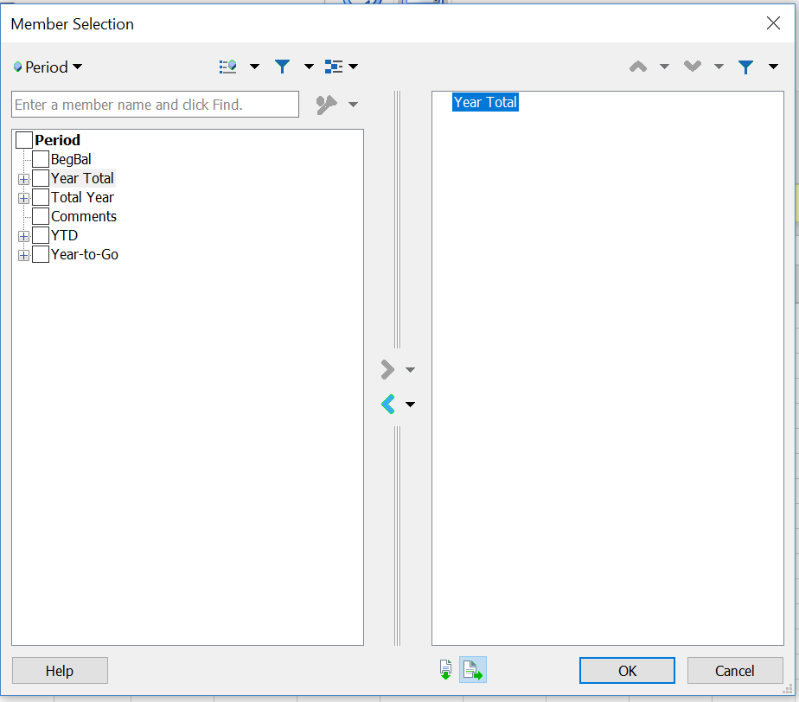

Step 28: Click once on the dimension you want to select a member for (Project). Click “Member Selection” in the “Planning Ad Hoc” ribbon.
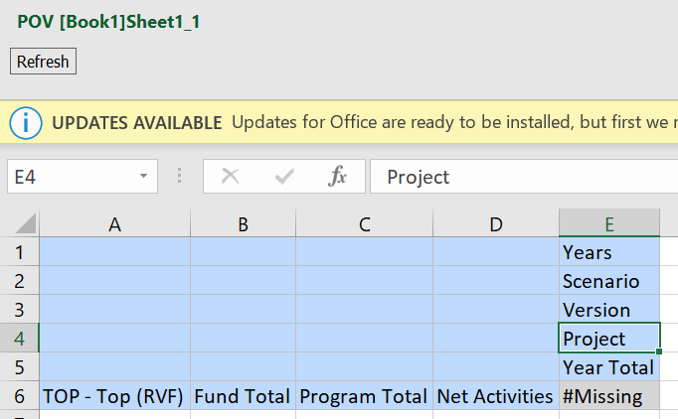

Step 29: Ensure that the desired dimension is selected in the top left. Use the check boxes next to the member names to select the member you want. Then you will be using the arrows in the center of the window to move the desired member to right. In this case, we will be moving Project to the left and “River Falls Project Total” to the right. This is because we no longer want the top level “Project” member in the grid but rather “River Falls Project Total.” Click “OK” once your selection is made.
If the top-level dimensional member isn’t listed on the right, nothing needs to be moved left.

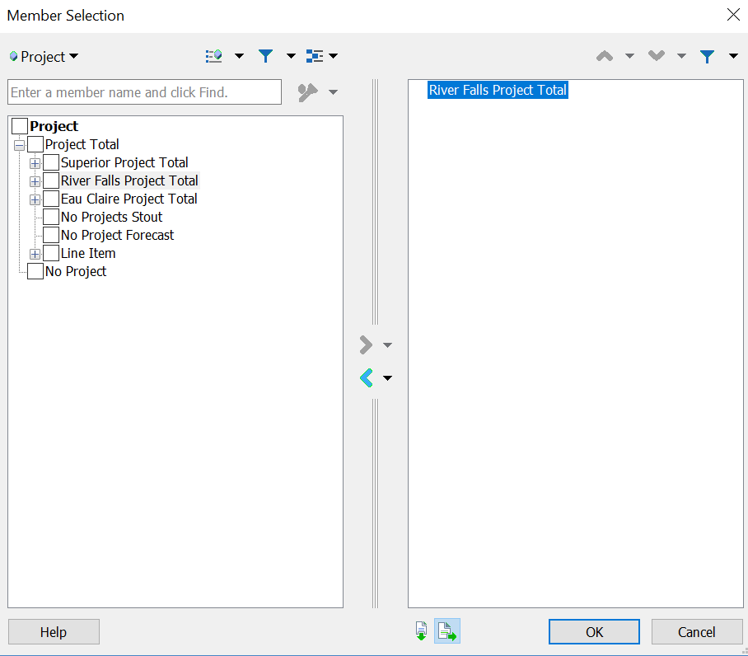
Step 30: Click once on the dimension you want to select a member for (Version). Click “Member Selection” in the “Planning Ad Hoc” ribbon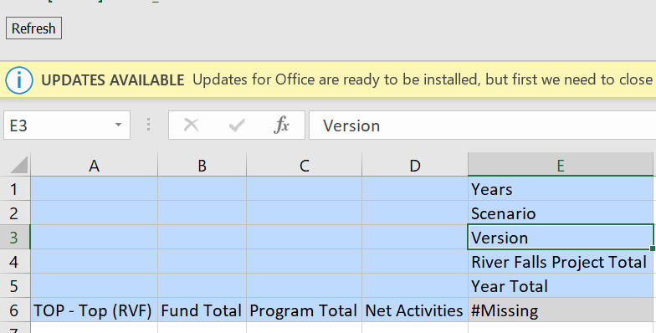
Step 31: Ensure that the desired dimension is selected in the top left. Use the check boxes next to the member names to select the member you want. Then you will be using the arrows in the center of the window to move the desired member to right. In this case, we will be moving Version to the left and “Final” to the right. This is because we no longer want the top level “Version” member in the grid but rather “Final.” Click “OK” once your selection is made.
If the top-level dimensional member isn’t listed on the right, nothing needs to be moved left.

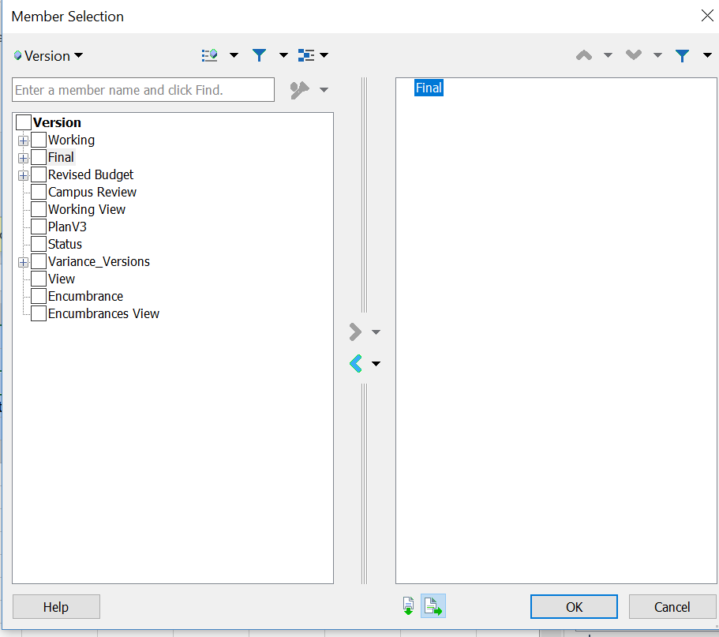

Step 32: Click once on the dimension you want to select a member for (Scenario). Click “Member Selection” in the “Planning Ad Hoc” ribbon

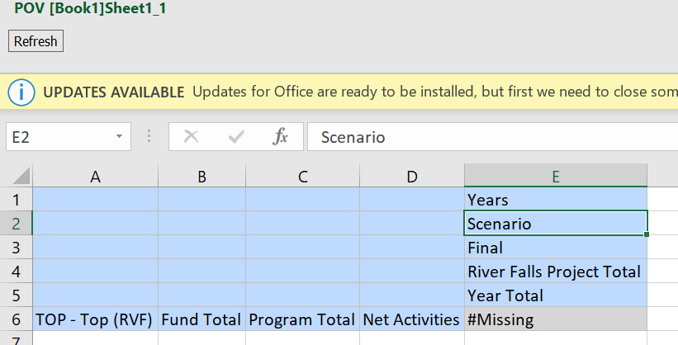

Step 33: Ensure that the desired dimension is selected in the top left. Use the check boxes next to the member names to select the member you want. Then you will be using the arrows in the center of the window to move the desired member to right. In this case, we will be moving Scenario to the left and “Actual” to the right. This is because we no longer want the top level “Scenario” member in the grid but rather “Actual.” Click “OK” once your selection is made.
If the top-level dimensional member isn’t listed on the right, nothing needs to be moved left.

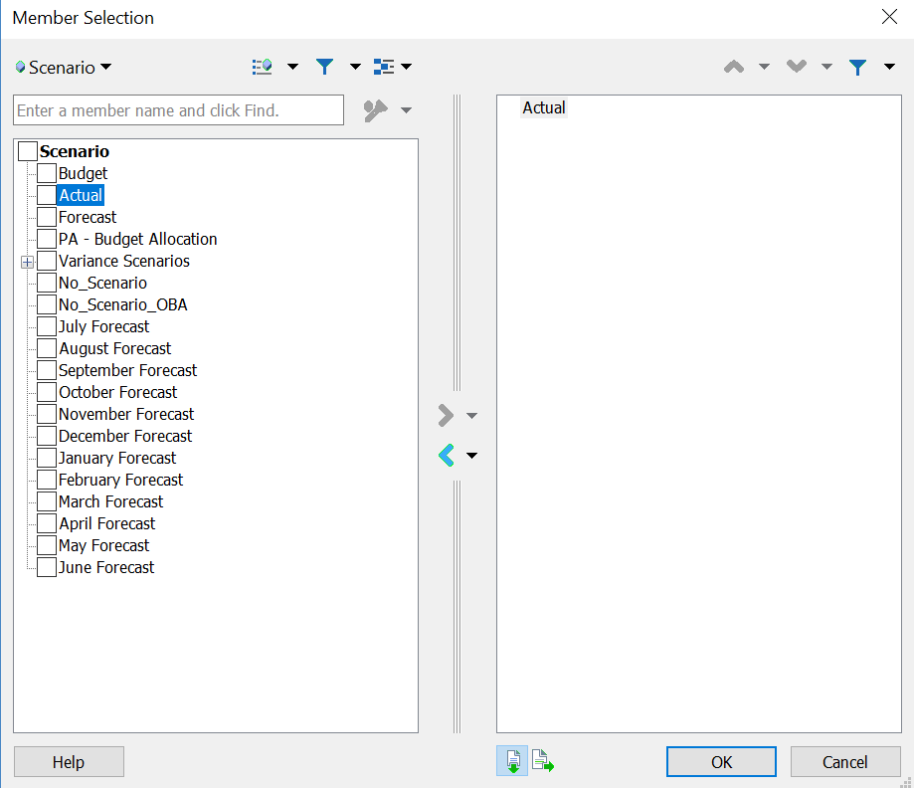

Step 34: Click once on the dimension you want to select a member for (Years). Click “Member Selection” in the “Planning Ad Hoc” ribbon
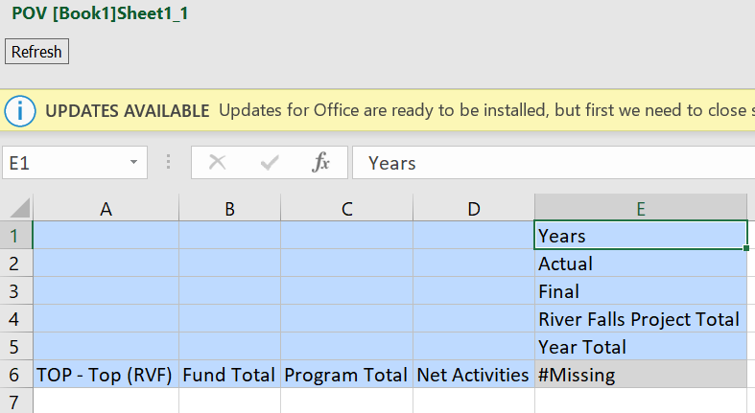

Step 35: Ensure that the desired dimension is selected in the top left. Use the check boxes next to the member names to select the member you want. Then you will be using the arrows in the center of the window to move the desired member to right. In this case, we will be moving Years to the left and “2019 - 2020” to the right. This is because we no longer want the top level “Years” member in the grid but rather “2019 - 2020.” Click “OK” once your selection is made.
If the top-level dimensional member isn’t listed on the right, nothing needs to be moved left.

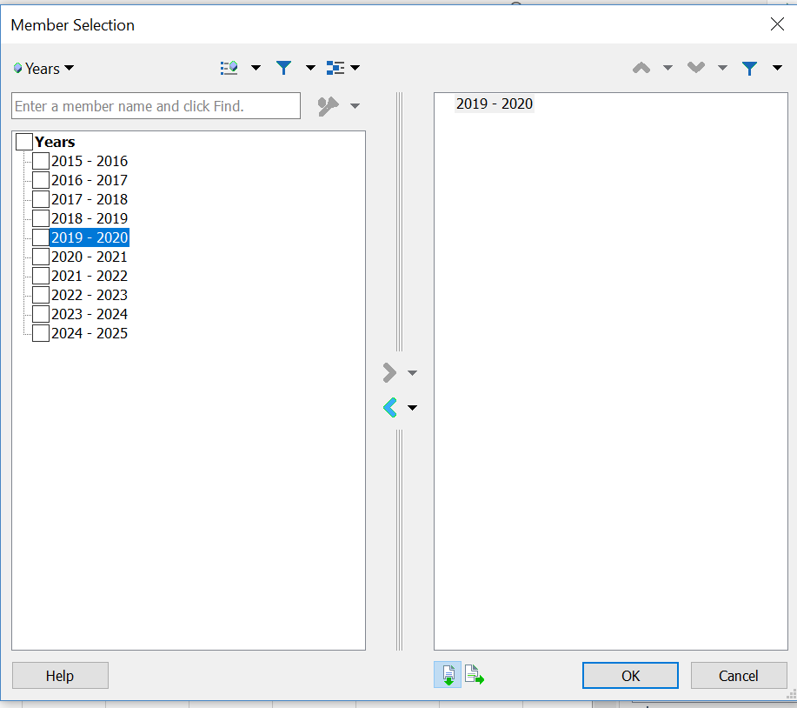

Step 36: Click “Refresh.” At this step you should no longer be seeing missing data, but rather a number.
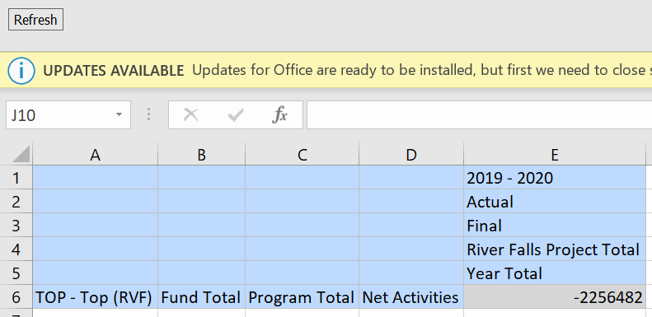
Step 37: In this example we will be pulling an additional column of data. We want to see this year’s Final Budget in addition to YTD FY20 Actuals.
If you want to add an additional column you can either select each dimension as we did in the previous steps, or you can copy and paste the column you have already constructed. If doing the latter, you only need to select the dimensions you want to change.
In the image below we are “Copying” the actuals column we had set up previously.
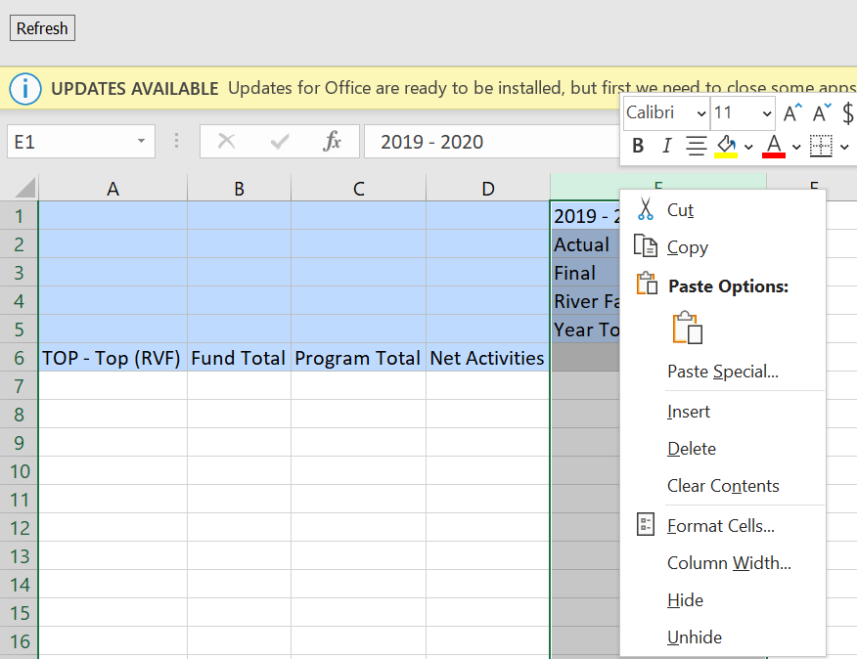

Step 38: Paste the column you just copied in the adjacent blank column.
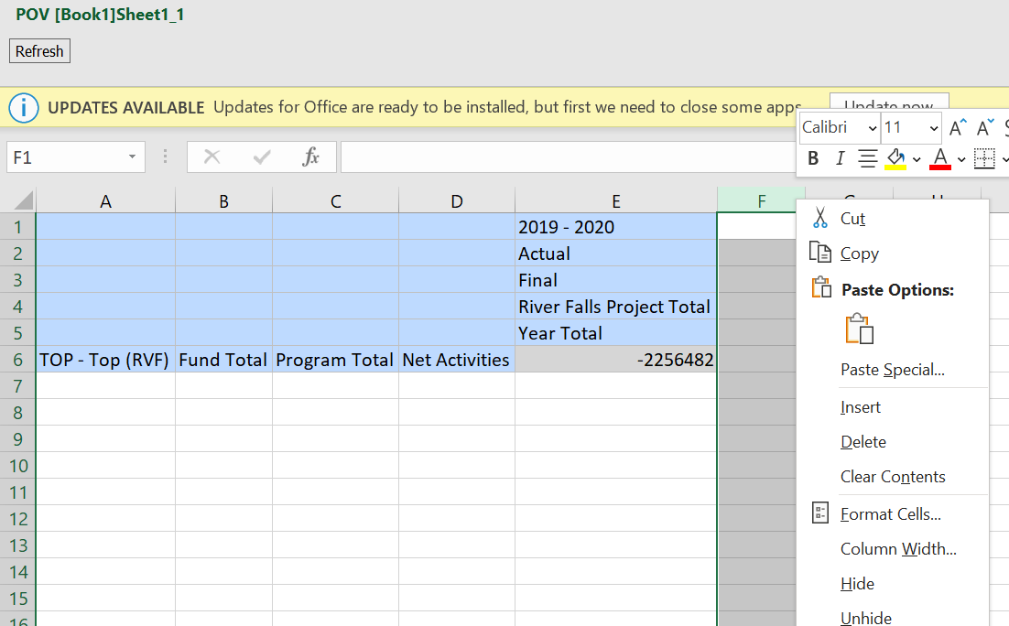

Step 39: You will see that your pasted column is not in the same color as the rest of your data grid. When adding additional columns/row you will need to “Refresh” so that the column is a dynamically connected entity rather than just a pasted value. Below you can see two different ways to refresh the grid.
Depending on what paste function you use, the cells you paste may be blue.
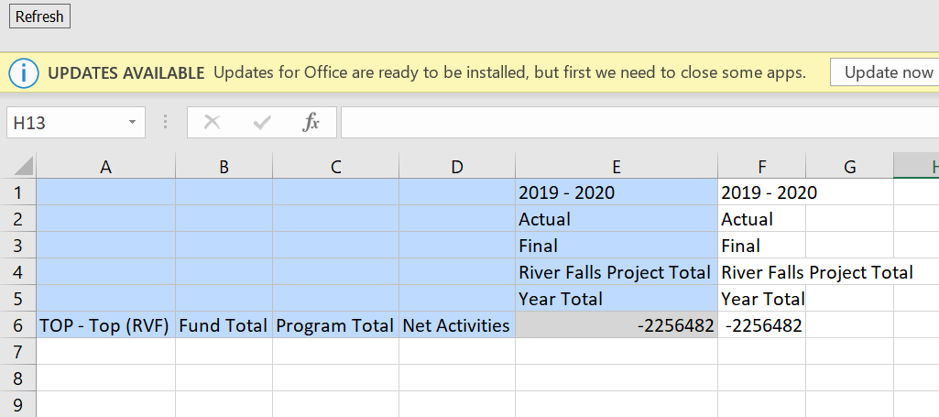
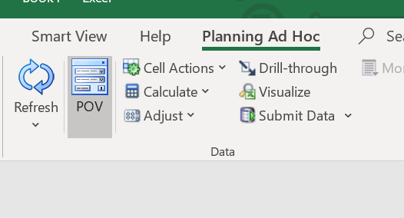

Step 40: Once you hit “Refresh” you will see that the column mimics the formatting of the rest of the grid. Next, we will be altering the column dimensionality to pull in FY20 Final Budget.
Click once on the member you want to change (Actual). Click “Member Selection” in the “Planning Ad Hoc” ribbon.

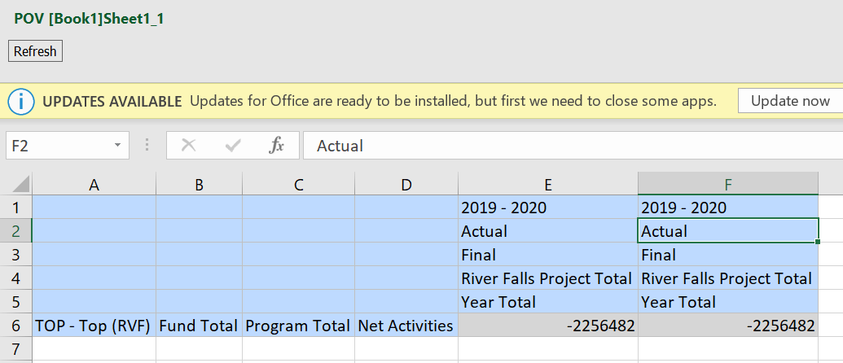

Step 41: Ensure that the desired dimension is selected in the top left. Use the check boxes next to the member names to select the member you want. Then you will be using the arrows in the center of the window to move the desired member to right. In this case, we will be moving Actual to the left and “Budget” to the right. This is because we no longer want the member “Actual” in the grid but rather “Budget.” Click “OK” once your selection is made.
If the top-level dimensional member isn’t listed on the right, nothing needs to be moved left.
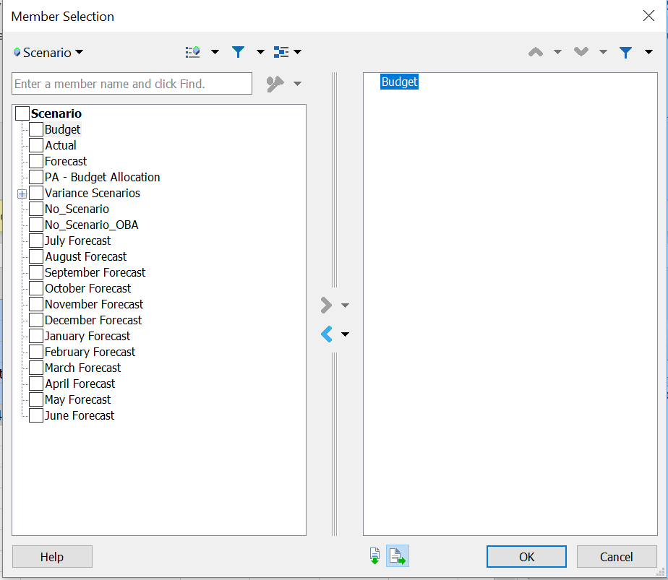
Step 42: Click “Refresh” once you are done, so that the grid is pulling Budget and not Actuals in your new column.

PART TWO: PULLING DATA FOR LEVEL 0 MEMBERS BY DEPARTMENT, FUND, AND PROGRAM
You have now set up your grid. The next portion of this documentation will walk you through zooming in on all the dimensions in the rows. This will create a grid that pulls data by all level 0 Departments, Funds, Programs, and Accounts.
For some institutions this is a rather large data set and Excel may not be capable of pulling that large of a data set. If this is the case, refer back to steps 13-23 and select a smaller data set. You can do this by choosing a Division (ex. RVF_General_Education_Admin), a fund grouping (ex. GPR/Tuition), or Program (ex. P_2). This was not an issue with the institution we are using as our example in this documentation.

Step 42: The first step we want to take before zooming in is re-enabling suppression. We want to pull only intersections with data, otherwise the data set becomes too large and unmanageable for Excel.
In the Smart View ribbon click “Options.”
Step 43: Navigate to the “Data Options” tab. Check “No Data/Missing” under both “Suppress Rows” and “Suppress Columns”. Additionally, under Mode, select “Suppress Missing Blocks.” Click OK.
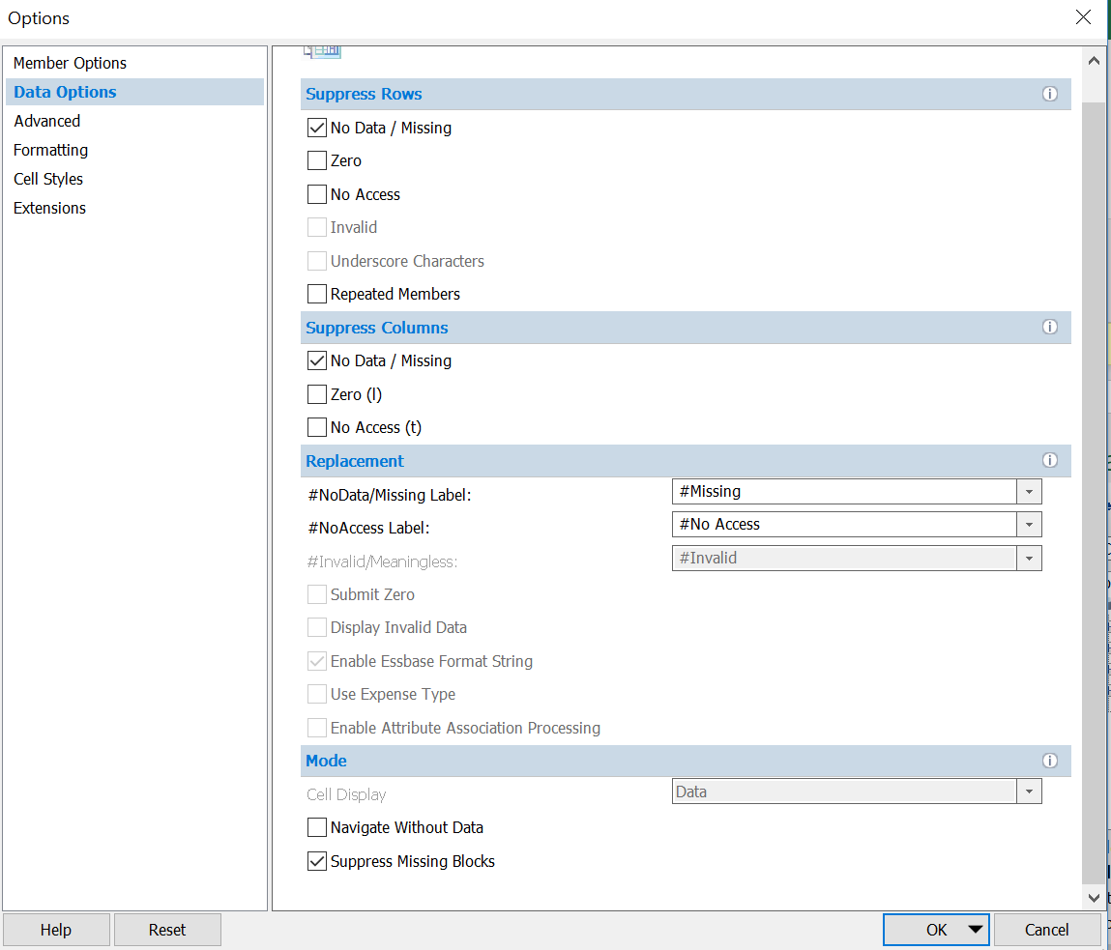
Step 44: We will start by zooming into Department. Click the member of the Department dimension you selected. In the “Planning Ad Hoc” ribbon, use the “Zoom In” drop down to pull all “Bottom Level” Departments. This will pull all Sub Departments within your institution. If you were to Select “All Levels” it would pull every Division/Department/Sub Department under the selected member. If you were to click “Next Level,” it would pull only the Children of the member you selected. In this case, it would be the divisions under Total Institution.
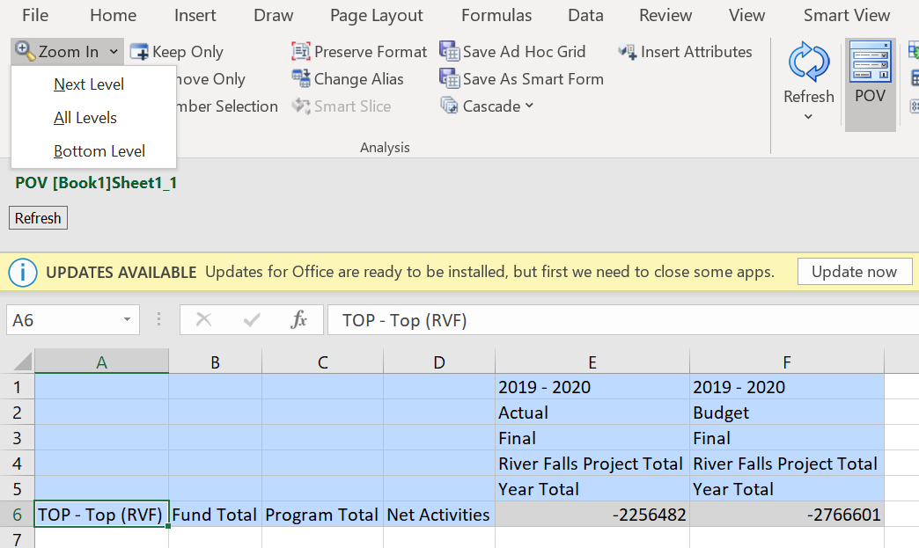
Step 45: In this step you can see the result of your previous click. You can see this action pulled all Sub Departments under UWRVF.
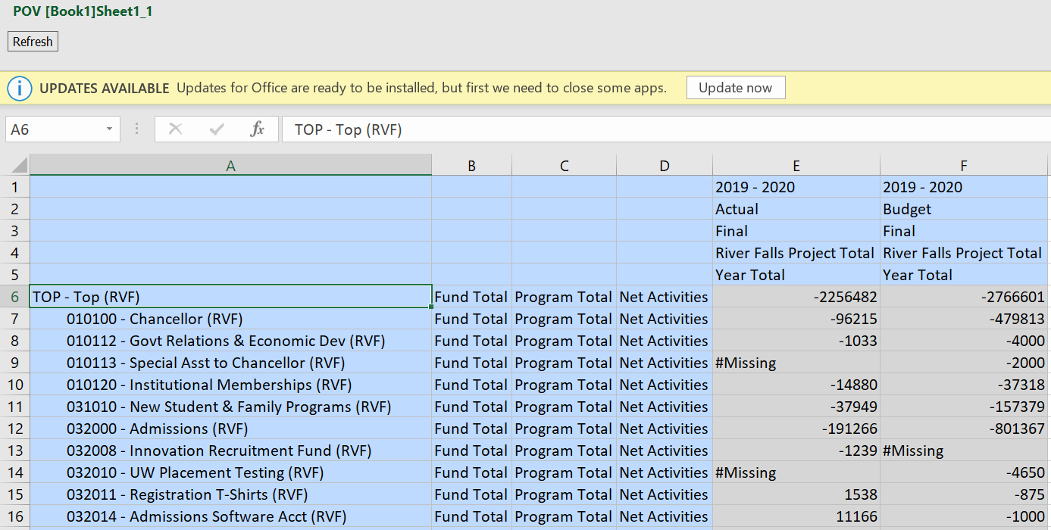

Step 46: Next we will zoom into Fund. Click the member of the Fund dimension you selected. In the “Planning Ad Hoc” ribbon, use the “Zoom In” drop down to pull all “Bottom Level” Funds. This will pull all Level 0 Funds that contain data within your institution.
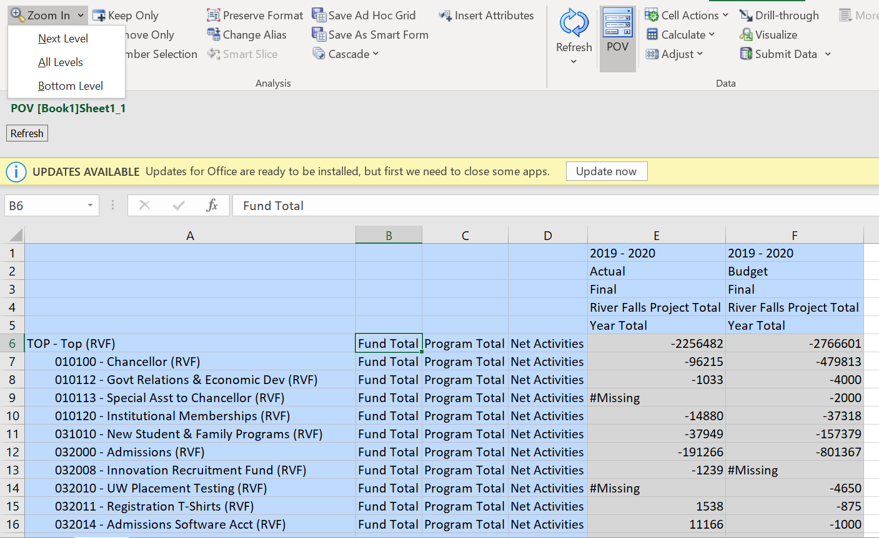
Step 47: In this step you can see the result of your previous click. You can see this action pulled all Level 0 Funds under Fund Total.

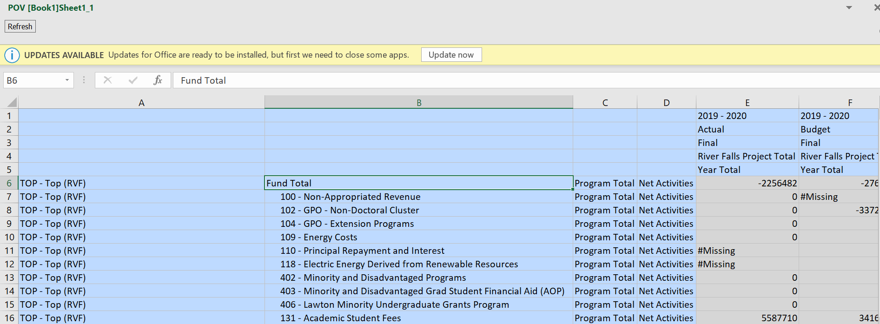

Step 48: Next we will zoom into Program. Click the member of the Program dimension you selected. In the “Planning Ad Hoc” ribbon, use the “Zoom In” drop down to pull all “Bottom Level” Programs. This will pull all Level 0 Programs that contain data within your institution.
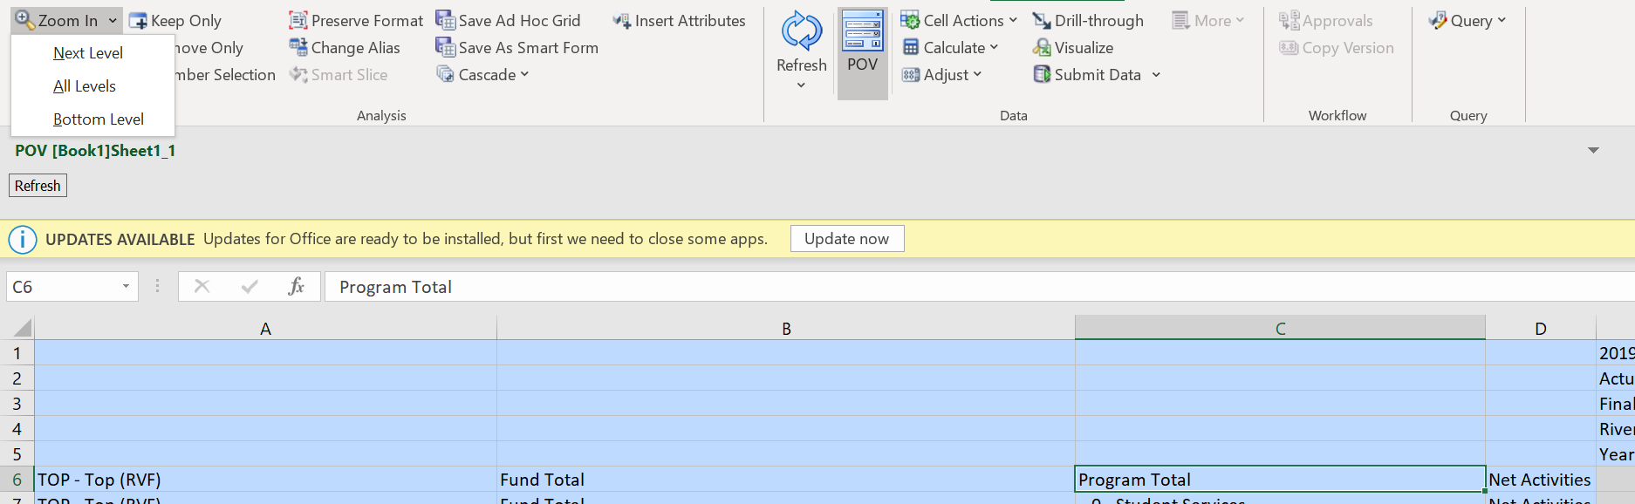

Step 49: In this step you can see the result of your previous click. You can see this action pulled all Level 0 Programs under Program Total.
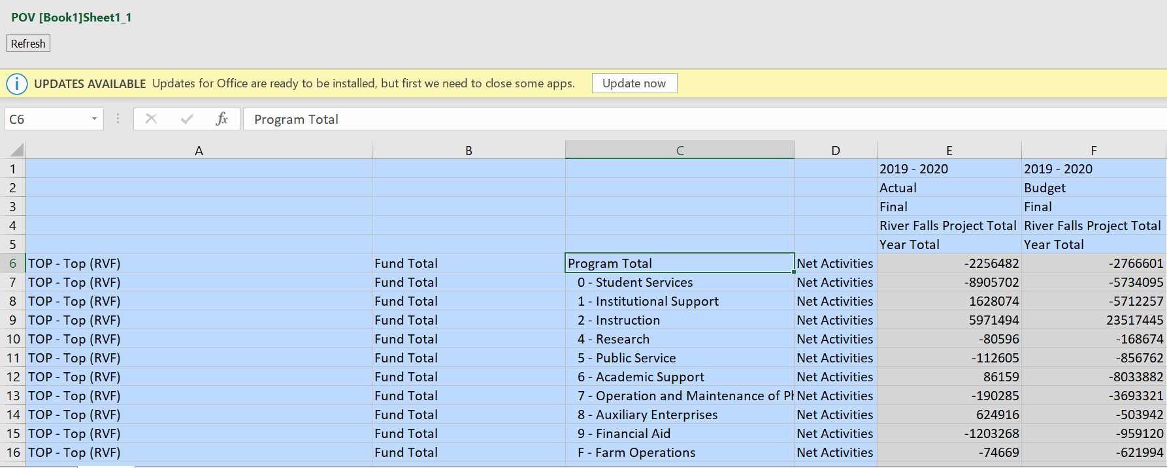

Step 50: Next we will zoom into Account. Click the member of the Account dimension you selected. In the “Planning Ad Hoc” ribbon, use the “Zoom In” drop down to pull all “Bottom Level” Accounts. This will pull all Level 0 Accounts that contain data within your institution.
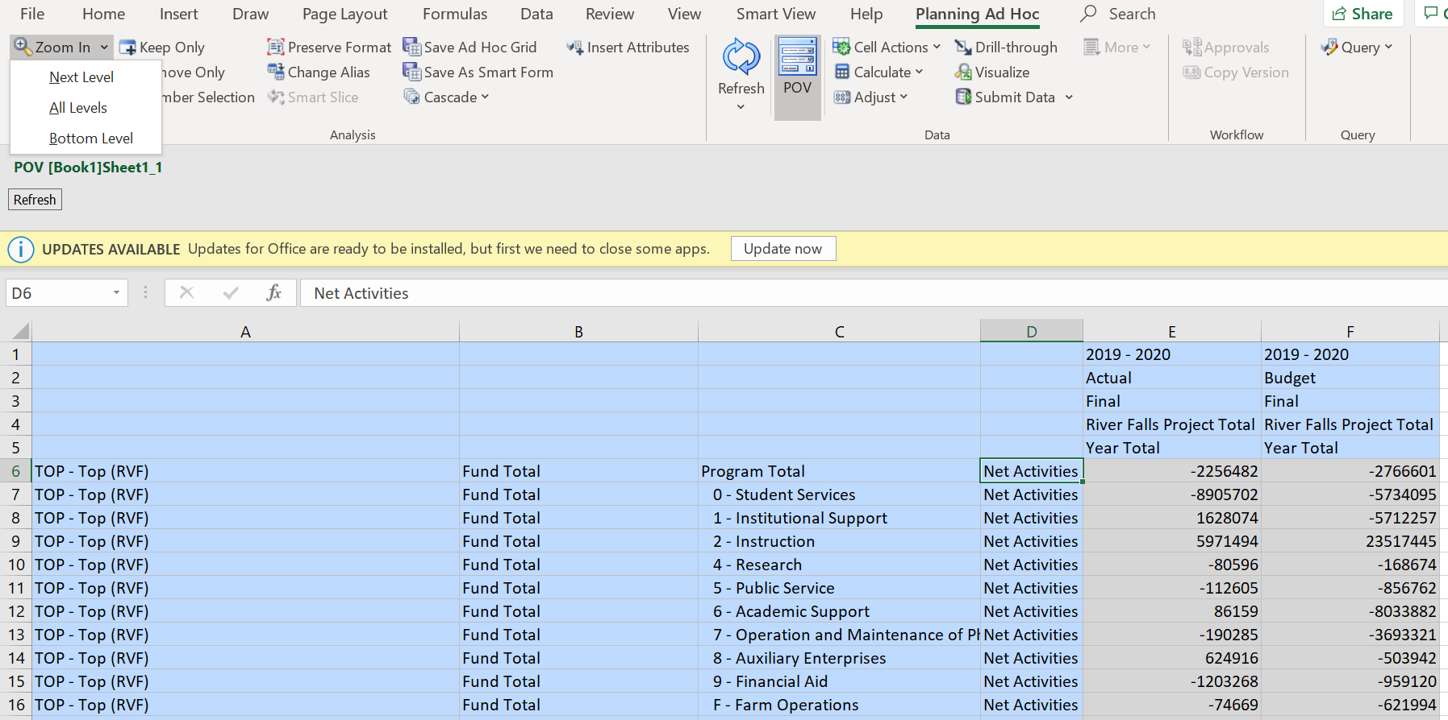
Step 51: In this step you can see the result of your previous click. You can see this action pulled all Level 0 Accounts under Net Activities.

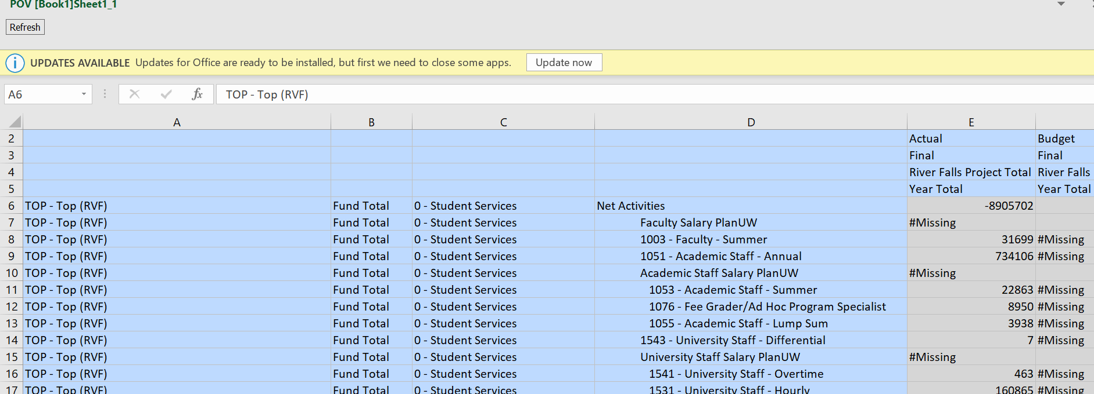

Step 52: Next, insert one row at the top of the data but below the headers:
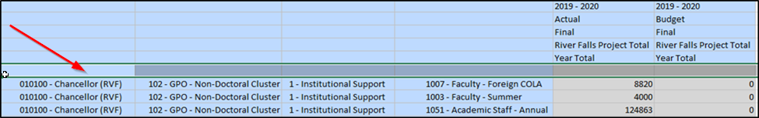

Using the member selection method described in the above section, select the top-level department, top-level fund, top-level program, and top-level account member (example below with top-level dimensions – detailed instructions are on next page)
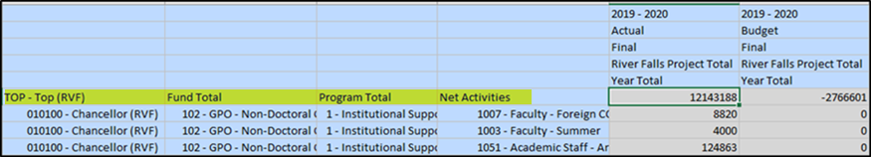

For Department, click into the blank cell located in the Department Column.

Click Member Selection.
Using the window, ensure that the desired dimension is selected in the top left and then select the top-level department and move it to the right. Anything that is defaulted on the right will need to be moved left. Click “OK” once your selection is made.
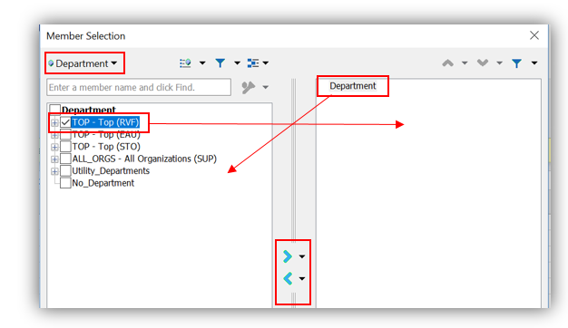
For the remaining 3 dimensions steps please follow this same method or refer to previous steps.

Step 53: Next, click on Net Activities and Click “Zoom In”

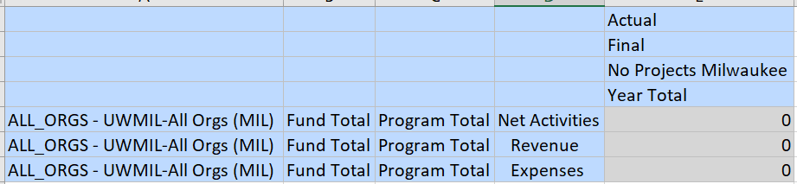
This is the result of the “Zoom In” done in step #53 above.

PART THREE: ROLLING THE GRID TO PULL AT TOP LEVEL MEMBERS
Each institution will periodically add Sub Departments or change member names within each Dimension. This will not automatically be pulled into your grid and has the potential to disable your grid from being Refreshed.
In order to do this, you will need to zoom out to the top level of each Dimension and then follow the steps in Part Two to repull all Level 0 members.
Step 54: Click the top-level member from the Department dimension (Top – Top (RVF)). In the “Planning Ad Hoc” ribbon, click “Keep Only.”

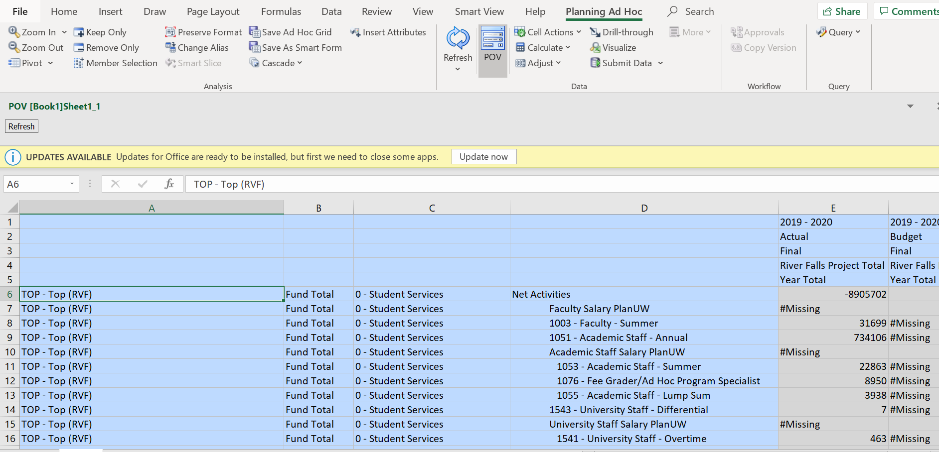

Step 55: Click the top-level member from the Fund dimension (Fund Total). In the “Planning Ad Hoc” ribbon, click “Keep Only.”

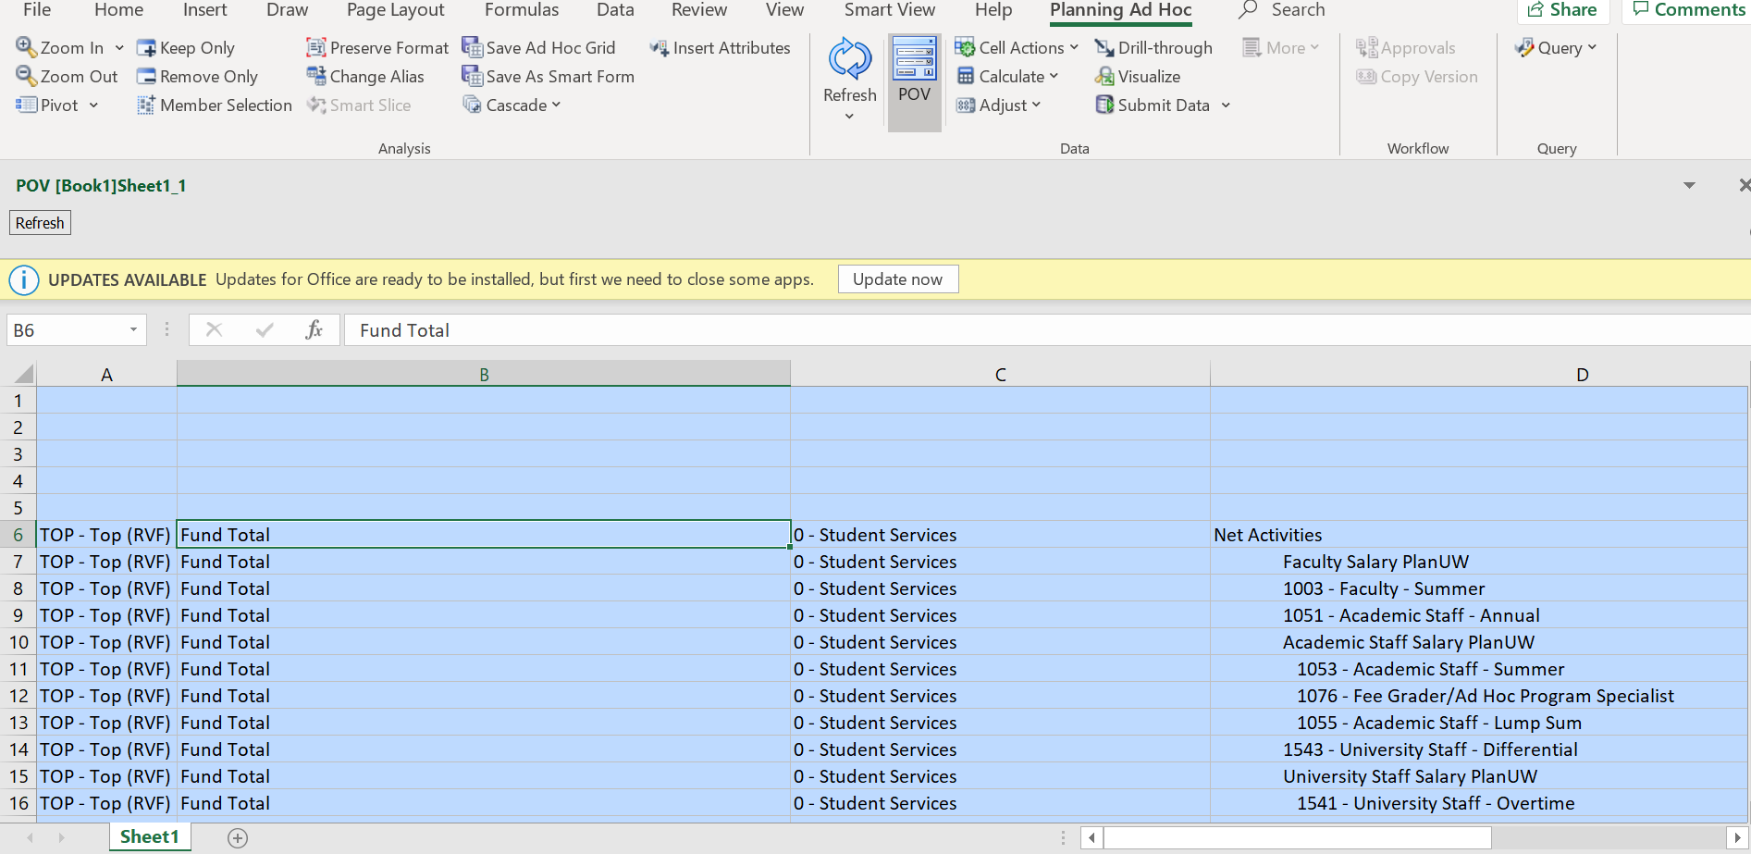

Step 56: Click the top-level member from the Program dimension (Program Total). In the “Planning Ad Hoc” ribbon, click “Keep Only.”

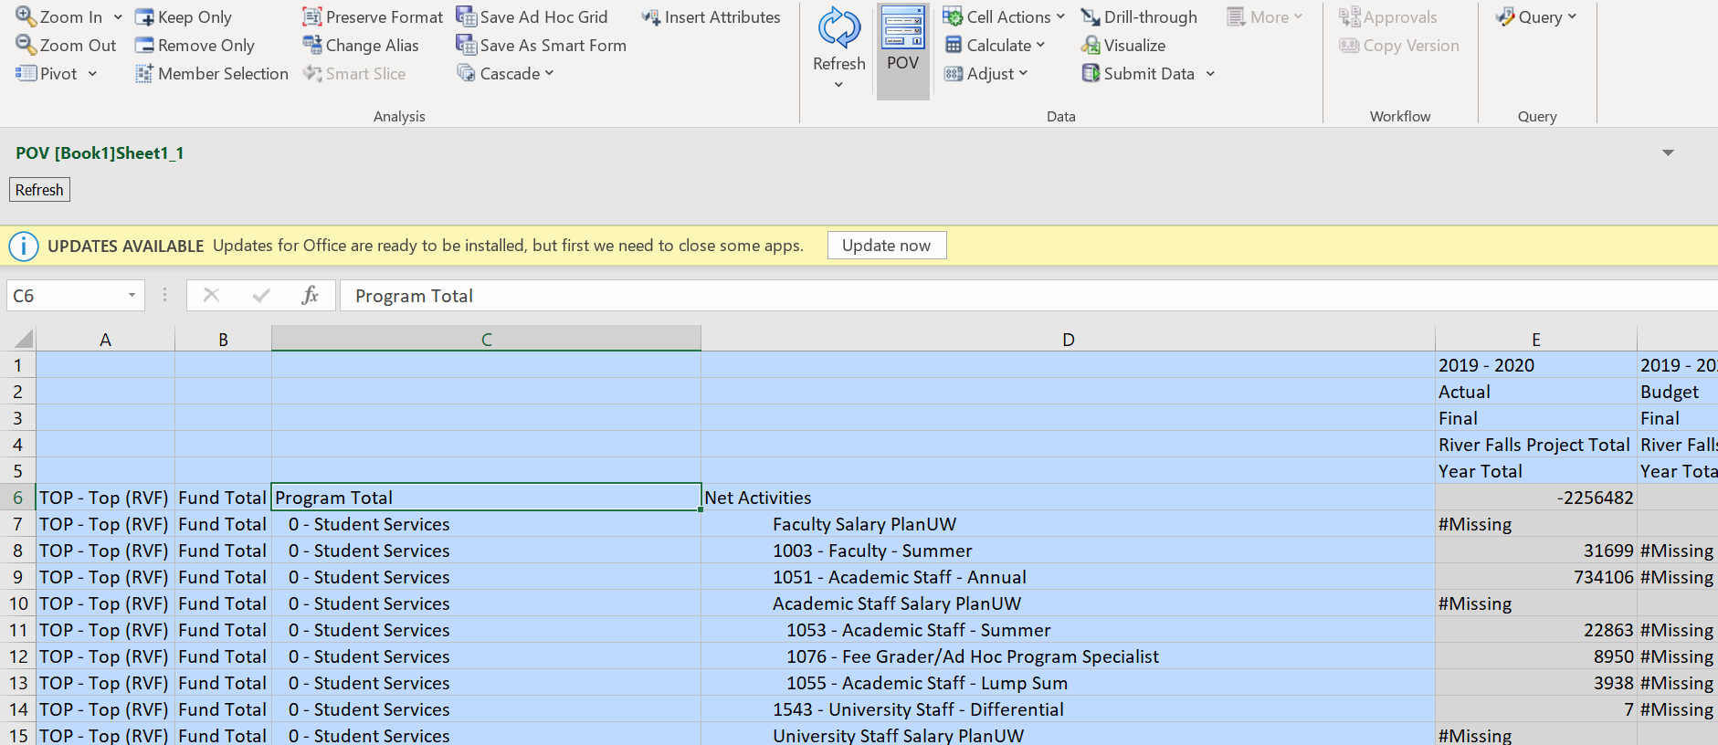

Step 57: Click the top-level member from the Account dimension (Net Activities). In the “Planning Ad Hoc” ribbon, click “Keep Only.”

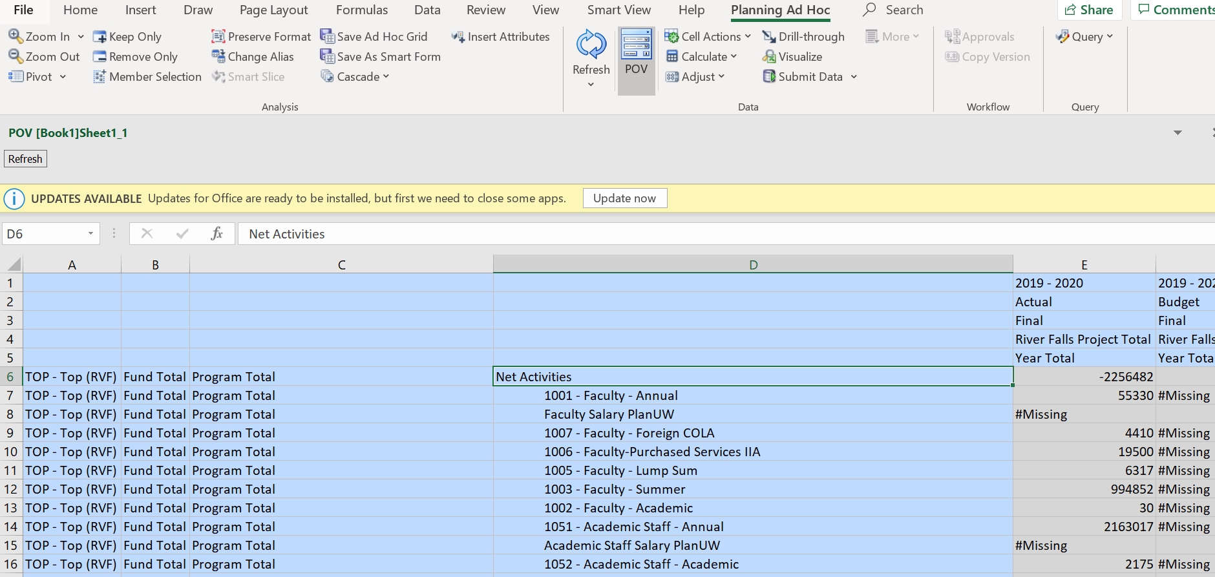

Step 58: The Rolled-up grid will end up looking like the one below, with only the top level members from each dimension showing.
